ANTI UP RETURN WITH DOUBLE SINGLE DROP:
“THE WEEKEND” & “CONTROL THE MEDIA”

EAGERLY AWAITED COACHELLA SETS SLATED FOR FRIDAY, APRIL 12 AND 19

LISTEN HERE

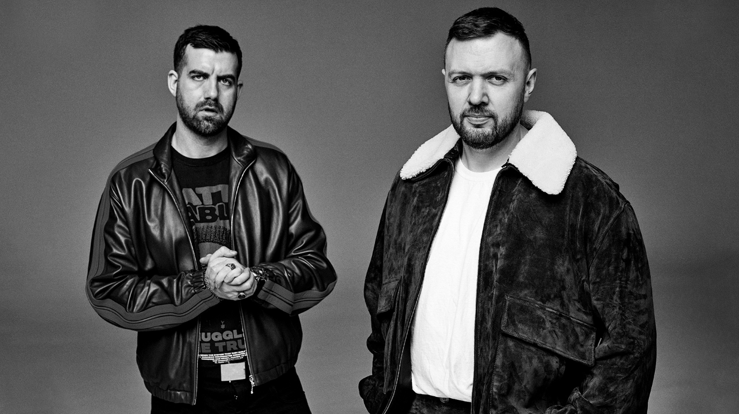
DOWNLOAD HI-RES IMAGES HERE

Anti Up – the supergroup comprised of two of dance music’s most in-demand DJ/producers, Chris Lake and Chris Lorenzo – have dropped their eagerly awaited new music, “The Weekend” & “Control The Media” available now via Big Beat Records HERE.

Anti Up, the DJ/Producer duo comprised of Chris Lorenzo & Chris Lake, returns for their first release in almost 2 years after being locked away in the studio all this time. The duo is returning to the dance floor with music that satisfies the same high-octane fervor fans have grown to love, while simultaneously pushing sonic boundaries to their bleeding edge.

Chris Lake is one of the biggest names in dance music, known for his electrifying DJ sets and a massive discography of original productions and remixes that have earned him multiple Platinum and Gold certifications and chart-topping hits around the globe, including remixes for superstars such as The Chemical Brothers, collaborations with Four Tet, Grimes, and many more. Last year he closed the Outdoor Stage at Coachella with Fisher with their ‘Under Construction’ event series, as well as shut down Hollywood Blvd in October for their 12k person street party, the first time an event of this nature has ever been done. His most recent release “Somebody”, remake of Gotye and Kimbra’s “Somebody That I Used to Know”, with FISHER and Sante Sansone is out everywhere.

Widely acknowledged for being a pioneer in electronic music, Chris Lorenzo’s flawless production and high-octane DJ sets have earned him a fanatical and ever-growing global following. Among his growing body of work are such hits as “California Dreamin” – currently boasting over 100M streams across all platforms – as well as his spin on J Balvin and Skrillex’s “In Da Getto,” which proved the most played remix of 2021.

Together as Anti Up since 2018, the duo have earned acclaim for such adrenaline-pumping productions as “Sensational” and “Chromatic,” the latter of which was declared the #1 Most Heard Track of 2022 and one of the best received hits played out by the world’s top DJs in front of the largest festival crowds. Now, with “The Weekend” // “Control The Media,” Anti Up are back, continuing to push the boundaries and define a new age of dance music.

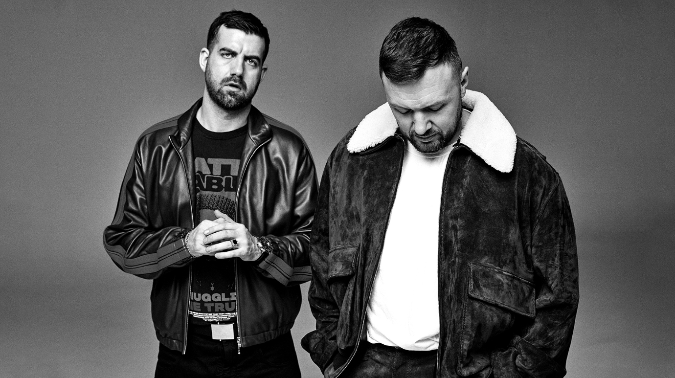
DOWNLOAD HI-RES IMAGES HERE

# # #

CONNECT WITH ANTI UP
FACEBOOK | INSTAGRAM | TWITTER | YOUTUBE

For more information: paige.rosoff@atlanticrecords.com

