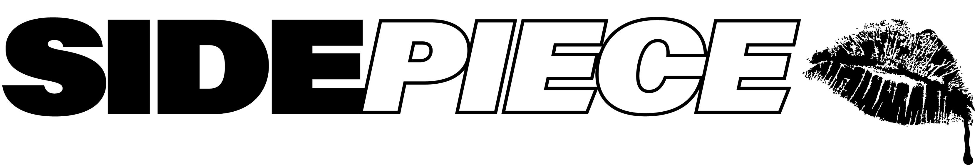

GRAMMY® AWARD-NOMINATED DANCE DUO SIDEPIECE JOIN FORCES WITH INTERNATIONALLY ACCLAIMED ARTIST FAOUZIA
FOR “ON MY WAY”

NORTH AMERICAN HEADLINE TOUR BEGINS OCTOBER 6 IN MIAMI
& INCLUDES TOP-BILLED SETS AT AUSTIN CITY LIMITS MUSIC FESTIVAL, EDSEA, DECADENCE: THE DIGITAL CITY & MORE

LISTEN TO “ON MY WAY (FT. FAOUZIA)” HERE

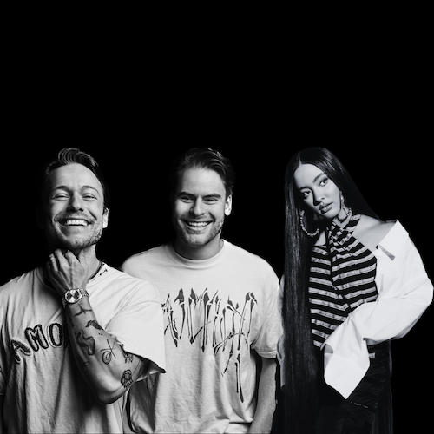
DOWNLOAD HI-RES PRESS PHOTO HERE

SIDEPIECE – the GRAMMY® Award-nominated dance duo comprised of multimillion streaming DJ/producers NITTI (Ricky Mears) and Party Favor (Dylan Ragland) – open a new chapter in their already incredible discography with “On My Way (Ft. Faouzia),” available now via Big Beat Records at all DSPs and streaming services HERE.

“On My Way” – which fuses SIDEPIECE’s signature dancefloor-filling production with internationally acclaimed Moroccan-Canadian singer/songwriter/multi-instrumentalist Faouzia’s spectacular vocal prowess and one-of-a-kind knack for melody – marks the latest in an ongoing musical run that includes this summer’s sizzling two-track single, “Stimulate” // “What You Need.” “SIDEPIECE have consistently managed to capture the fun and energetic essence of summer house with their releases,” declared This Song Is Sick. “Both tracks fit into a tech house mold but each provide their own unique spark.”

SIDEPIECE will hit the road on their “SIDEPIECE PRESENTS HOME RUN 2023/2024” North American headline tour, beginning October 6 at Miami, FL’s Club Space and then continuing into January 2024. A wide range of special guests will support throughout the run, including It’s Murph, Mark Knight, Martin Ikin, Cloverdale, DJ Susan, Freak On, Gene Farris, Kaleena Zanders, and more. In addition, SIDEPIECE will perform top-billed sets at Austin, TX’s Austin City Limits Music Festival (October 8 and 15), Denver, CO’s electronic New Year’s Eve celebration, Decadence: The Digital City (December 31), BOO! SEATTLE (October 28) and dance music-filled Caribbean cruise EDSea (November 4 to November 8.) For complete details and remaining ticket information, please visit youasidepiece.com.

MORE ON SIDEPIECE:
While Dylan Ragland and Ricky Mears meant to start a side project, they weren’t expecting to create SIDEPIECE – a GRAMMY® Award-nominated house duo that’s clocked more than 362M global streams since its inception. The two creatives – Ragland makes music as fan favorite Party Favor while Mears produces as dancefloor igniter NITTI – first linked via DM in 2019 to share track ideas. Sensing their musical chemistry, they jumped on Facetime. By the end of the call, they’d registered the @youasidepiece social handles and their own figurative sidepiece had been born.

“It started out as a fun passion project because we both love and care about house music,” says Dylan Ragland, “but it’s grown so much bigger than we originally planned.”

Indeed, success came fast for the pair. SIDEPIECE’s second single, the 2020 Diplo collaboration “On My Mind,” proved a global smash, earning more than 225M global streams, Gold and Platinum certifications in a dozen countries around the world, and a prestigious 2021 GRAMMY® Award nomination for “Best Dance Recording.”

A flurry of additional hit singles followed, with SIDEPIECE carving out a signature sound rooted in catchy vocals – “The most important element,” says Ragland – and an ever-intoxicating bump-and-grind house groove. Spanning tech house, bass house, and beyond, tracks including “Acrobatic,” “Temptation,” “Sextacy” and “Reborn” are all quintessentially SIDEPIECE – party-starting club records with a pop-lean and serious sex appeal.

“Huge streaming numbers are cool,” says Ricky Mears, “but seeing people in the crowd singing along to the song, that makes it all feel real.”

# # #

SIDEPIECE PRESENTS
HOME RUN 2023/2024

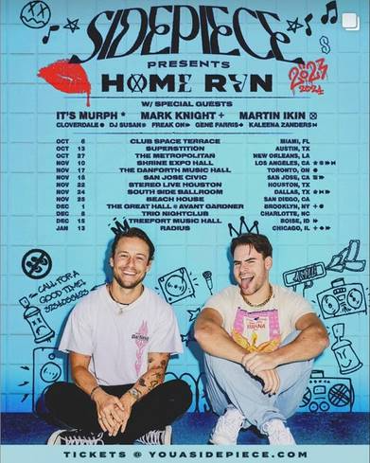

OCTOBER
6 – Miami, FL – Club Space
8 – Austin, TX – Austin City Limits Music Festival *
13 – Austin, TX – Superstition
15 – Austin, TX – Austin City Limits Music Festival *
27 – New Orleans, LA – The Metropolitan
28 – Seattle, WA - BOO! SEATTLE*

NOVEMBER
8 – Miami, FL - EDSea *
10 – Los Angeles, CA – Shrine Expo Hall
17 – Toronto, ON – The Danforth Music Hall
18 – San Jose, CA – San Jose Civic
22 – Houston, TX – Stereo Live Houston
24 – Dallas, TX – South Side Ballroom
25 – San Diego, CA – Beach House

DECEMBER
1 – Brooklyn, NY – The Great Hall @ Avant Gardner
8 – Charlotte, NC – Trio Nightclub
15 – Boise, ID – Treefort Music Hall
31 – Denver, CO – Decadence: The Digital City *

JANUARY 2024
13 – Chicago, IL – Radius

* FESTIVAL PERFORMANCE

# # #

CONNECT WITH SIDEPIECE
WEBSITE | FACEBOOK | INSTAGRAM | SOUNDCLOUD | SPOTIFY | TWITTER | YOUTUBE

Press contacts: Paige.Rosoff@atlanticrecords.com, Gabrielle.Reese@atlanticrecords.com

