FOR IMMEDIATE RELEASE
SEPTEMBER 8, 2023

COBRAH IS COMING IN HOT WITH “FEMININE ENERGY” + ANNOUNCEMENT OF FORTHCOMING EP

FEMININE ENERGY IS THE THIRD SINGLE FROM FORTHCOMING EP SUCCUBUS TO BE RELEASED ON FRIDAY, OCTOBER 13TH

OFFICIAL MUSIC VIDEO CONTINUES STORY OF THE ALIEN INCEPTION WHICH BEGUN IN “SUCK” VISUAL

UPCOMING NORTH AMERICAN LIVE DATES INCLUDE SHOWS WITH PABLLO VITTAR
AND TOP-BILLED PERFORMANCE AT SAN FRANCISCO’S PORTOLA FESTIVAL

LISTEN TO “FEMININE ENERGY” | WATCH OFFICIAL MUSIC VIDEO
PREORDER SUCCUBUS EP

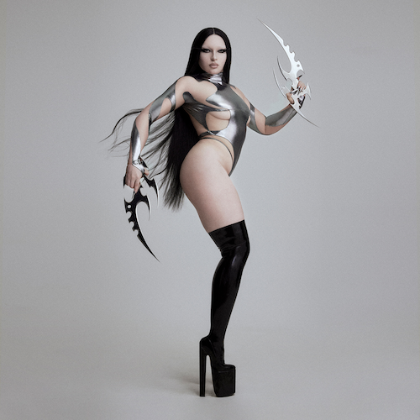
DOWNLOAD HI-RES ARTWORK // CREDIT: NINJA HANNA

Multi-faceted experimental artist COBRAH is back with her divinely empowered new single, “FEMININE ENERGY,” available now HERE. An official music video – which continues the shocking tale of alien impregnation begun in the official visual to COBRAH’s recent smash club anthem, “SUCK” – premieres today HERE.

“FEMININE ENERGY” heralds the eagerly anticipated arrival of COBRAH’s label debut EP, SUCCUBUS, arriving via Big Beat Records on Friday, October 13th. Pre-orders are available now HERE.

In addition to “FEMININE ENERGY,” SUCCUBUS includes the aforementioned “SUCK” (available now HERE) as well as the feverish “MANIC,” the latter joined by its own official music video streaming now HERE. All three tracks – as well as all other songs on the 7-track EP – feature riveting cover art displaying a different form of succubi (a demon that assumes a female form to attack and have sex with men, especially appearing in their dreams).

The seven succubi that populate SUCCUBUS will come to life in a series of limited-edition trading cards available exclusively at COBRAH’s upcoming North American tour. The dates include a series of shows alongside Brazilian drag superstar Pabllo Vittar as well as a top-billed performance at San Francisco, CA’s Portola Festival (September 30-October 1). The upcoming schedule follows hot on the heels of COBRAH’s hugely successful first-ever US live run, THE ICON TOUR, highlighted by sold-out two-night stands at Los Angeles, CA’s historic El Rey Theatre and Brooklyn, NY’s Elsewhere as well as an explosive performance at Boiler Room Toronto in front of over 8,000 ecstatic fans. Additional dates will be announced. For updates, please visit www.cobrahcore.com.

COBRAH
TOUR 2023

SEPTEMBER
25 – Toronto, ON – History *
27 – Chicago, IL – Concord Music Hall *
30 – San Francisco, CA – Portola Festival †

OCTOBER
2 – Los Angeles, CA – The Novo *
20 – Amsterdam, NL – Melkweg

* w/ Pabllo Vittar
† Festival Appearance

# # #

Five years ago, Clara, aka COBRAH, squeezed herself into a black latex catsuit for the first time. On top of it she added a corset, cinched tight. Really tight. In this moment, she says, she’d “never been so thrilled about anything. It was like falling in love.”

It wasn’t just about the thrill of skintight fetish wear. It was that in this moment, Clara fully transformed into COBRAH, the experimental electronic artist that’s since become not only her alter-ego, but a globally celebrated vocalist, producer, fashion iconoclast and cultural boundary-pusher whose sleek, playful, often subversive views of sexuality and female power emanate from every note, every purred vocal and every clothing stich. The multidisciplinary artist grew up in Gothenburg, Sweden’s second largest city, but soon moved to her country’s capitol. It was there COBRAH became immersed in Stockholm’s fetish scene, which inspired and shaped her already ambitious creativity.

2019 saw the arrival of her debut EP, ICON, highlighted by the lead single, “U KNOW ME,” which saw featured placement on EA’s blockbuster FIFA 22, as well as the breakout hit, “IDFKA,” joined by a stunning companion video later honored with a “Music Video of the Year” nomination from the Swedish Grammis.

The self-titled COBRAH EP arrived in 2021, self-released on the artist’s own GAGBALL label. Hailed by NME as “a self-assured slab of sexy, celebratory wonky-pop,” the EP saw COBRAH’s star ascend via bangers like “GOOD PUSS,” which earned more than 25M worldwide streams and a prestigious Grammis nod for “Electro/Dance of the Year.” Moreover, the irresistible track was featured in the trailer to A24’s acclaimed 2022 film, Bodies Bodies Bodies, and was recently remixed by like-minded Chicago rapper CupcakKe (streaming HERE).

In addition to international press attention spanning Out to i-D, COBRAH – who recently lit up stages in London and Stockholm alongside Charli XCX – has seen worldwide support from such top dance playlists as Spotify’s “mint” and “Dance Rising,” along with dynamic collaborations with high fashion brands like Jean Paul Gaultier. On Tik Tok, COBRAH’s official sounds have been used by the likes of Jeffree Star, Sonia Mayu, Taylor Tomlinson, Sugar and Spice, Brianna Chickenfry, and more.

# # #

COBRAH
SUCCUBUS
(Big Beat Records)
Release Date: Friday, October 13
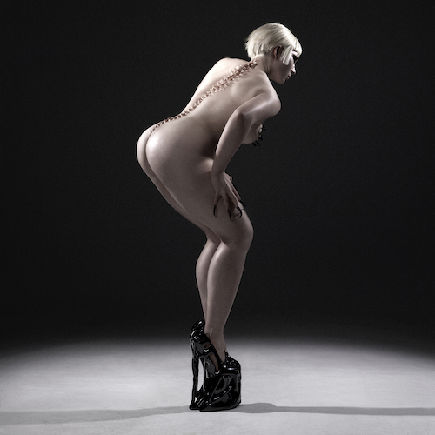
DOWNLOAD HI-RES ARTWORK // PHOTO CREDIT: NINJA HANNA

Tracklist:
10/10
FEMININE ENERGY
ACTIVATE
SUCK
TEQUILA
MANIC
BAD POSITION

# # #

DOWNLOAD HI-RES IMAGE // PHOTO CREDIT: NINJA HANNA

# # #

CONNECT WITH COBRAH
OFFICIAL | FACEBOOK | INSTAGRAM | TIKTOK | TWITTER | YOUTUBE

FOR MORE INFORMATION ON COBRAH:
Paige Rosoff – Atlantic Records
Paige.Rosoff@atlanticrecords.com

