FOR IMMEDIATE RELEASE
AUGUST 11, 2023

COBRAH GETS A LITTLE “MANIC” IN NEW SINGLE

UPCOMING NORTH AMERICAN LIVE DATES INCLUDE SHOWS WITH PABLLO VITTAR
AND TOP-BILLED PERFORMANCE AT SAN FRANCISCO’S PORTOLA FESTIVAL

LISTEN TO “MANIC” + WATCH OFFICIAL MUSIC VIDEO HERE
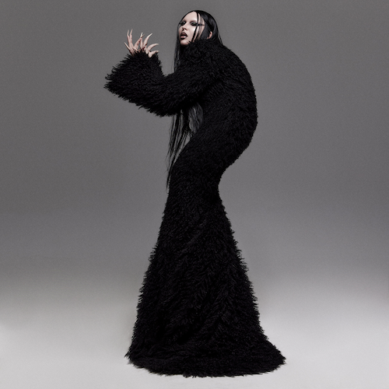
DOWNLOAD HI-RES COVER ART // CREDIT: NINJA HANNA

Multi-faceted experimental electronic artist COBRAH is back with her latest single, “MANIC” alongside its official music video - available now HERE via Big Beat Records.

“MANIC” showcases the originality and creative genius of COBRAH’s world she’s building. With the latex and bondage chains featured in the video to her edgy lyrics, COBRAH is showing the world what she’s truly capable of – and she’s only just getting started.

“I loved making this record but if anything, it really brought out the manic in me”, said COBRAH.

“MANIC” follows the release of her debut track and music video on Big Beat Records - “SUCK”.

A number of North American live dates are coming up for COBRAH, including a series of shows alongside Brazilian drag superstar Pabllo Vittar as well as a top-billed performance at San Francisco, CA’s Portola Festival (September 30-October 1). The upcoming dates follow COBRAH’s hugely successful first-ever US live run, THE ICON TOUR, highlighted by sold-out two-night stands at Los Angeles, CA’s historic El Rey Theatre and Brooklyn, NY’s Elsewhere as well as an explosive performance at Boiler Room Toronto in front of over 8,000 ecstatic fans. For updates, please visit www.cobrahcore.com.

COBRAH
TOUR 2023

SEPTEMBER
25 – Toronto, ON – History *
27 – Chicago, IL – Concord Music Hall *
30-10/1 – San Francisco, CA – Portola Festival †

OCTOBER
2 – Los Angeles, CA – The Novo *
20 – Amsterdam, NL – Melkweg

* w/ Pabllo Vittar Tour
† Festival Appearance

# # #

Five years ago, Clara, aka COBRAH, squeezed herself into a black latex catsuit for the first time. On top of it she added a corset, cinched tight. Really tight. In this moment, she says, she’d “never been so thrilled about anything. It was like falling in love.”

It wasn’t just about the thrill of skintight fetish wear. It was that in this moment, Clara fully transformed into COBRAH, the experimental electronic artist that’s since become not only her alter-ego, but a globally celebrated vocalist, producer, fashion iconoclast and cultural boundary-pusher whose sleek, playful, often subversive views of sexuality and female power emanate from every note, every purred vocal and every clothing stich. The multidisciplinary artist grew up in Gothenburg, Sweden’s second largest city, but soon moved to her country’s capitol. It was there COBRAH became immersed in Stockholm’s fetish scene, which inspired and shaped her already ambitious creativity.

2019 saw the arrival of her debut EP, ICON, highlighted by the lead single, “U KNOW ME,” which saw featured placement on EA’s blockbuster FIFA 22, as well as the breakout hit, “IDFKA,” joined by a stunning companion video later honored with a “Music Video of the Year” nomination from the Swedish Grammis.

The self-titled COBRAH EP arrived in 2021, self-released on the artist’s own GAGBALL label. Hailed by NME as “a self-assured slab of sexy, celebratory wonky-pop,” the EP saw COBRAH’s star ascend via bangers like “GOOD PUSS,” which earned more than 25M worldwide streams and a prestigious Grammis nod for “Electro/Dance of the Year.” Moreover, the irresistible track was featured in the trailer to A24’s acclaimed 2022 film, Bodies Bodies Bodies, and was recently remixed by like-minded Chicago rapper CupcakKe (streaming HERE).

In addition to international press attention spanning Out to i-D, COBRAH – who recently lit up stages in London and Stockholm alongside Charli XCX – has seen worldwide support from such top dance playlists as Spotify’s “mint” and “Dance Rising,” along with dynamic collaborations with high fashion brands like Jean Paul Gaultier. On Tik Tok, COBRAH’s official sounds have been used by the likes of Jeffree Star, Sonia Mayu, Taylor Tomlinson, Sugar and Spice, Brianna Chickenfry, and more.

# # #

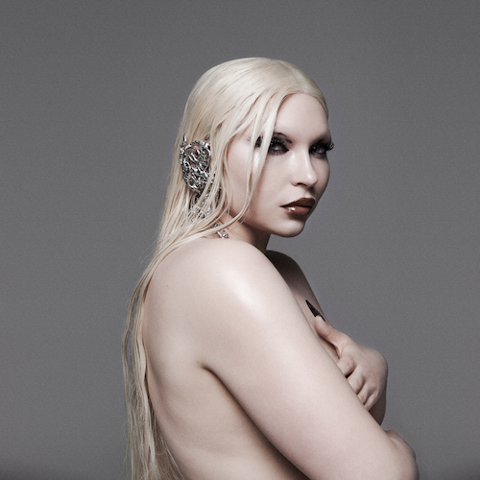
DOWNLOAD HI-RES IMAGE // PHOTO CREDIT: NINJA HANNA

# # #

CONNECT WITH COBRAH
OFFICIAL | FACEBOOK | INSTAGRAM | TIKTOK | TWITTER | YOUTUBE

FOR MORE INFORMATION ON COBRAH:
Paige Rosoff – Atlantic Records
Paige.Rosoff@atlanticrecords.com

