BILLY GILLIES & MADISON AVENUE DROP “DON’T CALL ME BABY”

BELFAST-BASED DJ/PRODUCER ADDS HIS SPIN TO
AUSTRALIAN HOUSE DUO’S CHART-TOPPING 1999 CLUB CLASSIC

LISTEN HERE

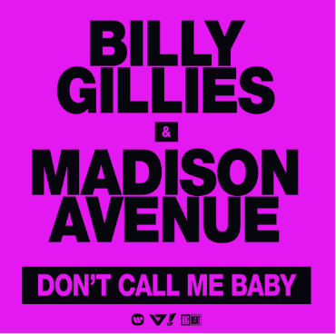

Belfast, Northern Ireland-based DJ/producer Billy Gillies releases a brand-new rework of Australian house duo Madison Avenue’s chart-topping 1999 club classic, “Don’t Call Me Baby,” available now HERE.

Increasingly known as a globetrotting mainstage superstar, Billy has blown up on stages all over the world, including North America, Asia, Australia, South America, the UK, and Europe. Along with his own sell-out headline sets, the rising DJ/producer has rocked top festivals like 2022’s Creamfields, which saw a capacity crowd singing back the instrumental melody of his track “Lagoon” (watch HERE). Billy is set for a wide array of live performances through the summer, including an eagerly awaited appearance at EDC Las Vegas, set for May 19-21. Additional North American dates will be announced soon.

MORE ON BILLY GILLIES
To listen to Northern Irishman Billy Gillies is to capture true joy, because everything he touches radiates pure passion and vibrant spirit.

Billy’s musical obsession started in the 2000s when his sister started buying Clubland compilation CDs and dating a local DJ. 11-year-old Billy snuck into his sister’s room to play with her boyfriend’s turntables. At 17, Billy talked his way into a club and started dreaming of his own chance to rock a crowd. He taught himself Ableton Live and started sending his tracks to BBC Radio 1 DJ Judge Jules, who played them on his show every Friday night.

At 28, Billy earned a spot on the lineup of Luminosity 2019 alongside major trance legends Paul Van Dyk, Ferry Corsten, Gareth Emery and more. He played a set of all-original material, and a recording posted to Soundcloud earned more plays than any of the headliners. International booking requests flooded in, sending him to Argentina to Australia—and then COVID struck. Billy saw this as a chance to experiment.

In 2022, he self-released a single titled “Lagoon”, and it changed the course of his life. A perfect distillation of the Eurodance hooks that brought Billy to Clubland in the early 2000s, it heightens those bright and bouncy hallmarks with a decidedly modern edge that has come to define the Billy Gillies style.

“I love what I do,” he says. “I'm proud of the way I built up my career by myself. To see so many comments like ‘wow, that's the first time I've seen you play, and you've got a fan for life.’ I haven't jumped straight up to the top. I've gradually built me fan base through the years. I enjoy the process of building step by step, not stressing out on the final outcome, and just enjoying each day as it comes.”

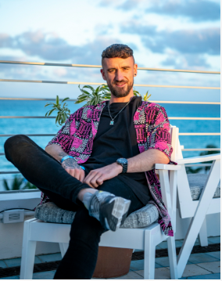
DL press photo HERE (credit Stephen Bondio, Alive Coverage)

CONNECT WITH BILLY GILLIES:
FACEBOOK | INSTAGRAM | SOUNDCLOUD | TIK TOK | YOUTUBE

# # #

Press contact: gabrielle.reese@atlanticrecords.com

