ELDERBROOK RELEASES SOPHOMORE ALBUM LITTLE LOVE

“I’LL BE AROUND” CRACKS TOP 25 AT DANCE RADIO

HIGHLY ANTICIPATED NORTH AMERICAN HEADLINE TOUR UNDERWAY
BUY TICKETS HERE

2023 MARQUEE FESTIVAL SLOTS INCLUDE COACHELLA, BONNAROO & GLASTONBURY

Buy/Stream Little Love Here

“…lush, emotionally evocative melodic house…” – BILLBOARD

“…perfectly tuned for all tastes…” – SPIN

“An emotional electronica offering… Elderbrook makes the world want to dance all night, ensconced in the resounding visceral energy he radiates in each release.” – DANCING ASTRONAUT

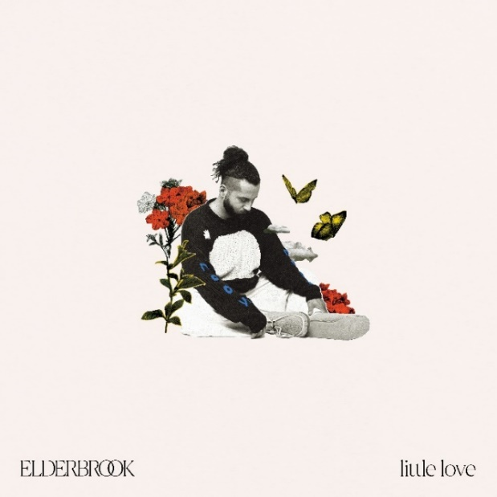
download hi-res artwork here

GRAMMY-nominated and multi-platinum singer-songwriter/producer Elderbrook celebrates the release of his introspective sophomore album Little Love, out today via Big Beat Records (buy/stream here).

Little Love’s 11 tracks showcase the UK artist’s soulful and melodic take on house music, while delving into the life-changing impact of parenthood. The result is a positive and uplifting dance-focused LP, full of music that is uniquely Elderbrook.

The LP arrives alongside a stunning live performance video (watch here), featuring magnetic renditions of title track ‘Little Love,’ recent single ‘I’ll Be Around,’ which opens the visual, and many other standout tracks. The 37-minute piece was filmed on location in Denver, CO, against a backdrop of snow-capped mountains.

Of the inspiration for the album, he shares, “It became clear that the overarching theme was about the messages I’d want to share with my children as they grow older. We all lived through such a bizarre and difficult few years during the pandemic but I was given the greatest gift and biggest responsibility of all in that time, and it seemed only fitting that my second album be a dedication to that, to them, my little loves.”

Album openings ‘Just Like Us’ and ‘I Need You’ set the tone as powerful synth-laden anthems with heartfelt vocals about the universal struggles that bring us together. Next up is album centerpiece ‘Howl’, a collaboration with Tourist, addressed to Elderbrook’s newborn daughter and the first he wrote for the project; “It’s inspired by those sleepless nights listening to your child cry as you try and console them - I wanted her to know then, and always, that I’d be there for her.”

The elegiac ‘Wasted On You’ is a reflection on the selflessness required of a parent, and ‘Talk It Over’ is a poignant, uplifting anthem, pairing Elderbrook’s soulful vocals with a breezy melodic house arrangement produced by iconic Brazilian DJ Vintage Culture. Further album collaborations include “I’ll Be Around” with American producer Amtrac – currently Top 20 and rising at US Dance radio – and “Beautiful Morning,” co-produced by Harrison Mills and Clayton Knight (both of ODESZA),

In addition to highly anticipated sets at both weekends of Coachella this April and at Bonnaroo and Glastonbury in June, Elderbrook is in the midst of his headline North American tour. The run kicked off February 22nd in Vancouver and will culminate on April 8 in Dallas, TX, featuring stops in Seattle, Chicago, Boston, Toronto, Brooklyn, NY (a sold-out show in the Great Hall at Avant Gardner), and many more cities in between [routing below – additional info + tickets here].

This year’s touring follows a run of arena shows supporting ODESZA in 2022, as well as two sold-out shows at Red Rocks with Louis the Child in 2021.

His previous full-length (2020’s Why Do We Shake in the Cold?) received critical acclaim, including from NPR + Billboard (“…lush, emotionally evocative melodic house…”), while his 2021 EP InnerLight was hailed by SPIN as “…perfectly-tuned-for-all-tastes…”

###

LITTLE LOVE ALBUM TRACK LIST:
1. Just Like Us
2. I Need You
3. Howl
4. Talk It Over
5. Beautiful Morning
6. I’ll Be Around
7. Little Love (Little Interlude)
8. Wasted On You
9. If You Want Somebody
10. Tied To You
11. The End

UPCOMING TOUR DATES:
APRIL
1 – Jannus Live – St. Petersburg, FL
5 – Republic NOLA – New Orleans, LA
6 – White Oak Music Hall Downstairs – Houston, TX
7 – Emo’s – Austin, TX
8 – The Echo Lounge & Music Hall – Dallas, TX
15 – Coachella Valley Music and Arts Festival – Indio, CA
22 – Coachella Valley Music and Arts Festival – Indio, CA

MAY
2 – Rescue Rooms – Nottingham, UK
3 – Thekla – Bristol, UK
4 – The Crossing – Birmingham, UK
5 – Manchester New Century Hall – Manchester, UK
6 – O2 Forum Kentish Town – London, UK
8 – Mandela Hall – Belfast, UK
9 – Vicar Street – Dublin, Ireland
11 – Annabel – Rotterdam, Netherlands
12 – Paradiso – Amsterdam, Netherlands
15 – Ancienne Belgique, AB Box – Brussels, Belgium
16 – Le Trabendo – Paris, France
18 – Tama – Poznan, Poland
19 – Klub B90 – Gdansk, Poland
20 – Progresja – Warsaw, Poland
22 – Roxy – Prague, Czech Republic
24 – Astra Kulturhaus & Huxleys Neue Welt – Berlin, Germany
25 – Fabrik – Hamburg, Germany
26 – Zoom – Frankfurt, Germany
27 – Les Docks – Lausanne, Switzerland
29 – Conrad Sohm – Dornbirn, Austria
30 – Orpheum – Graz, Austria
31 – Posthof – Linz, Austria

JUNE
2 – Vienna Arena / Arena Wien – Vienna, Austria
17 – Bonnaroo Music & Arts Festival – Manchester, TN

JULY
8 – Electric Love Festival 2023 – Salzburg, Austria

MORE ON ELDERBROOK:
A live phenomenon, multi-instrumentalist, producer and singer-songwriter, Elderbrook has an innate flair for creating emotive music that explores the sensitive and introspective themes of identity and mental wellbeing.

Over 1.5 billion global streams, GRAMMY and Ivor Novello nominations, tours with Jungle, Rüfüs Du Sol and Odesza, and collaborations with Camelphat, Diplo, Tourist, Bob Moses, Rudimental and more have earned him a revered reputation as a dynamic, multi-faceted, forward-thinking talent.

download hi-res press images here

For more information on Elderbrook, please visit:
Website | Instagram | Twitter | Facebook | Spotify

FOR ALL PRESS INQUIRIES, PLEASE CONTACT:
Libby Kober | Libby.Kober@atlanticrecords.com
Gabby Reese (Tour) | Gabrielle.Reese@atlanticrecords.com

