**Global superstar Robin Schulz returns with new single “Sweet Goodbye”**

**BUY/STREAM** [**HERE**](https://wmg.click/SweetGoodbye)

**Touring North America this spring – including stops in NYC, LA, Boston, Chicago, San Francisco + more**



*download hi-res photo* [*here*](https://warnermusicgroup.app.box.com/s/7pxqfhirdz8xxtrn1g2u4xase3fyra88/file/1127066844467)*; Courtesy of Warner Music Group*

Today, DJ, producer, and global superstar **Robin Schulz** has returned with new single “**Sweet Goodbye**” [buy/stream [here](https://wmg.click/SweetGoodbye)], released via Big Beat Records in the US. The track sees the GRAMMY®-nominated, Billions Club member eschew the sunlight, so he can once again focus on the dancefloor.

Fans can look forward to hearing the song live on Schulz’s **upcoming North American tour** [set for March/April], which will include a night in **NYC** on **March 3**, as well as shows in **LA**, **Boston**, **Chicago**, **San Francisco**, and **Denver**, among many more cities [full routing below].

Following recent standout singles “**Miss You**” (with **Oliver Tree**) and “**Sun Will Shine**” (with **Tom Walker**), “**Sweet Goodbye**” is an epic tune that kickstarts another season of EDM-meets-pop euphoria. Pure vocal bliss paves the way, until the first drop announces the moment when dusk comes to an end, and the night is finally upon us, as we hear the striking lyric: *“I love the moonlight.”*

Highlighted by emotional verses and uplifting choruses, “Sweet Goodbye” is the ultimate anthem for endless spring nights spent on dancefloors and in clubs. The song was written by the same team behind Tiësto's "The Business" – Anton Rundberg, James Bell and Julia Karlsson – with Bell also delivering vocals.

Playing with the concept of how AI innovation can be both a blessing and a curse, the release of “Sweet Goodbye” is accompanied by a **groundbreaking visual**, taking things to the next (meta) level [watch [here](https://www.youtube.com/watch?v=YPHd4PJWYOc)].

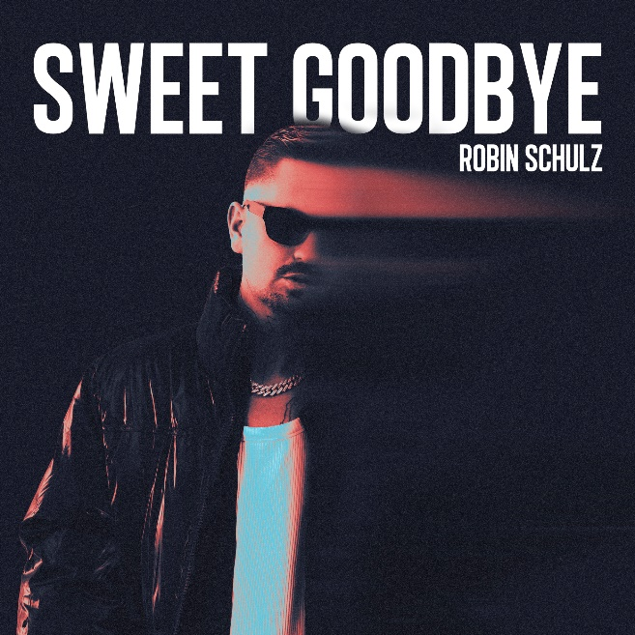

*download hi-res artwork* [*here*](https://warnermusicgroup.app.box.com/s/bg32v10doq7ad0oyme40nrol7pfwuy99/file/1127080613016)*; Courtesy of Warner Music Group*

About Robin Schulz:

10 years after his initial remix smash “Waves” (originally by Mr. Probz), Robin Schulz has easily become international House/Dance royalty – with more than 20 million records sold, 450+ Gold/Platinum/Diamond certifications (in 30 countries), 4 German ECHO Award wins, and a GRAMMY® nomination for “Best Remixed Recording.”

Known for his iconic collaborations with musical greats including David Guetta, James Blunt, Justin Bieber and Sam Martin, which also made him an airplay #1 sensation in his native Germany [a pinnacle he’s reached 14 times], Schulz’s tracks have topped the charts in more than 20 countries.

With over 4 billion streams to his name, Robin Schulz is one of the most streamed artists on the planet.

Upcoming Tour Dates:

MARCH

3 – New York, NY – Marquee

4 – Boston, MA – Big Night Live

5 – Tampa, FL – Wtr Pool

10 – Denver, CO – The Church

11 – Los Angeles, CA – Academy LA

17 – San Francisco, CA – 1015 Folsom

18 – Salt Lake City, UT – Sky SLC

24 – Philadelphia, PA – NOTO Philadelphia

25 – Montreal, QC – New City Gas

31 – Chicago, IL – TAO

APRIL

1 – Dallas, TX – Stereo Live Dallas

2 – Parque Fundidora Monterrey, Mexico – Tecate Pal Norte 2023