ELDERBROOK RELEASES NEW SINGLE “HOWL” WITH TOURIST

Buy/Stream “Howl” Here
Watch Video Here

GRAMMY-NOMINATED ELECTRONIC ARTIST ON TOUR WITH ODESZA THIS FALL – TICKETS ON SALE HERE

PRAISE FOR ELDERBROOK

“…perfectly-tuned-for-all-tastes…” – SPIN

“…lush, emotionally evocative melodic house…” – BILLBOARD

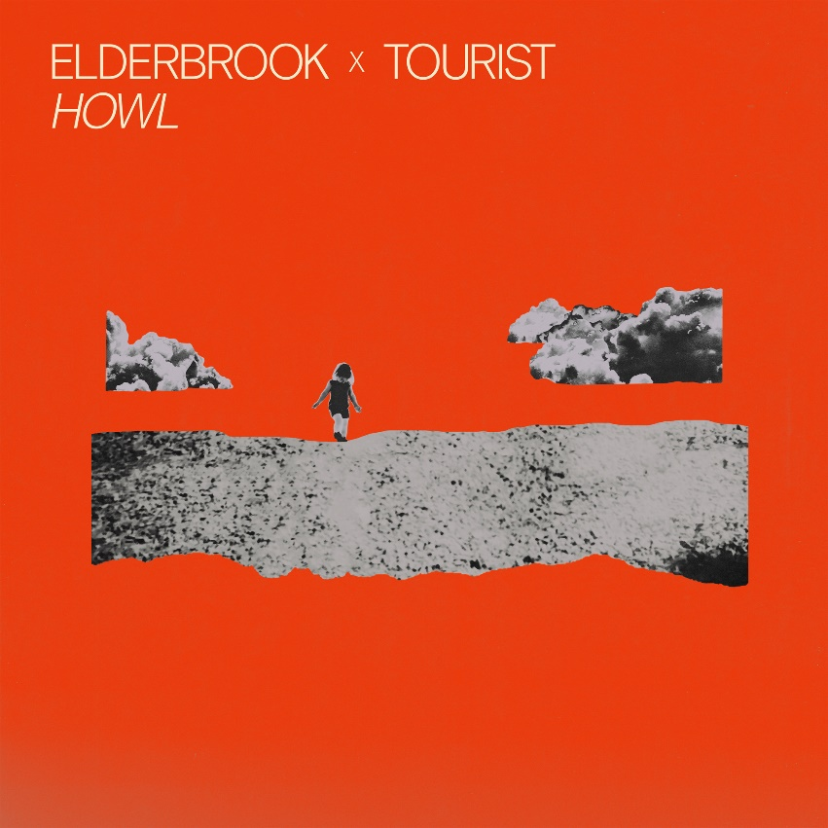
download hi-res artwork here

Today, Grammy-nominated UK electronic artist Elderbrook releases the stunningly emotive, highly danceable new single, “Howl,” with fellow UK electronic musician and songwriter Tourist, out today via Big Beat Records (buy/stream here). Steeped in poignance and restrained euphoria, the track combines rousing piano chords with spine-tingling breakdowns and Elderbrook’s flawless vocals.

Tender lyrics illuminate the depth of the song’s inspiration, as Elderbrook details below:

“‘Howl’ is written about my daughter, Adaline. How she would find it difficult to sleep and how it has been difficult to leave her.”

“Howl” follows Elderbrook’s acclaimed 2021 EP, Innerlight (buy/stream here), which incorporated features from Bob Moses, Louis The Child, LA-based artist Emmit Fenn, and dance music master Kölsch. SPIN hailed each track on the project - “perfectly-tuned-for-all-tastes lead single, ‘Inner Light’… the introspective ‘Dominoes’… the melancholic ‘I Will Find My Way to You’… the vocal-focused ‘Broken Mirror’” - and Billboard described “Inner Light” as “a lush, emotionally evocative melodic house record that brings out the best of [Elderbrook’s and Bob Moses’] respective talents.”

In 2020, Elderbrook released acclaimed single “Together” with Carnage and The Martinez Brothers, and in 2021, contributed a track with Diplo to Black Coffee’s GRAMMY® Award-winning album, Subconsciously. Earlier this year, Elderbrook also collaborated on “Unbothered” with ZHU, a standout track from the latter’s new album, Musical Chairs Mixtape (Vol. 1).

This month, Elderbrook will traverse the US and Canada, supporting ODESZA on tour in major cities including Chicago, Portland, Vancouver, Toronto, and more. Tickets are on sale here and all dates are listed below.

download hi-res press images here

A live phenomenon, self-taught multi-instrumentalist, producer and singer-songwriter, Elderbrook arrived on the global stage in 2017, lending his vocals and co-writing the platinum-selling smash ‘Cola’ with Camelphat which received both Grammy and Ivor Novello nominations. He then dropped his debut album Why Do We Shake In The Cold? in 2020, an acclaimed release that was lauded by critics including NPR and Billboard. With over 1 billion streams to date, and tours alongside the likes of Bonobo, Friendly Fires, and Jungle, he is a global sensation who continues to grow as an artist.

Tourist is best known for winning the Grammy for co-writing Sam Smith’s “Stay With Me.” Since then, he has gone on to release four full-length albums and several more EPs. He remains active as a writer, producer, and remixer - including remixing works for artists like Christine and the Queens, Hozier, Wolf Alice, and CHVRCHES.

Upcoming Elderbrook Tour Dates
September 1 – Toronto, ON – Budweiser Stage*
September 2 – Montreal, QC – Parc Jean Drapeau*
September 3 – Gilford, NH – Bank of New Hampshire Pavilion*
September 4 – Mansfield, MA – Xfinity Center*
September 7 – Cincinnati, OH – Riverbend Music Center*
September 8 – Clarkston, MI – DTE Energy Music Theatre*
September 9 – Chicago, IL – Huntington Bank Pavilion at Northerly Island*
September 10 – Chicago, IL – Huntington Bank Pavilion at Northerly Island*
September 12 – Minneapolis, MN – Armory*
September 13 – Minneapolis, MN – Armory*
September 14 – Maryland Heights, MO – Hollywood Casino Amphitheater*
September 16 – Greenwood Village, CO – Fiddler’s Green Amphitheatre*
September 17 – Greenwood Village, CO – Fiddler’s Green Amphitheatre*
September 20 – West Valley City, UT – USANA Amphitheater*
September 22 – Portland, OR – Sunlight Supply Amphitheater*
September 23 – Vancouver, BC – PNE Amphitheatre*
September 24 – Vancouver, BC – PNE Amphitheatre*

*Supporting ODESZA

# # #

For more information on Elderbrook, please visit:
Website | Instagram | Twitter | Facebook | Spotify

FOR ALL PRESS INQUIRIES, PLEASE CONTACT:
Libby Kober | Libby.Kober@atlanticrecords.com

