ELDERBROOK DROPS HIGHLY-ANTICIPATED NEW EP INNERLIGHT

North American Headline Tour Underway | Includes Oct. 9 Album Release Show At Irving Plaza

“The EP’s perfectly-tuned-for-all-tastes lead single, ‘Inner Light’… the introspective ‘Dominoes’… the melancholic ‘I Will Find My Way to You’… the vocal-focused ‘Broken Mirror.’” – SPIN

Buy / Stream Innerlight Here

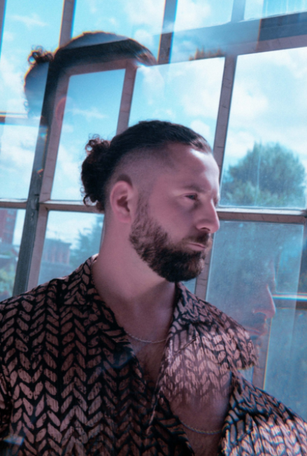
download hi-res press images here

Grammy-nominated UK electronic artist Elderbrook has dropped his hotly anticipated new EP Innerlight, out today via Big Beat Records (listen here).

A four-track release, Innerlight opens with the euphoric title track featuring Bob Moses. Previously released as a single, it’s a poignant, emotionally charged dose of electronica that blurs the lines between electronic and organic sounds. Next up is Elderbrook’s most recent single “I’ll Find My Way To You.” A collaboration with LA-based artist Emmit Fenn, it’s a rousing track that pairs lush melodies with evocative vocals. “Broken Mirror” follows, a life-affirming melodic techno creation produced by dance music master Kölsch and, closing things out is the stunning “Dominoes,” a collaboration with electronic duo Louis The Child that finds Elderbrook at his most vulnerable.

“The EP is all about how important it is to trust your instincts and believe that you do have the right ideas,” Elderbrook explains. “That it’s important to follow your own inner light. It represents the journey of self-discovery that I have been on since becoming a father and learning how to navigate that and trust in myself.

He continues: “The last few years I've toured the US many times and met and played shows with some amazing artists. Whilst stuck in the UK during lockdown, I wanted to see if I could make some records with some of the artists I love from over there, and all the collaborations on this EP came about by working via a combination of zoom and phone calls and emails.”

Elderbrook is currently in the midst of his North American headline tour, having kicked off the run of dates with performances at Lollapalooza and 2 sold-out nights at Red Rocks. The majority of the dates on the tour have sold out, with second nights added in Vancouver, Denver, and Santa Barbara. The run includes stops at The Novo in LA, as well as a special album release show tomorrow evening at New York’s iconic Irving Plaza (full dates below).

A live phenomenon, self-taught multi-instrumentalist, producer and singer-songwriter, Elderbrook arrived on the global stage in 2017, lending his vocals and co-writing the platinum-selling smash ‘Cola’ with Camelphat which received both Grammy and Ivor Novello nominations. He then dropped his debut album Why Do We Shake In The Cold? last year, an acclaimed release that was lauded by critics including NPR and Billboard. With over 1 billion streams to date, and tours alongside the likes of Bonobo, Friendly Fires and Jungle, he is a global sensation who continues to grow as an artist.

A stunning collection of tracks, Innerlight is Elderbrook’s finest body of work to date.

Innerlight EP Tracklist
- Elderbrook & Bob Moses – ‘Inner Light’
- Elderbrook & Emmit Fenn – ‘I Will Find My Way To You ‘
- Elderbrook – ‘Broken Mirror’ (produced by Kölsch)
- Elderbrook & Louis The Child – ‘Dominoes’

Elderbrook North American Tour Dates
October 8 – Cambridge, MA – The Sinclair *sold out*
October 9 – New York, NY – Irving Plaza
October 15 – Philadelphia, PA – The Foundry *sold out*
October 16 – Denver, CO – Bluebird Theater *sold out*
October 17 – Denver, CO – Bluebird Theater *sold out*
October 20 – Santa Barbara, CA – Soho Music Club
October 21 – Santa Barbara, CA – Soho Music Club *sold out*
October 22 – Los Angeles, CA – The Novo
October 23 – San Francisco, CA – Regency Ballroom
October 26 – Santa Cruz, CA – The Atrium @ The Catalyst
October 28 – Austin, TX – The Concourse Project (w/ Diplo & Amtrac)
December 1 – Vancouver, BC – Celebrities Nightclub
December 2 – Vancouver, BC – Celebrities Nightclub
December 3 – Toronto, ON – Danforth Music Hall *sold out*
December 4 – Montreal, QC – L’Astral *sold out*
December 5 – Trois-Rivieres, QC – Cabaret Notre Dame
December 11 – Boulder, CO – Powabunga Vail

# # #

For more information on Elderbrook, please visit:
Instagram | Twitter | Facebook | Spotify

