THE KNOCKS SHARE DELUXE EDITION OF CHART-TOPPING NEW ALBUM, HISTORY

EXPANDED RELEASE INCLUDES THE BRAND NEW SINGLE,
“SUPER SIZE (FT. PEACEMODE)”

NORTH AMERICAN CO-HEADLINE TOUR WITH CANNONS
BEGINS SEPTEMBER 27 IN PHOENIX, AZ

HISTORY (DELUXE) AVAILABLE EVERYWHERE NOW HERE

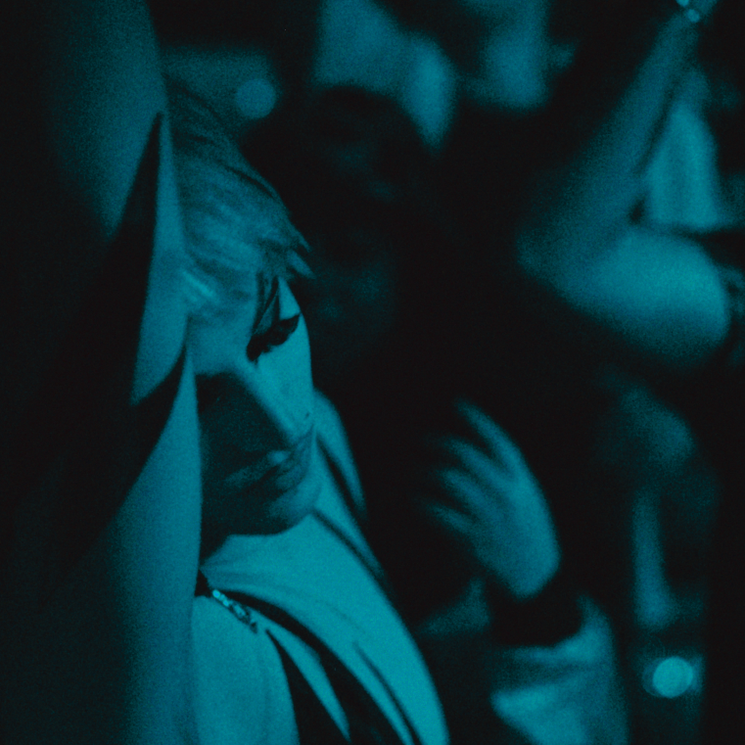
DL photo here

Multi-platinum electronic luminaries The Knocks have returned with a deluxe edition of their third studio album, HISTORY, streaming HERE. The deluxe includes the brand new single, “Super Size (Ft. PEACEMODE),”.

“We wrote this one with our friend, the incredible Joe Janiak, very early on in the album process,” says The Knocks, “and we loved how it captured this feeling of adventure and letting loose. It’s basically about being your (weird) self and doing whatever makes you tick.”

“Ever since meeting The Knocks at parties years back, we’ve shared a musical connection and friendship” says PEACEMODE. “When PEACEMODE was just an idea, The Knocks were listening to the demos and giving love. It’s an honor to share this song together ahead of the upcoming EP with people who’ve inspired us so much from the start. We hope people love ‘Supersize’ as much as we do."

HISTORY reached #1 on the iTunes “Top Electronic Albums” chart upon its original release earlier this year, fueled by collaborations with MUNA, Cannons, and Cold War Kids, along with the top 15 Alternative radio favorite, “All About You (Ft. Foster The People).” HISTORY also includes such high-energy singles such as “Bang Bang (Ft. Donna Missal) ,“Walking On Water (Ft. Totally Enormous Extinct Dinosaurs)“ and the spellbinding disco smash, “Slow Song (w/ Dragonette),” joined by an official visual in Mexico City and starring Aquaria from Ru Paul’s Drag Race and The Real Housewives of New York City. The NYC-based duo recently unveiled an exclusive St. Lucia remix “Slow Song,” streaming HERE.

The Knocks – who spent much of their summer lighting up such festivals as New York City’s Governors Ball, Rothbury, MI’s Electric Forest, Long Pond, PA’s Elements Music & Arts Festival, Columbus, OH’s WonderBus, and more – will celebrate the deluxe release of HISTORY with an eagerly awaited co-headline tour alongside Cannons, kicking off September 27 at The Van Buren in Phoenix, AZ and then traveling through a special Halloween show at Seattle, WA’s Showbox SoDo on October 31. For updates and additional information, please visit https://www.theknocks.com/tour/.

ABOUT THE KNOCKS:
The Knocks have been hailed worldwide for a carefree electronic sound that freely draws from soul, funk, disco, hip hop, house, and pop. Comprised of James Patterson and Ben Ruttner, the duo have unleashed a dizzying array of dance music for more than a decade, spanning two acclaimed albums, multiple EPs, collaborations with artists across the musical spectrum, high profile network TV appearances, and showstopping DJ sets and live performances all over the world. In addition to HISTORY, recent career highlights include collaborations ODESZA’s “Love Letter (Ft. The Knocks),” Kungs’ “People,” and their RIAA platinuSm certified collaboration with Purple Disco Machine, “Fireworks.”

ABOUT PEACEMODE:
Peacemode is a new alternative rock band from Los Angeles CA. Their forthcoming ‘Deadheads’ EP is a vivid introduction to the technicolor sound dreamed up in their Hollywood hideout. The record is a tour de force of pounding drums, sun drenched guitars and soaring melodies battling emotions of hope, love, fear and self-loathing in the city.

THE KNOCKS
NORTH AMERICAN TOUR 2022

SEPTEMBER
27 - Phoenix, AZ - The Van Buren *
29 - Austin, TX - Emo’s *
30 - Dallas, TX - House of Blues Dallas *

OCTOBER
1 - Houston, TX - House of Blues Houston *
3 - Orlando, FL - The Beacham *
4 - Ft. Lauderdale, FL - Culture Room *
5 - Tampa, FL - The Ritz Ybor *
7 - Charlotte, NC - Blackbox Theater *
8 - Charleston, SC - Charleston Music Hall *
9 - Atlanta, GA - Variety Playhouse *
11 - Washington, DC - 9:30 Club *
13 - Brooklyn, NY - Great Hall at Avant Gardner *
14 - Philadelphia, PA - Union Transfer *
15 - Boston, MA - Big Night Live *
17 - Detroit, MI - Majestic Theatre *
18 - Lexington, KY – The Burl *
20 - Nashville, TN - Brooklyn Bowl *
21 - Chicago, IL - Concord Music Hall *
22 - Madison, WI - The Sylvee *
23 - Minneapolis, MN - First Avenue *
25 - Englewood, CO - Gothic Theatre
26 - Salt Lake City, UT - Rockwell at The Complex *
28 - Vancouver, BC - Vogue Theatre *
29 - Portland, OR - Roseland Theater *
31 - Seattle, WA - Showbox SoDo *

NOVEMBER
2 - Santa Cruz, CA - The Catalyst
4 - San Francisco, CA - The Regency Ballroom
5 - Los Angeles, CA - The Fonda Theatre

* CO-HEADLINE w/CANNONS

# # #

CONNECT WITH THE KNOCKS
WEBSITE |INSTAGRAM | FACEBOOK|TWITTER|SPOTIFY|TIKTOK|YOUTUBE

Press Contact:
Paige.Rosoff@atlanticrecords.com
Big Beat Records | Atlantic Records

