ST. LUCIA REMIXES THE KNOCKS’ “SLOW SONG” (WITH DRAGONETTE)

THIRD STUDIO ALBUM HISTORY OUT NOW

HEADLINING NORTH AMERICAN TOUR WITH CANNONS
BEGINS SEPTEMBER 27 IN PHOENIX
PURCHASE TICKETS HERE

WATCH THE MUSIC VIDEO FOR “SLOW SONG” (WITH DRAGONETTE) HERE

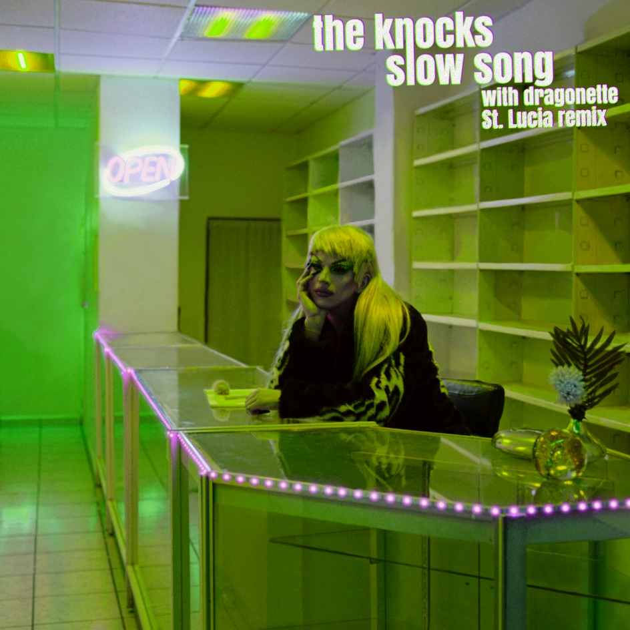
DL photo here

Multi-platinum electronic luminaries The Knocks return with a St. Lucia remix of the disco single, “Slow Song” (with Dragonette). Listen HERE. The Knocks and Dragonette released the spellbinding single earlier this year comprised of an official visual that included cameos from Aquaria (Drag Race and Real Housewives HERE). The Mexico City shot video was directed by Austin Peters (HAIM, Major Lazer) and the Director of Photography was Eric Yu (Inception, Savages, Warrior, A$AP Rocky).

“To cut a long story short, we wouldn't be here without B Roc discovering us and Heavy Roc Music (The Knocks label) putting out our first single, "All Eyes On You”, says St. Lucia. Our first-ever tour was with them; we've written and released many songs with them, including "Modern Hearts" and "Limo." So, to say our bond is thicker than blood would be a gross understatement: we're basically family.”
The original version of “Slow Song” (with Dragonette) heralds the NYC-based duo’s hugely anticipated third studio album HISTORY, which was released on April 29th. The Knocks trumpeted the album with the previously released and powerfully soulful track, “Walking On Water (Ft. Totally Enormous Extinct Dinosaurs).”

About The Knocks:
The Knocks have been hailed worldwide for a carefree electronic sound that freely draws from soul, funk, disco, hip hop, house, and pop. Comprised of James Patterson and Ben Ruttner, the NYC-based duo have unleashed a dizzying array of dance music for more than a decade, spanning two acclaimed albums, multiple EPs, collaborations with artists across the musical spectrum, high profile network TV appearances, and showstopping DJ sets and live performances all over the world. Their most recent album release HISTORY reached #1 on the iTunes electronic charts and features the fan favorite “Bodies” with MUNA, their collaborations with Cannons and Cold War Kids, and “All About You” with Foster the People which landed the #14 spot on the alt radio charts. The album follows the duo’s recent collaborations with Kungs (“People“), ODESZA’s “Love Letter (Ft. The Knocks) and their platinum selling hit with Purple Disco Machine, “Fireworks.”

Last month, The Knocks kicked off the summer with festival performances at New York City’s Governors Ball, Rothbury, MI Electric Forest. Upcoming live dates include Long Pond, PA’s Elements Music & Arts Festival (Friday, August 19), and Columbus, OH’s WonderBus (Friday, August 26), and The Underground Music Showcase (headlining on Saturday, 7/30). Their co-headline tour with Cannons kicks off on 9/27 in Phoenix, AZ. For updates and additional information, please visit www.theknocks.com/tour.

About St. Lucia:
St. Lucia has stayed faithful to what they're best at: putting on incredible live shows everywhere from Coachella to Kansas City, producing shimmery synth-driven pop grooves, and having a damn good time doing what they love. St. Lucia has always stirred good vibes. It started with their debut album, When The Night, which entered the Billboard Top 200 and hit #6 on Billboard's Heatseekers Album chart. The follow-up album, Matter, yielded the hit "Dancing On Glass," while the band collaborated with Jack Antonoff, RAC and others. Two years later, Hyperion represented a creative and critical high watermark with praise from Billboard, who hailed the album as "buoyant," and PopMatters who raved, "it feels revelatory." Their latest album Utopia will be released on October 7th.

THE KNOCKS x CANNONS NORTH AMERICAN TOUR 2022

SEPTEMBER
27 - Phoenix, AZ - The Van Buren
29 - Austin, TX - Emo’s
30 - Dallas, TX - House of Blues Dallas

OCTOBER
1 - Houston, TX - House of Blues Houston
3 - Orlando, FL - The Beacham
4 - Ft. Lauderdale, FL - Culture Room
5 - Tampa, FL - The Ritz Ybor
7 - Charlotte, NC - Blackbox Theater
8 - Charleston, SC - Charleston Music Hall
9 - Atlanta, GA - Variety Playhouse
11 - Washington, DC - 9:30 Club
14 - Philadelphia, PA - Union Transfer
15 - Boston, MA - Big Night Live
17 - Detroit, MI - Majestic Theatre
18 - Louisville, KY - Headliners Music Hall
20 - Nashville, TN - Brooklyn Bowl
21 - Chicago, IL - Concord Music Hall
22 - Madison, WI - The Sylvee
23 - Minneapolis, MN - First Avenue
26 - Salt Lake City, UT - Rockwell at The Complex
28 - Vancouver, BC - Vogue Theatre
29 - Portland, OR - Roseland Theater
31 - Seattle, WA - Showbox SoDo

# # #

CONNECT WITH THE KNOCKS
WEBSITE | INSTAGRAM | FACEBOOK | TWITTER | SPOTIFY | TIKTOK | YOUTUBE

CONNECT WITH DRAGONETTE
INSTAGRAM | FACEBOOK | TWITTER | SPOTIFY | TIKTOK | YOUTUBE

Press Contact:
Paige.Rosoff@atlanticrecords.com
Big Beat Records | Atlantic Records

