FAST RISING PRODUCER DWILLY RELEASES NEW HEART_BEATS.ZIP EP

LISTEN HERE: https://BigBeat.lnk.to/HeartBeatszipPR

OUT TODAY VIA BIG BEAT RECORDS

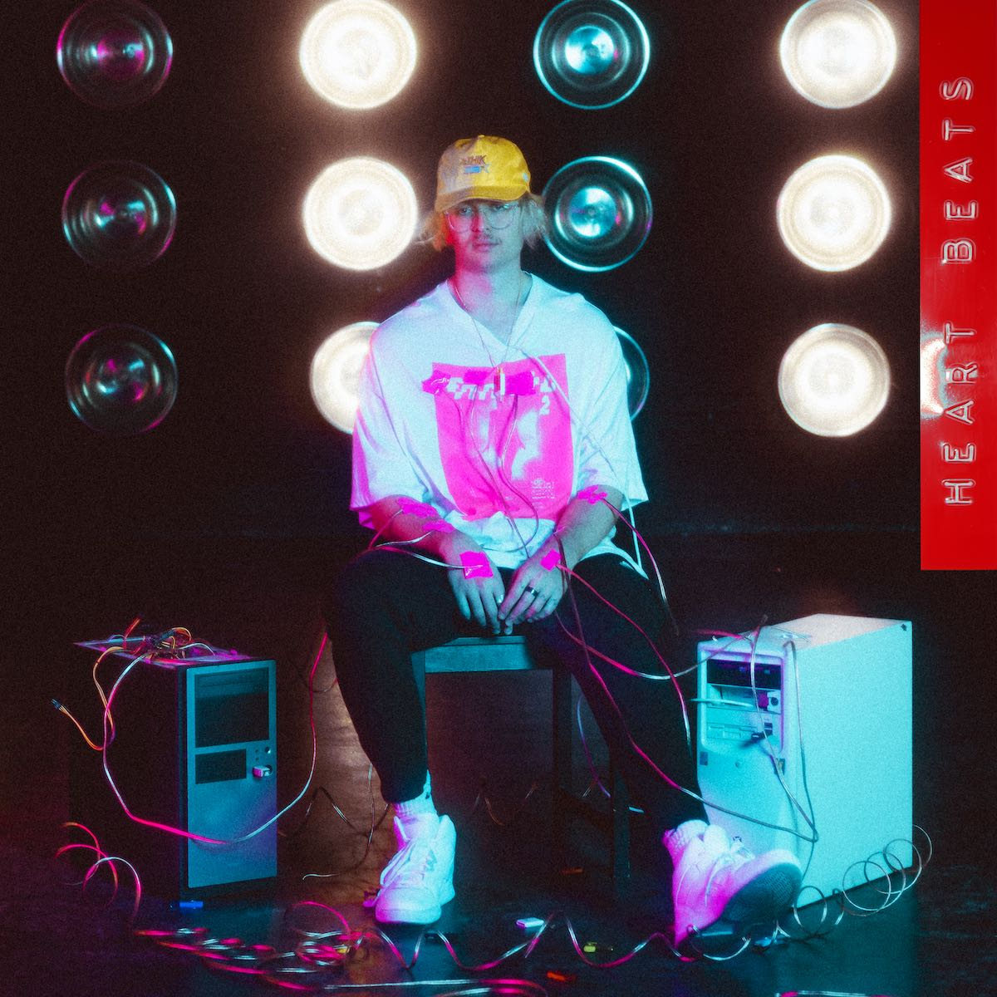

The in-demand producer, songwriter and multi-instrumentalist extraordinaire dwilly has been making his unique mark on the electronic world for the past few years, and today sees the release of his new heart_beats.zip EP through Big Beat Records. Featuring the infectious, previously released single “if you only knew” (feat. Tia Scola), the new EP is paired with two brand-new anthemic tracks, “love is scary” and “say so,” each of which incorporate elements of trap, hip-hop and emo, polished off with dwilly’s signature electronic touch. It’s an undeniably fresh EP from the moment you hit play, from the beginning of “love is scary” til the end of the breezy, alternative R&B-leaning track “say so” - LISTEN HERE!

Already being hailed by Ones To Watch as "music's most brilliant threat,” dwilly’s status is truly cemented with Heart_Beats.zip. Only three years into his career, dwilly has already produced records for Mike Posner, Ty Dolla $ign, Wiz Khalifa and more, on top of being commissioned to do official remixes for "So Close" by NOTD & Felix Jaehn, "Move On" by Mike Posner, "Open My Mouth" by Kiiara, and more. Another recent dwilly single “Duck Duck Goose” has garnered over 11,100 uses on Tik Tok, with total impressions eclipsing 5 million and counting – and his last three releases have cumulated over two million streams alone!

On top of his studio work, he’s also taken his DJ sets on the road, impressing and garnering fans worldwide, most notably joining GRiZ on his last US tour and another high-profile support slot opening for Zedd at Red Rocks. For such a uniquely talented producer so early on in his career whose ability to seamlessly fuse genres is nearly uncanny, dwilly is certainly poised for big things, and heart_beats.zip is just the tip of the iceberg. Stay tuned for more from dwilly, sooner than later!

CONNECT WITH DWILLY:
Instagram | Facebook | Twitter | Spotify

DWILLY PRESS ASSETS: https://press.wearebigbeat.com/singles/dwilly

FOR MORE INFORMATION:
Paige Rosoff – Big Beat Records
Paige.Rosoff@atlanticrecords.com

