BLVK JVCK puts his signature
spin on a Biggie classic in “LOOT”

LISTEN HERE

OUT NOW VIA BIG BEAT RECORDS!

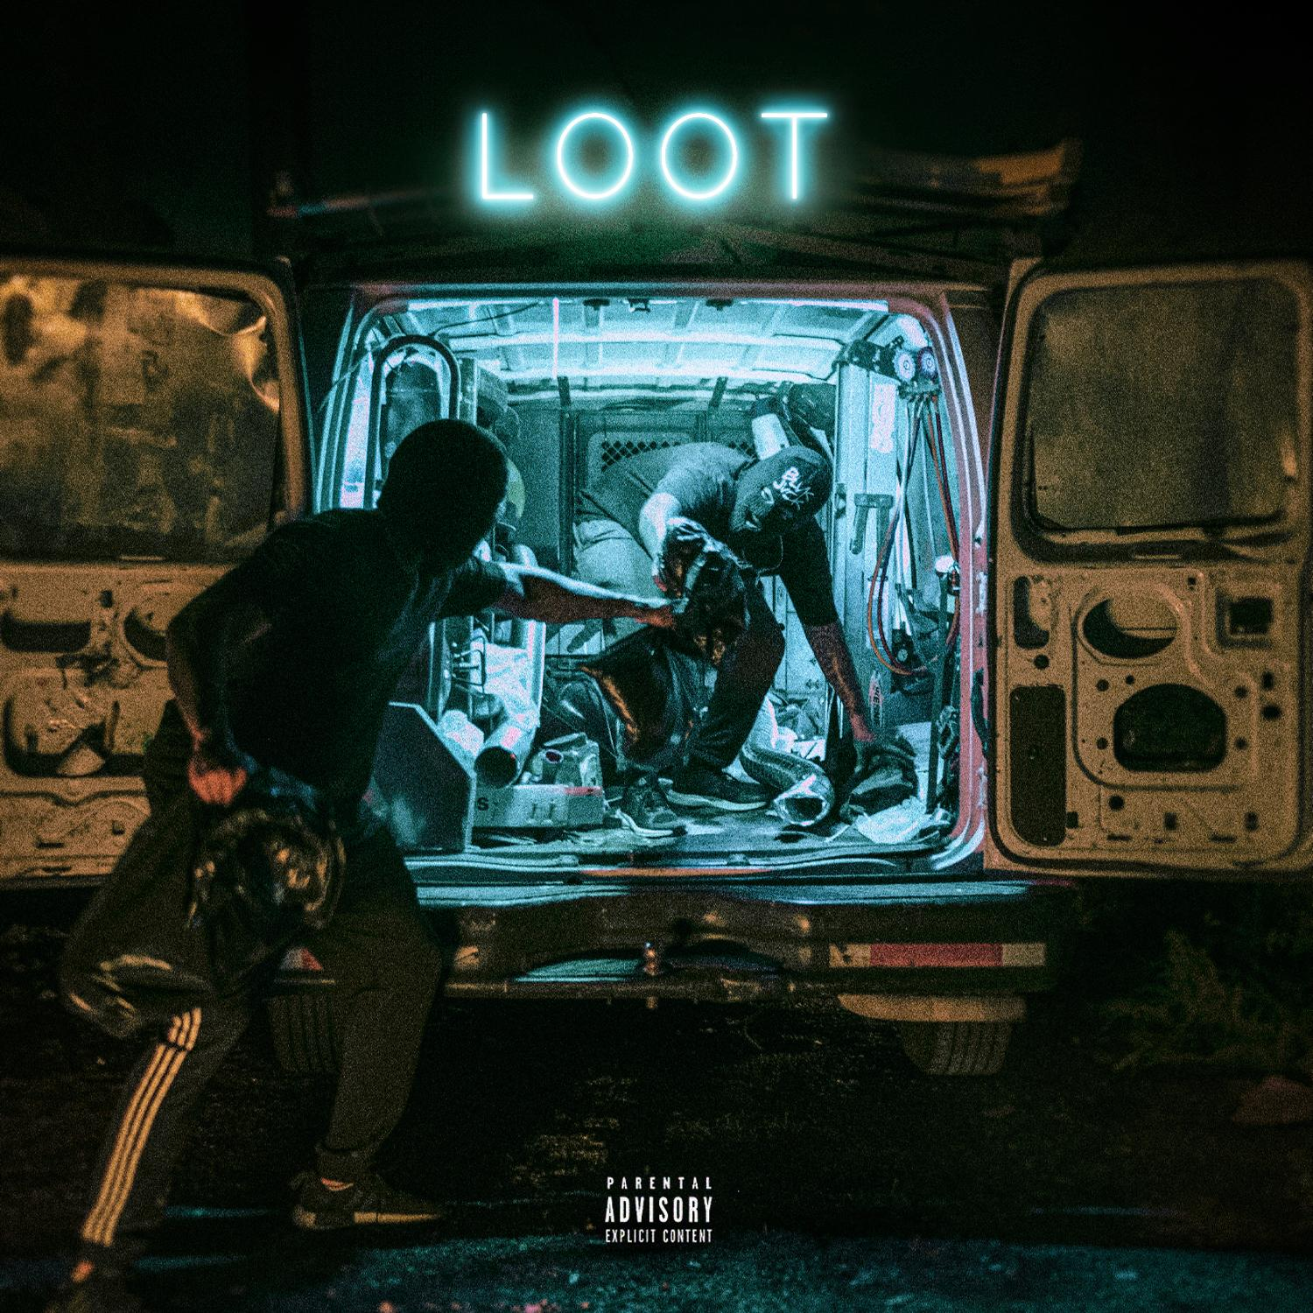

BLVK JVCK is known and coveted for his hoodstep beats and brutal blend of dubstep and hip-hop influences – but today he combines his signature sound with old school lyricism to create his new track “LOOT”, and it’s no surprise to anyone that it goes hard. You’ll notice a slew of recognizable samples and ad-libs leading up to one of the most aggressive drops you’ll hear this year. “LOOT” is out today alongside the official music video on Big Beat Records. Listen/watch HERE.

BLVK JVCK, aka Jermaine "Mayne Zayne" Jackson, says “LOOT is the record I always dreamed about makin!! It embodies everything we love about a great song. Melody, concept, bars and the hardest drop that’ll make you rob your grandmother on Christmas!!! Just joking about the robbing part!”…and if that’s not enough incentive to get you to press play, I don’t know what is!

BLVK JVCK’s groundbreaking sound has carved the way for him to previously team up with heavy hitting urban collaborators such as Ace Hood, Jessie Reyez and Flosstradamus. "LOOT" is just the beginning of his takeover molding the streets with the bass stages, expect to see more collaborations and solo records coming soon from BLVK JVCK.

ABOUT BLVK JVCK
BLVK JVCK is a fresh electronic music project stemming from one of the legendary production members of The Runners. Previously as a producer for DJ Khaled’s team, Jermaine "Mayne Zayne" Jackson cut his teeth creating hit club records for the biggest names in music. He was behind the sonic innovation on hit singles "Go Hard” (DJ Khaled) and “Hustlin" (Rick Ross) as producers, amongst a vast library of tracks for artists including Rihanna, Justin Bieber, Chris Brown, Rick Ross, Lil’ Wayne, Usher, Fabolous, and Fat Joe. BLVK JVCK enter a new era in music as artists, entering the scene with an official remix for Bruno Mars’ global smash “That’s What I Like” and more recently working with collaborators like Flosstradamus, Jessie Reyez and H.E.R. His latest original “THVT SH!T” and “HITTIN EERBODY” arrived earlier this year and will be sure to keep you moving on the bass stages.

Follow BLVK JVCK
www.instagram.com/blvkjvck
https://www.facebook.com/BLVKJVCK
https://soundcloud.com/blvkjvck
https://twitter.com/BlvkJvck
https://spoti.fi/2miACu1

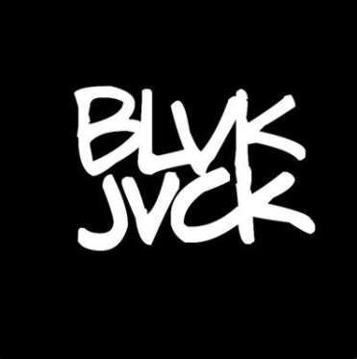

FOR MORE INFORMATION PLEASE CONTACT:
Paige.Rosoff@atlanticrecords.com

