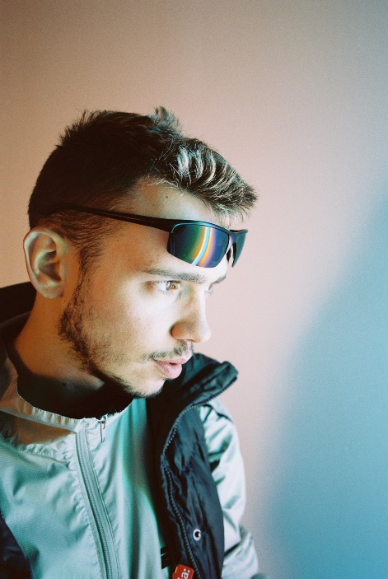
X-COAST is Brooklyn-based Serbian producer Bojan Cizmic. He is known for his 2016 rave anthem, “Mango Bay”, which has garnered hundreds of thousands of views on YouTube and has earned him a ravenous reputation on the internet and beyond.
With a talent for effortlessly moving between various styles and an ear for the freakier side of 90s dance music, X-Coast’s nostalgic, high-energy productions and over-the-top DJ sets draw their influence from UK hardcore, breakbeat, euro pop, Latin house and trance, as well as hacker culture, the deep net, robotics, and video games.
He has released music on Big Beat Records, Steel City Dance Discs, Lost Palms, UNDERTHESEA, and his own label, X-Coast.

