RISING ARTIST/PRODUCER WHIPPED CREAM RECRUITS JASIAH
FOR NEW SINGLE “DUMB SH!T”

OUT TODAY VIA BIG BEAT RECORDS

LISTEN HERE

WHIPPED CREAM 2020 TOUR BEGINS MARCH 7
SEE BELOW FOR DATES | GET TICKETS HERE

DOWNLOAD ARTWORK HERE

The prolific artist, producer and DJ, WHIPPED CREAM, has been on a tear since her very first release, steadily churning out hit after hit. Today is no different, since fans of the fast-rising artist can stream her latest track called “DUMB SH!T,” a hard-hitting, hip-hop influenced tune featuring another genre-defying artist, Jasiah, on vocals. “DUMB SH!T” takes no prisoners from the very first beat, with WHIPPED CREAM’s penchant for dark, heavy bass music mixed with clanging trap-heavy percussion on full display. Combine that with Jasiah’s addictingly aggro, in-your-face delivery, and you have a true banger that doesn’t let up for a split second - LISTEN HERE!

WHIPPED CREAM is the project of Caroline Cecil, a former competitive figure skater who trained for the Olympics, but after a debilitating accident on the ice and then a transformative experience at an Active Child show, she was led to channel her emotions through creating music… and the rest was history. Not only did Cecil just sign a deal with Big Beat Records, announced that she’s on the bill for Coachella, Ultra Music Festival, and several other major 2020 festivals, but she was also nominated for two International Dance Music Awards. From being profiled in both Billboard and DJ Mag, chosen as one of Billboard Dance’s “Ones to Watch” and Mixmag’s “most exciting new names in bass music,” it’s clear that WHIPPED CREAM is making her mark on the music industry with no signs of slowing down.

Jasiah is known for his groundbreaking fusion of styles, combining melodic R&B and emo rap to aggro rock and even opera. Jasiah made a name for himself with a slew of self-produced tracks on SoundCloud before truly exploding onto the national consciousness with “Case 19 (Feat. 6Ix9ine),” which was released alongside a companion video for the single that proved an equivalent smash with total video views now approaching 10 million. “Shenanigans (Feat. Yung Bans)“ followed shortly after, quickly rising to #1 on both SoundCloud’s “New & Hot” chart as well as the official TikTok chart, where it has become an undeniable viral favorite. As if all that weren’t enough, after the release of his latest single, “Heartbreak (Feat. Travis Barker),” Complex praised the song, highlighting “Jasiah and Barker’s high-performance energy, which oscillates between hushed and aggressive.”

With her stock steadily rising thanks to her unparalleled production and frenzied work ethic, WHIPPED CREAM is well on her way to becoming one of the most in-demand collaborators in electronic music and beyond. Aside from high-profile festival slots this year, catch her at one of her headlining dates throughout North America starting March 7 (see below). Until then, check out “Dumb Sh!t”!
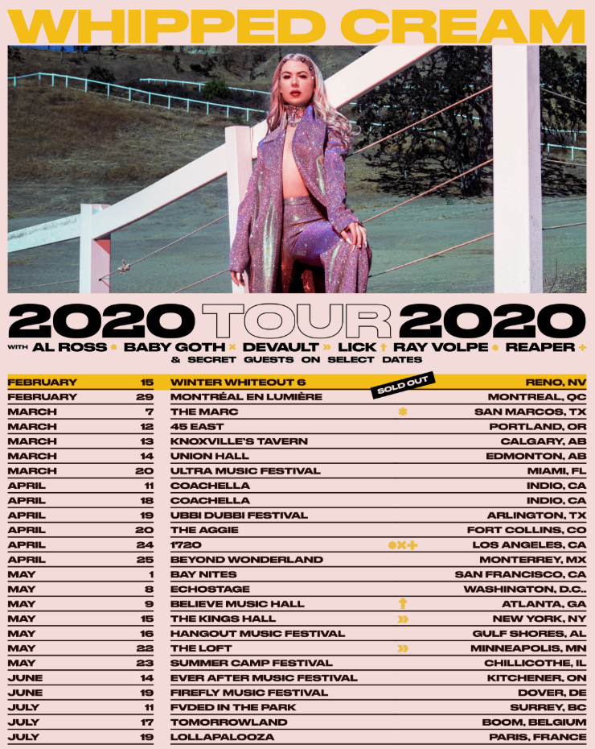

CONNECT WITH WHIPPED CREAM:
Website | Instagram | Facebook | Twitter | Spotify

PRESS ASSETS: https://press.wearebigbeat.com/artists/whipped-cream/

CONNECT WITH JASIAH:
Instagram | Facebook | Twitter | Spotify

FOR MORE INFORMATION:
Paige Rosoff – Big Beat/Atlantic Records
Paige.Rosoff@atlanticrecords.com

