WHIPPED CREAM SHARES SONG INSPIRED BY HEARTBREAK “BAD FOR ME” OUT NOW ON BIG BEAT RECORDS
LISTEN/SHARE: https://youtu.be/Vp7q3TuUN9c
STREAM/BUY: https://BigBeat.lnk.to/BFMPR

Press Shots + Album artwork available for download HERE

“Her sense of realness and acceptance truly resonates through her unique sound.” - EARMILK
“There’s something to be said for staying in your own lane. But there’s a lot more
to be said for whipping out a machete and hacking open your own path.” - NEST HQ
“If you haven't been following WHIPPED CREAM yet, you’ll definitely want to start paying attention to this quickly-rising producer.” - This Song Is Sick
“she’s proven beyond a shadow of a doubt why we chose to also include her in our Artists To Watch in 2018 list.” - Your EDM

Vancouver Island based, WHIPPED CREAM aka Caroline Cecil, has spent her life fully immersed in music. Transcending multiple genres, her style can only really be described as 'limitless'. Today she releases her new single “Bad For Me” via Big Beat Records. Listen HERE

Coming in heavy with rolling basslines, WHIPPED CREAM delivers drum breaks that are crisp and profound, while the vocal work harmonizes to balance the single’s progression from start to finish and gives the track her female touch.

WHIPPED CREAM shares, "I turned my unanswered questions, my heartbreak, into art; and I continue to fuel everything I do by it. The idea for this song started over a year ago. I was in a weird place in life, I felt stuck emotionally to someone I was in love with. I knew it wasn't healthy for either of us and everyone around us knew as well. I stayed for much longer than I should have out of fear. Until one day, I was done hurting and realized I was only holding on to feelings I once had and was strong enough to break free and find the love I needed within myself to walk away for good. This song represents my decision to put all of that unappreciated love for him into myself. I broke free. The moment the drop says " BREAK" is my release."

###
More on WHIPPED CREAM:
Following WHIPPED CREAM's ‘Persistence’ EP released in late 2017 on Skrillex's owned and operated Nest HQ, her hit single off the EP 'Ignorant', has received millions of plays and caught the attention of the biggest players in electronic music today. Joining United Talent Agency and Prodigy Artists, Caroline has spent 2018 in a state of perpetual music production and touring. Having performed over 50+ shows this year thus far, including festival performances at HARD Summer, Shambhala, Audiotistic, Electric Zoo and more, WHIPPED CREAM has announced yet another impressive run of nearly 30 North American dates including a co-headline tour with YehMe2, a headline tour of her native Canada and more festival stops to close out the year.

Instagram | Soundcloud | Facebook | Spotify

Press tools available for download: http://press.wearebigbeat.com/singles/bad-for-me-whipped-cream/

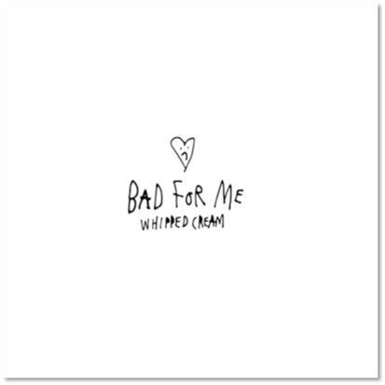

For more information:
WHIPPED CREAM press inquiries:
Lindsay Herr: Publicity, The Wanderlvst
Lindsay@thewanderlvst.com

For Big Beat Records inquiries:
Jordan Frazes: Head of Publicity, Big Beat Records
Jordan.Frazes@atlanticrecords.com

