FOR IMMEDIATE RELEASE
FEBRUARY 28, 2020

WHETHAN TAPS GROUPLOVE FOR NEW SINGLE “UPSIDE DOWN”

LIMITED SPRING HEADLINE TOUR DATES TO KICK OFF MARCH 26TH IN LOS ANGELES
TICKETS ON SALE NOW HERE

DEBUT FULL-LENGTH ALBUM FANTASY COMING SOON

LISTEN TO “UPSIDE DOWN (FEAT. GROUPLOVE)” HERE
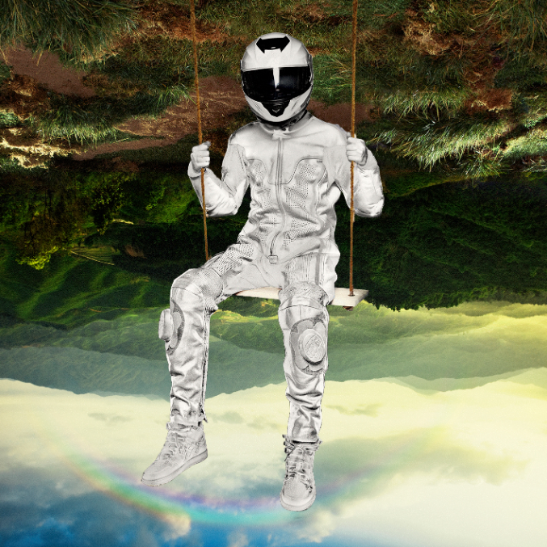
DOWNLOAD ARTWORK HERE

Today, acclaimed producer Whethan has released another irresistible new single “Upside Down” featuring alternative rock band Grouplove. The upbeat and infectious track showcases the musical chemistry between the critically acclaimed rock group - whose own album Healer arrives March 13 - with the producer’s high energy beats and dance-floor ready sound. “Upside Down (feat. Grouplove)” is available now on all streaming platforms and DSPs – listen HERE.

“Upside Down” was preceded by the two recently released tracks “All In My Head (feat. grandson)” and “Stay Forever (feat. STRFKR)” from Whethan’s forthcoming debut album FANTASY. “Stay Forever (feat. STRFKR)” was met with widespread critical acclaim with SPIN labeling it a “dreamy guitar-driven collab.” The track arrived alongside a futuristic, TRON-inspired companion video streaming now at Whethan’s official YouTube channel HERE.

Whethan will kick off his North American headline Fantasy tour on March 26th at Los Angeles, CA’s The Novo with additional stops in San Francisco, Chicago, and Brooklyn (see details below). Each date will operate as a pop-up show, providing a sneak peek for what’s to come in addition to special surprises for fans at each stop. Chrome Sparks (DJ set) and Ramzoid will join Whethan as support for the announced dates and grandson will be joining as a special guest at the Chicago show. In addition to his tour, Whethan will also take the stage at Ultra Music Festival on March 20 and EDC Las Vegas on May 16. Tickets for all live dates on sale now. For complete details, please visit www.whethan.com/tour.

Hailed by Atwood Magazine as “a continuously-developing musical identity that shines by elevating the very best traits of his collaborators,” Whethan has quickly become one of electronic dance music’s most in-demand artists, spanning superstar collaborations, blockbuster remixes, and his own extraordinary solo output. The 20-year-old has unleashed a steady stream of viral smashes, making history as the youngest ever artist on Australia’s hugely influential Future Classics label while also over famous fans including EDM icon Skrillex.

Recently, Whethan collaborated with Oliver Tree on “Cash Machine” off the genre-defying sensation’s upcoming album Ugly is Beautiful. The long awaited release of Whethan’s debut EP, Life of a Wallflower Vol. 1, includes collaborations with HONNE, Bipolar Sunshine, Oh Wonder, and Broods, among others. The EP earned widespread critical applause, with Billboard raving, “The whole collection of songs plays perfectly into Whethan’s pastel-colored sonic palette. It’s soft as petals falling in the breeze, but just as bright and intoxicating as cherry blossom perfume. His super-clean production makes even rough-edged noise sound cute. Really, it’s just freakin’ fun.”

As if that weren’t enough, Whethan has released a range of remixes – including his most recent rework of Foster the People’s “Pumped Up Kicks,” as well as Travis Scott X Skrillex’s “SICKO MODE” and Post Malone x Justin Bieber’s “Deja Vu” – along with such major league partnerships as frequent collaborator Oliver Tree’s “Movement“ (featured in Apple’s iPhone X commercial campaign and weekly on Monday Night Football) and Wafia’s acclaimed “Hurts (feat. Louis the Child & Whethan).”

In addition to his recorded work, Whethan has lit up crowds at countless clubs and top festivals, including Coachella, Lollapalooza, Billboard Hot 100 Music Festival, Outside Lands, SXSW, and Electric Daisy Carnival, to name but a few. Recent highlights include a sold-out co-headline show at Morrison, CO’s iconic Red Rocks Amphitheatre and a headline performance at MTV’s year-ending Snowglobe Music Festival in South Lake Tahoe, CA as well as a massive New Years Eve performance at Decadence Festival in Colorado.

ABOUT GROUPLOVE
Grouplove kicked off 2020 with their anarchistic, high-energy new single “Deleter,” and show no signs of slowing down in the lead-up to their fourth studio album HEALER – out March 13th via Canvasback/Atlantic Records. The Los Angeles based five-piece has spent the past two years writing and recording their most visceral and cathartic songs to date, all while experiencing and bearing witness to a great deal of change, trauma, and growth. From recording in El Paso within eyeshot of the border during the height of the family separation crisis, to brain surgery for frontwoman Hannah Hooper, to immersing themselves in new creative spaces with producers Dave Sitek and Malay – their new album represents a re-birth and a full-circle return to their initial idealism.

It's been almost ten years since Grouplove met on a commune in Greece and brought the idea of forming a band back to California. They'd never have anticipated making it this far: three albums under their belts, multiple chart-topping singles across alternative and pop formats, and critical acclaim from outlets such as Rolling Stone which heralded the group as “a band who have perfected big, radio-friendly rock songs.” A deeply adored live act, Grouplove has spent much of its existence performing energetic live shows to crowds around the globe, including headline treks and festival appearances on every massive stage from Coachella and Lollapalooza to Glastonbury and Bonnaroo. For more information on Grouplove, please visit www.grouplovemusic.com.

Grouplove is: Hannah Hooper, Christian Zucconi, Andrew Wessen, Daniel Gleason, Benjamin Homola

# # #

CONNECT WITH WETHAN
OFFICIAL
FACEBOOK
TWITTER
INSTAGRAM
YOUTUBE
PRESS ASSESTS

CONNECT WITH GROUPLOVE
OFFICIAL
FACEBOOK
INSTAGRAM
YOUTUBE
SOUNDCLOUD
PRESS ASSETS

Press requests:
Jessica Nall / Jessica.nall@atlanticrecords.com

WHETHAN
FANTASY TOUR – NORTH AMERICA 2020
MARCH
26 – Los Angeles, CA – The Novo
27 – San Francisco, CA – The Warfield

APRIL
2 – Chicago, IL – The Riviera Theatre
4 – Brooklyn, NY – Brooklyn Steel

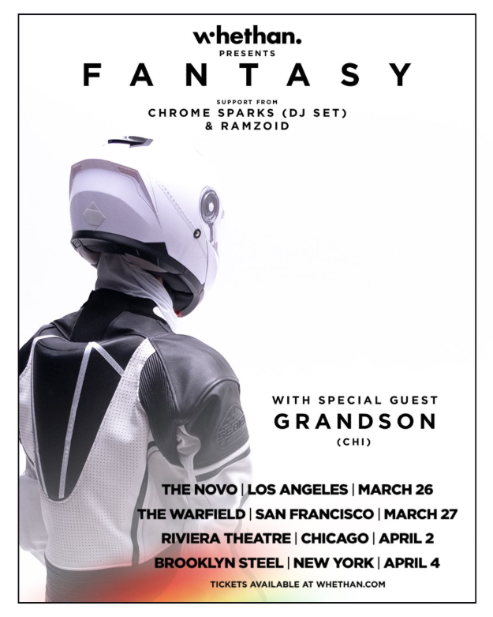
*DOWNLOAD OFFICIAL ART*

