CHICAGO-BORN/LA-BASED DJ AND PRODUCER
WHETHAN DELIVERS “SUPERLOVE” FT. OH WONDER

OUT TODAY ALONGSIDE THE ANNOUNCEMENT OF HIS
2018 TOUR “LIFE OF A WALLFLOWER”

FESTIVAL PERFORMANCES AT MAMBY ON THE BEACH,
FVDED IN THE PARK, OUTSIDE LANDS & MORE THIS SUMMER

BUY/STREAM: https://whethan.lnk.to/SuperlovePR

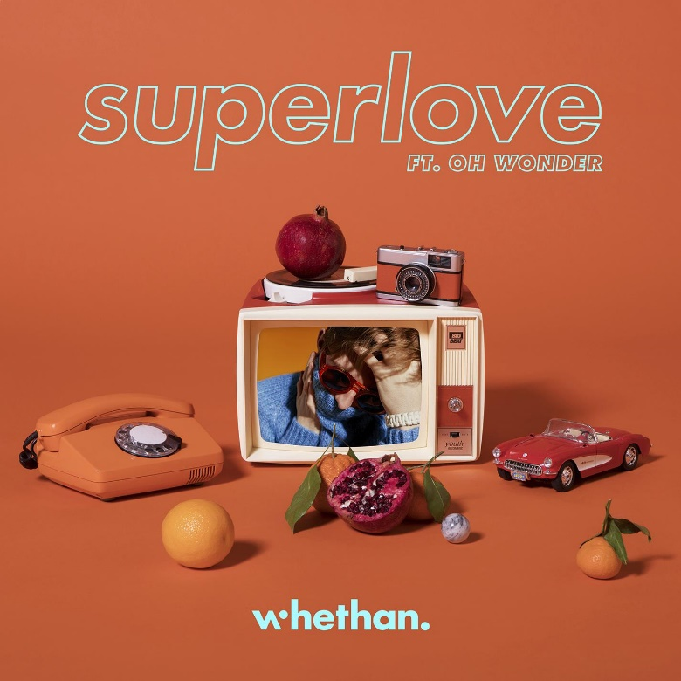

"Being able to collaborate with Oh wonder was such an honor. I have been a fan of them and their music for a long time. So excited to show this song because it takes me to such a happy place. Josephine and Anthony were amazing to work with and couldn’t be happier with this final product."
-Whethan

“Working with Ethan on 'Superlove' was magic. We had a day together in a studio in LA and wrote 'Superlove' within half an hour of sitting down with him. We went to get pizza, came back and knew we had written something cool. This is our first collaboration with another artist and we are so hyped to be doing that with Whethan. We love what's he done with the production and he instantly knew how the song should sound. Whethan is a true talent.”
-Oh Wonder

Fresh off a buzzing second Coachella appearance and the release of his recent “Be Like You” with BROODS, Whethan returns with a new collaboration, “Superlove” featuring the London-based alt-pop duo Oh Wonder. Out today via Big Beat Records, the song is another chapter in Whethan’s ever-evolving sound and unparalleled production – beginning with a beautifully simplistic beat and Oh Wonder’s Josephine Vander Gucht’s seductive vocals; it quickly erupts into irresistible tropical rhythm – LISTEN HERE!

Whethan’s headlining “Life of a Wallflower” tour kicks off in San Marcos, Texas at The Marc on September 13th. Advanced tickets will be available as an artist presale on Tuesday, June 19th 10am local time, alongside a Spotify presale on Wednesday, June 20th 10am local time and venue presale on Thursday, June 21st 10am local time. The general on-sale for tickets on Friday, June 22nd 10 am local time will be available to fans by logging onto http://whethan.com/tour/ .

Whethan is the brainchild of the 19-year-old Chicago-born producer Ethan Snoreck. On the heels of a string of high-profile, chart-topping collaborations, including one with Dua Lipa called “High” off the “Fifty Shades Freed” soundtrack, as well as “love gang” (ft. Charli XCX), “Savage” (ft. Flux Pavilion & MAX), and “Good Nights” (ft. Mascolo), Whethan is just getting started.

Whethan first made a name for himself as a SoundCloud producer, remixing tracks for Louis The Child (“It’s Strange”), ZAYN (“Pillow Talk”) and Ty Dolla $ign (“Blasé feat. Future & Rae Sremmurd”) which all surpassed 2.5 million plays, before releasing a groundbreaking original cut – “Savage” (feat. Flux Pavilion & MAX)” – having amassed over 25 million streams worldwide. “Love gang” (feat. Charli XCX) was the next chapter in Whethan’s already ground-breaking discography, kicking off with clanging, discordant synths transposed with Charli XCX’s dazzling vocals, before exploding into an ethereal, hook-laden chorus. Gaining early attention from the likes of Skrillex and Flux Pavilion, Whethan continued to rise through the ranks building a loyal fanbase that’s led him on the meteoric rise he’s on today.

###
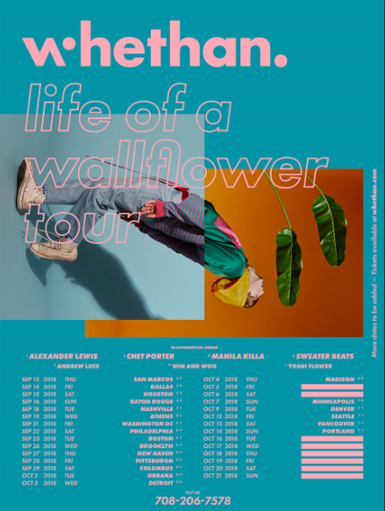
HI-RES DOWNLOAD

WHETHAN
“LIFE OF A WALLFLOWER” TOUR DATES
(PHASE 1 OF 2 PLUS ADDITIONAL FESTIVAL DATES)

Festival Dates:
WHETHAN
“LIFE OF A WALLFLOWER” TOUR DATES
Sept 13 – San Marcos, TX @ The Marc
Sept 14 – Dallas, TX @ Stereo Live Dallas
Sept 15 – Houston, TX @ Stereo Live Houston
Sept 16 – Baton Rouge, LA @ Varsity Theatre
Sept 18 – Nashville, TN @ Exit In
Sept 19 – Athens, GA @ Georgia Theatre
Sept 21 – Washington, DC @ 9:30 Club
Sept 22 – Philadelphia, PA @ Union Transfer
Sept 25 – Boston, MA @ Royale
Sept 26 – Brooklyn, NY @ Brooklyn Steel
Sept 27 – New Haven, CT @ Toad's Place
Sept 28 – Pittsburgh, PA @ Spirit Hall
Sept 29 – Columbus, OH @ Skully's
Oct 2 – Urbana, IL @ Canopy Club
Oct 3 – Detroit, MI @ Majestic Theatre
Oct 4 – Madison, WI @ The Sylvee
Oct 5 – Chicago, IL @ Concord Music Hall
Oct 6 – Chicago, IL @ Concord Music Hall
Oct 7 – Minneapolis, MN @ Skyway Theatre
Oct 9 – Denver, CO @ Ogden Theatre
Oct 12 – Seattle, WI @ Showbox SoDo
Oct 13 – Vancouver, BC @ Commodore Ballroom
Oct 14 – Portland, ME @ Wonder Ballroom
Oct 16 – San Luis Obispo, CA @ Fremont Theater
Oct 17 – Santa Cruz, CA @ Catalyst Club
Oct 18 – San Francisco, CA @ Warfield Theatre
Oct 19 – Santa Ana, CA @ The Observatory
Oct 20 – Los Angeles, CA @ The Novo
Oct 21 – San Diego, CA @ The Observatory North Park

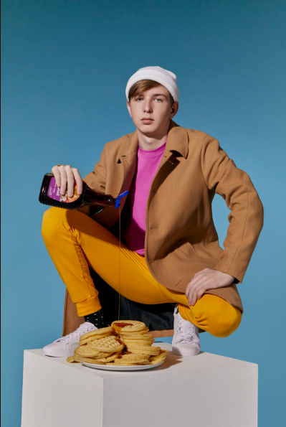
(Click for Hi-Res | Photo credit: Jimmy Fontaine)

Connect with @WhethanMusic: Facebook | Twitter | Instagram | SoundCloud | YouTube

For press assets: http://press.wearebigbeat.com/artists/whethan/

For more information: http://belikeyou.whethan.com/

Press Contact:
Jordan Danielle Frazes
Head of Publicity, Big Beat Records
Jordan.Frazes@atlanticrecords.com

