WHETHAN SHARES VIDEO FOR “RADAR” (FT. HONNE)
+ NEW EP ‘LIFE OF A WALLFLOWER VOL 1’ ARRIVES NOVEMBER 9TH ON BIG BEAT

WATCH “RADAR” (FEAT. HONNE): https://youtu.be/2gCt_CNQXQY
BUY/STREAM “RADAR” (FEAT. HONNE): https://whethan.lnk.to/RadarAY

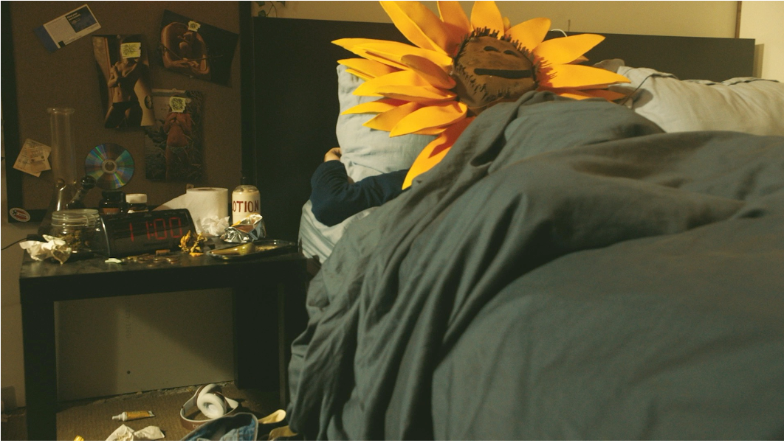

“Whethan and HONNE's “Radar” is one of our picks this month for our list of best pop songs in the world.” – FADER

“[Whethan’s] sophisticated sound… is sizable enough for radio while
deviating from standard dance-pop structure.” – Billboard

Prodigious 19-year-old Whethan preps for the release of his new “Life of a Wallflower Vol 1” EP, arriving on November 9th through Big Beat Records, through sharing the official music video today for his “…funky and unfadeable…” single “Radar” (feat. HONNE).

The hilarious video is literally symbolic of the album’s title, following a human ‘wallflower’ as he goes about his day- getting high, performing bike stunts and partying with friends. Deemed ”kooky sunflower dayz” in The FADER’s editorial premiere, watch and see how the flower’s day unfolds HERE!

The Chicago-born, Los Angeles-based, DJ, producer, and “…beat king…,” wrapped his “Life of a Wallflower” 30-city North American headline tour last week. Stay tuned for more Whethan coming soon!

WHETHAN - Life of a Wallflower Vol. 1
1. Radar (feat. HONNE)
2. Be Like You (feat. Broods)
3. Together
4. Superlove (feat. Oh Wonder)
5. Top Shelf (feat. Bipolar Sunshine)
6. Good Nights (feat. Mascolo)
7. I Miss You

Connect with @WhethanMusic: Facebook | Twitter | Instagram | SoundCloud | YouTube

For press assets: http://press.wearebigbeat.com/artists/whethan/

For more information: http://lifeofawallflower.whethan.com/

Press Contact:
Jordan Danielle Frazes
Head of Publicity, Big Beat Records
Jordan.Frazes@atlanticrecords.com

