WHETHAN ENLISTS JEREMIH ON NEW SINGLE
“LET ME TAKE YOU”
OUT TODAY ON ATLANTIC RECORDS!

LISTEN/SHARE: https://youtu.be/2Lea0hF1Jkk
BUY/STREAM: https://whethan.lnk.to/LMTY

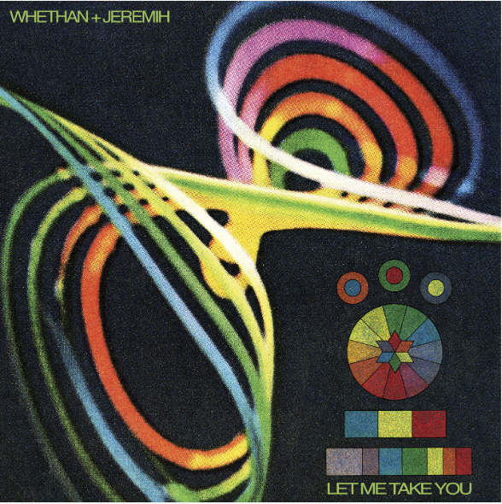

“Feels like a modern twist on the '90s diva house vibes many grew up on, and if this is what we can expect from Whethan in the near future, we're dumb excited.” -COMPLEX

Prodigious DJ/producer Whethan is fresh off releasing his debut Life of a Wallflower Vol.1 EP that gave rise to several luminary collabs with Broods, Oh Wonder, and HONNE. Whethan’s collaborative vision reaches the next level, having recruited R&B superstar Jeremih for his latest single out today on Atlantic Records – “Let Me Take You” – which juxtaposes Whethan’s effortlessly cool, sophisticated production with Jeremih’s sultry, impassioned vocals – LISTEN HERE!

Whethan says, "I had been sitting on this track with Jeremih for a while now and explored every possible version of the song before landing on this one. I've been really inspired by a lot of house music and wanted to find a way to bring that into my world. It was important to me that I made something that people could really dance too. This is probably my favorite track to date and I'm just excited to show my fans where the future of my music is headed."

Whethan is a 19-year old production genius who has yet to slow down since initially trickling out viral remixes since 2016, catching Skrillex’s ear early on. Despite his age, he’s slayed Coachella, Lollapalooza, the Billboard Hot 100 Music Festival, Outside Lands and Electric Daisy Carnival to name a few. He’s now announcing a run of 2019 US tour dates, including appearances at Lollapalooza, a co-headline show at Red Rocks with Big Wild, Forecastle Festival, Electric Forest, and more!

On top of his original music, he continues to release remixes and bootlegs such as, TRAVIS SCOTT X SKRILLEX – “SICKOMODE” (WHETHAN TURN), Post Malone x Justin Bieber – “Déjà vu” (Whethan Remix) in addition to major collaborations on tracks such as Dua Lipa’s “High” from the “Fifty Shades Freed” soundtrack and Oliver Tree’s “Movement” which was featured in Apple’s iPhone X commercial.

Grammy-nominated Jeremih’s 2015 release, Late Nights (December 2015) was his third Def Jam album, which contained a trio of double-platinum R&B/hip-hop/pop crossover hits: “Don't Tell 'Em” (featuring YG), “Planes” (featuring J. Cole), and “Oui.” Jeremih, whose combined YouTube views have passed the 730 million mark has the distinction of charting 17 RIAA gold, platinum, and multi-platinum smash singles, most recently co-writing French Montana’s 5x platinum “Unforgettable”. Jeremih was featured on Kanye West’s Ye (“Wouldn’t Leave”), Valee’s “Womp Womp”, and other releases from DJ Khaled, Chance The Rapper, and more.

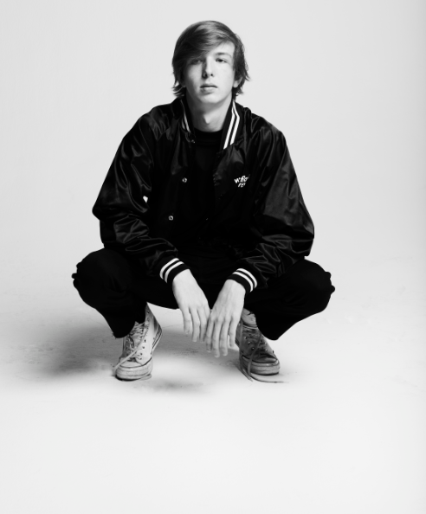
Whethan (credit Jimmy Fontaine, Download hi-res)

Jeremih (photo credit Meredith Truax, Download hi-res)

Whethan’s North American tour dates:
June 14-15: Quincy, WA @ Paradiso Festival
June 22nd: Herber City, UT @ Bonanza Campout
June 27-30: Rothbury, MI @ Electric Forest
July 14th: Louisville, NY @ Forecastle Festival
August 1-4: Chicago, IL @ Lollapalooza
September 19: Morrison, CO @ Red Rocks Amphitheatre (co-headline with Big Wild)

Connect with @WhethanMusic: Facebook | Twitter | Instagram | SoundCloud | YouTube| Website

For press assets: http://press.wearebigbeat.com/artists/whethan/

Press requests:
Jordan Danielle Frazes – Jordan.Frazes@atlanticrecords.com

Tour/Review requests:
Paige Rosoff – Paige.Rosoff@atlanticrecords.com

