FOR IMMEDIATE RELEASE
JULY 24, 2020

WHETHAN TAPS K. FLAY FOR ENERGIZING NEW SINGLE “HURTING ON PURPOSE”

ACCLAIMED PRODUCER AND INDIE POP STAR RELEASE HIGHLY ANTICIPATED NEW COLLAB

WHETHAN’S DEBUT FULL-LENGTH ALBUM FANTASY COMING SOON

LISTEN TO “HURTING ON PURPOSE (FEAT. K.FLAY)” HERE
WATCH THE ANIMATED MUSIC VIDEO HERE
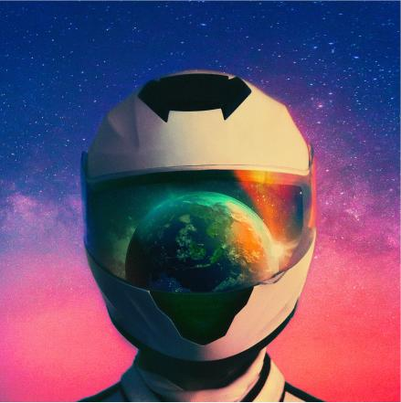
DOWNLOAD ARTWORK HERE

Acclaimed producer Whethan continues his collaborative vision, recruiting indie-pop-rock star, K.Flay for his latest single – “Hurting on Purpose” – available everywhere today HERE. The new rock-influenced track highlights Whethan’s effortlessly cool, alt-electronic production and K.Flay’s floating yet powerful vocals. “Hurting on Purpose (feat. K.Flay)” marks the latest release from Whethan’s forthcoming debut album, FANTASY. The track is accompanied but an animated music video, streaming now HERE.

“It all started when K.Flay sent me a song three years ago and I really loved the message,” Whethan shared. “I spent the next couple years working on it and perfecting the beat. The song refers to indulging in things like ‘drinking, driving fast, etc.’. Really just indulging in self-damaging behaviors. But ultimately realizing that you are in control of these things that are hurting you and you like it."

Whethan has racked up over 800 million streams and has been churning out banger after banger, including acclaimed singles “So Good (feat. bülow),” “Upside Down (feat. GROUPLOVE),” “All In My Head (feat. grandson)” and “Stay Forever (feat. STRFKR)”. Each track is featured on Whethan’s forthcoming debut album and have been met with widespread critical acclaim and showcase the versatility of the rising producer. Earmilk stated, “turning his hand to a multitude of genres with masterful ease, Whethan's style is becoming less about the genre and more about the distinctive dance-inspired energy that remains ever present through his stellar back catalogue” and EDM.com added to the praise with, “All signs point toward him eventually taking on a monster role within the industry…”

SPIN recently named “All In My Head (feat. grandson)” as one of the best songs of 2020 so far, stating, “Electro-pop producer Whethan lets his punk side shine on this two-and-a-half-minute heart racer. Wits are abandoned on the crunching, overripe bass…while grandson’s angsty, apathetic vocals drip with the cocky attitude of disaffected youth.” Billboard also hailed the track as “an alt-bop explosion good enough to leave on repeat…”

Hailed by Atwood Magazine as “a continuously-developing musical identity that shines by elevating the very best traits of his collaborators,” Whethan has quickly become one of electronic dance music’s most in-demand artists, spanning superstar collaborations, blockbuster remixes, and his own extraordinary solo output. The 21-year-old has unleashed a steady stream of viral smashes, making history as the youngest ever artist on Australia’s hugely influential Future Classics label while also over famous fans including EDM icon Skrillex.

Whethan recently collaborated with genre-defying sensation Oliver Tree on his debut album Ugly is Beautiful including current single “Let Me Down.” The long awaited release of Whethan’s debut EP, Life of a Wallflower Vol. 1, included collaborations with HONNE, Bipolar Sunshine, Oh Wonder, and Broods, among others. The EP earned widespread critical applause, with Billboard raving, “The whole collection of songs plays perfectly into Whethan’s pastel-colored sonic palette. It’s soft as petals falling in the breeze, but just as bright and intoxicating as cherry blossom perfume. His super-clean production makes even rough-edged noise sound cute. Really, it’s just freakin’ fun.”

As if that weren’t enough, Whethan has released a range of remixes – including his most recent rework of Charli XCX’s “claws” as well as Foster the People’s “Pumped Up Kicks,” Travis Scott X Skrillex’s “SICKO MODE” and Post Malone x Justin Bieber’s “Deja Vu” – along with such major league partnerships as frequent collaborator Oliver Tree’s “Movement“ (featured in Apple’s iPhone X commercial campaign and weekly on Monday Night Football) and Wafia’s acclaimed “Hurts (feat. Louis the Child & Whethan).”

In addition to his recorded work, Whethan has lit up crowds at countless clubs and top festivals, including Coachella, Lollapalooza, Billboard Hot 100 Music Festival, Outside Lands, SXSW, and Electric Daisy Carnival, to name but a few. Recent highlights include a sold-out co-headline show at Morrison, CO’s iconic Red Rocks Amphitheatre and a headline performance at MTV’s year-ending Snowglobe Music Festival in South Lake Tahoe, CA as well as a massive New Year’s Eve performance at Decadence Festival in Colorado. Most recently, Whethan has been performing unforgettable sets at major virtual music festivals including Digital Mirage Festival and EDC Virtual Rave-A-Thon.

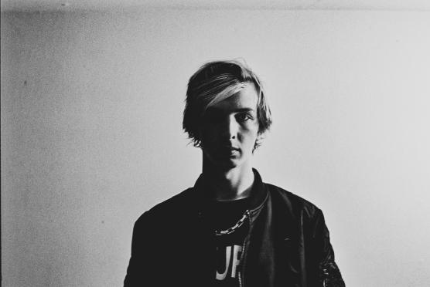
DOWNLOAD PRESS PHOTOS

WHAT PEOPLE ARE SAYING ABOUT WHETHAN:

“[Whethan] is good enough to leave on repeat…”
-BILLBOARD

“The young 21-year-old producer knocks it out of the park…”
-EARMILK

“[Whethan] works his magic when it comes to production delivering a four-on-the-floor pop-tinged gem that is simply irresistible…”
-DJ TIMES

“Electro-pop producer Whethan lets his punk side shine…”
-SPIN

“His captivating beats and synth-pop melodies have become the defining factor in his flourishing success…”
- FLAUNT

“One of 2020's most energizing releases…”
-L’OFFICIEL

“Not only has he charmed us since the fresh age of 16 with his gripping productions, but he knows exactly how to work a crowd behind the decks…”
- THIS SONG IS SICK

“Needless to say, Whethan's future is looking brighter than ever...”
- EDM.COM

“As Whethan’s experience grows, he has come to embrace a sound that resonates with listeners in search of music graced by a zest for life...”
- DANCING ASTRONAUT

“Whethan could not have offered up a better first taste of what Fantasy has in store for us all.”
- ONES TO WATCH

“At this point in his career, Whethan needs no introduction…[he] has an incredible talent for tastefully blending an indie/alt sound with his well-defined brand of electronic music, and ‘So Good’ is a perfect example of that.”
- RUN THE TRAP

“Whethan is ready to make a big splash on the world of future bass…”
- EDM TUNES

# # #

CONNECT WITH WHETHAN
OFFICIAL
FACEBOOK
TWITTER
INSTAGRAM
YOUTUBE
PRESS ASSESTS

PRESS REQUESTS:
Jessica Nall / Jessica.Nall@atlanticrecords.com

