RISING CHICAGO-BASED PRODUCER
WHETHAN
DELIVERS A NEW SINGLE OUT TODAY
“love gang” FT. CHARLI XCX
AHEAD OF LOLLAPALOOZA FOR BOTH ACTS
& OTHER NORTH AMERICAN FESTIVAL DATES!

WATCH/POST: www.youtube.com/watch?v=96Bo8n35LYw&feature

“Chicago producer Whethan, who attracted a lot of eyeballs for his clubby song ‘Savage’ last year, is back today. He's returned alongside Charli XCX for the radio-ready track "love gang”… It's Charli in fine form” – THE FADER

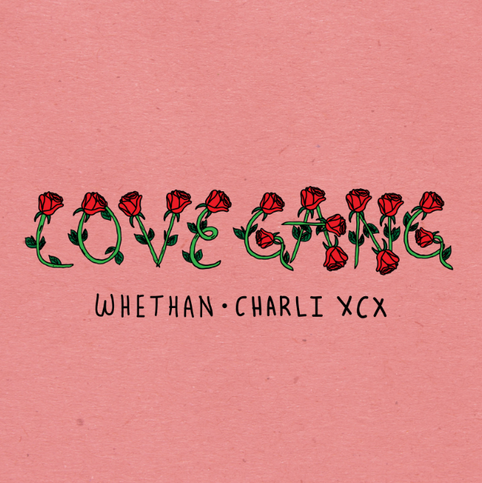

BUY/STREAM: https://BigBeat.lnk.to/lvegngPR

Fast-rising 17-year-old prodigy producer Whethan drops a new track, “love gang” featuring Charli XCX. The track kicks off with clanging, discordant synths transposed with Charli XCX’s dazzling vocals, before exploding into an ethereal, hook-laden chorus – LISTEN HERE.

Whethan is the moniker of the Chicago-based producer Ethan Snoreck, who first made a name for himself as a SoundCloud producer, remixing tracks for Louis The Child (“It’s Strange”), ZAYN (“Pillow Talk”) and Ty Dolla $ign (“Blasé feat. Future & Rae Sremmurd”) which all surpassed two million plays; before releasing a groundbreaking original cut - “Savage” (feat. Flux Pavilion & MAX) - having amassed over 20 million streams worldwide. “love gang” (out today via Big Beat) is the next chapter in Whethan’s already ground-breaking discography.

Whethan performed at Coachella this year, including appearances at DoLab & Heineken House, and will also be performing at Lollapalooza, along with a high-profile support slot on The Chainsmokers’ US arena tour. Gaining early attention from the likes of Skrillex and Flux Pavilion, he’s continued to rise through the ranks building a loyal fan-base in 2016.

Whethan Tour Dates:
May 16th @ BOK Center – Tulsa, OK
May 18th @ Scottrade Center – St. Louis, MO
May 19th @ FedExForum – Memphis, TN
May 20th @ KFC Yum! Center – Louisville, KY
June 3rd @ The Liacouras Center – Philadelphia, PA
June 10th @ Live 105 BFD – Mountain View, CA
June 17th @ WTF?! What The Festival – Portland, OR
June 22nd @ Electric Forest – Rothbury, MI
June 29th @ Electric Forest – Rothbury, MI
August 6th @ Lollapalooza – Chicago, IL
August 6th @ HARD Summer Music Festival – Fontana, CA
September 30th @ Rowdytown VI – Denver, CO

Website | Facebook | Twitter | Instagram | SoundCloud | YouTube | Press Site

Featured on Whethan’s “Love Gang,” British star Charli XCX will also appear at Lollapalooza this year, alongside other festival appearances at Hangout Festival, Governor’s Ball and The Free Press Summer Fest. The 24-year old many-times platinum songwriter has seen a meteoric rise to global pop stardom - garnering two Grammy nominations and four Billboard Music Award nominations for penned megahits, alongside the release of her own new “Number 1 Angel” mixtape, which came alongside four sold-out live appearances this month to prove it in San Francisco, New York, London and Paris.

Charli XCX is slated to release a highly-anticipated forthcoming third studio album, which Forbes names one of their “8 Of The Most Anticipated Pop Albums Of 2017,” Huffington Post’s “25 Albums To Look For In 2017,” and COMPLEX’s “50 Most Anticipated Albums of 2017.”

Charli XCX tour Dates:
May 19th @ Hangout Fest – Gulf Shores, AL
June 2nd @ Governor’s Ball – New York, NY
June 3rd @ Schimanski – Brooklyn, NY
June 4th @ Free Press Summer Fest – Houston, TX
August 5th @ HARD Summer Music Festival – Fontana, CA
August 6th @ Lollapalooza – Chicago, IL
October 20th @ Phoenix Festival – Phoenix, AZ

Charli XCX: Website | Facebook | Twitter | Instagram | SoundCloud | YouTube | Press Site

##

For more information please contact:

Jordan Danielle Frazes
Head of Publicity, Big Beat Records
Jordan.Frazes@atlanticrecords.com

