WHETHAN SHARES NEW SINGLE
“BE LIKE YOU” (FT. BROODS)!

WATCH/POST: https://BigBeat.lnk.to/BLYDi/youtube
BUY/STREAM: https://BigBeat.lnk.to/BLYPR

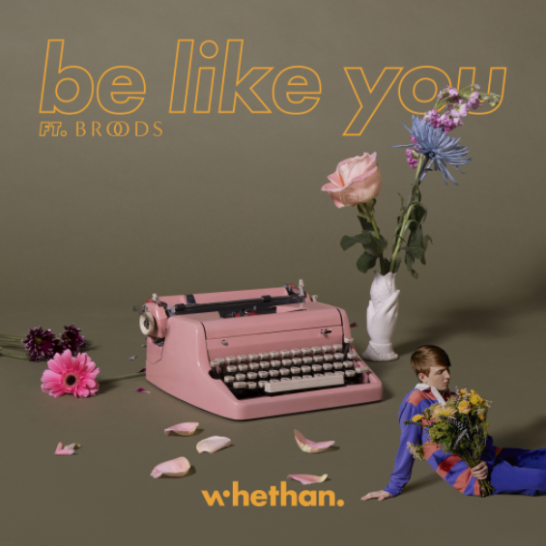

“The lush electronic track pairs booming, syncopated beats with BROODS vocalist Georgia Nott's ethereal melodies.” – PAPER

“‘Be Like You,’ is a smoldering time bomb, layering Broods vocalist Georgia Nott's ethereal singing over gritty thuds of bass and rattling percussion.” – Billboard

“Georgia Nott's falsetto adds a haunting chill to Whethan's already chilly beat under her.”
– Nylon

Prodigious young producer Whethan (aka Ethan Snoreck) is fresh off a successful 2017 that saw him rise through the ranks, thanks to a prolific string of high-profile, chart-topping collaborations. Now, Whethan kicks off 2018 with an innovative single, “Be Like You,” featuring and co-written by the award-winning sibling duo BROODS. “Be Like You” (out now via Big Beat Records) brims with Whethan’s forward-thinking, chest-rattling production, juxtaposed against an ethereal topline courtesy of BROODS’ vocalist Georgia Nott – LISTEN HERE!

The past year has been a massive one for the 18-year old Chicago native. Currently featured alongside Dua Lipa on the “Fifty Shades Freed” soundtrack with their track “High,” Whethan has put out a series of smash collaborations including “love gang (ft. Charli XCX),” “Good Nights (ft. Mascolo),” and “Savage (ft. Flux Pavilion & MAX)” – the last of which has gone on to amass over 50 million streams worldwide.

Whethan just wrapped a European tour with Louis The Child, following his 2017 North American headline “Good Nights Tour.” Earlier in 2017, he toured arena stages around the country in support of The Chainsmokers, and shone during festival appearances including Billboard Hot 100 Music Festival, a hometown headline set at Lollapalooza, and Coachella’s DoLab & Heineken House to name a few. He returns to Coachella in 2018.

Whethan first made a name for himself as a SoundCloud producer, remixing tracks for Louis The Child (“It’s Strange”), ZAYN (“Pillow Talk”) and Ty Dolla $ign (“Blasé feat. Future & Rae Sremmurd”) which all surpassed 2.5 million plays, before releasing his groundbreaking original cut “Savage.” Gaining early attention from the likes of Skrillex, Whethan has continued to build a loyal fan base during his meteoric rise, while garnering critical acclaim for his unique and elevated production.

Multi-award winning brother-sister duo BROODS (Caleb and Georgia Nott) are one of the most celebrated young bands to emerge out of New Zealand in recent times. Announcing their arrival with glossy synth-pop ballads “Bridges” and “Never Gonna Change,” and their self-titled debut EP, they've gone on to release two full length albums, Evergreen and Conscious. Over an ever-growing itinerary of performances across the world, their sound and live show has become increasingly crucial. Along the way, they’ve sold-out headline tours and played renowned festivals such as Coachella, Lollapalooza, Outside Lands, and The Meadows, to name a few. They’ve also shared stages with Ellie Goulding, HAIM, CHVRCHES, Tove Lo, and supported Sam Smith on his sold-out US tour.

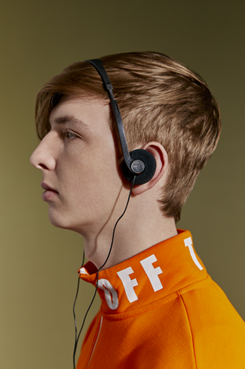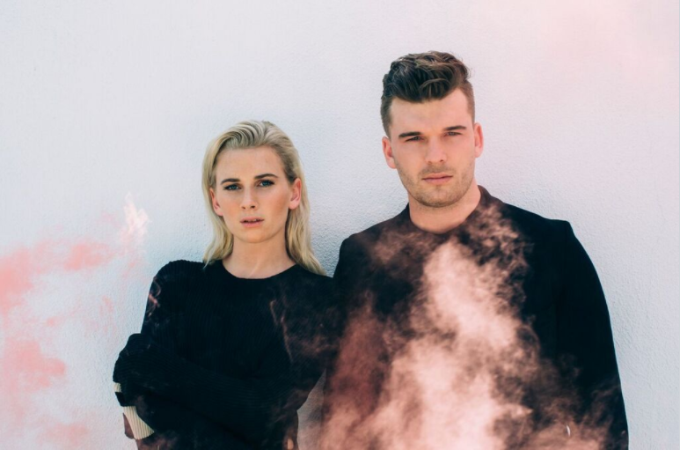
Photo Credit: Jimmy Fontaine Photo Credit: Catie Laffoon

Connect with Whethan:
Press Assets | Website | Facebook | Twitter | Instagram | SoundCloud | YouTube

For Whethan press inquiries:
Jordan Frazes - Jordan.Frazes@atlanticrecords.com
Catherine Corkery - Catherine.Corkery@atlanticrecords.com

Connect with BROODS:
Website | Facebook | Twitter | Instagram | SoundCloud | YouTube

For BROODS press inquiries:
Chris Iacullo - chris@btpr.biz

