WHIPPED CREAM RELEASES HER LIMITLESS DEBUT EP
“WHO IS WHIPPED CREAM”

LISTEN HERE: https://bigbeat.lnk.to/WIWC

OUT TODAY VIA BIG BEAT RECORDS

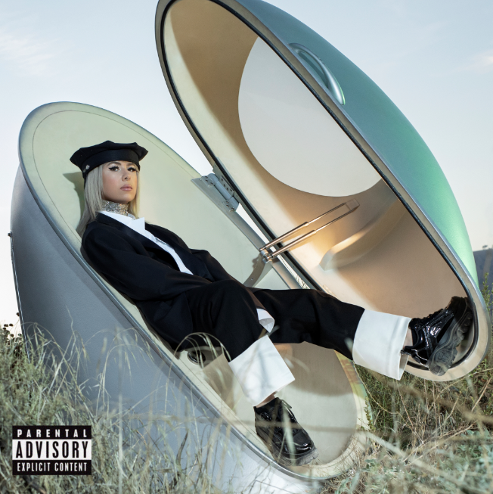
DOWNLOAD ARTWORK HERE

The emerging queen of electronic music’s debut EP “WHO IS WHIPPED CREAM” is officially out today through Big Beat Records. The nine songs that make up the EP are a testament to her limitless style, which draws from roots in hip-hop and electronic. Featuring collaborations with Baby Goth, Lil Xan, Ravenna Golden, Lil Keed, Finn Askew and more, “WHO IS WHIPPED CREAM” is sure to get stuck on repeat - LISTEN HERE.

“WHO IS WHIPPED CREAM” answers the very question, one that many fans have had since she first arrived in the scene: who is WHIPPED CREAM? This project not only reveals who Caroline is as a human but also as an innovator who continues to blend genres and tell a sensory story through her music. The fearless and relentless producer is set to prove that she will continue pushing boundaries and creating music that can be felt by anyone.

EP opener “Us” is a song to listen to on a long drive and feel connected to. It’s a cinematic song about human connection. “Do I” (feat. Mulatto & Baby Goth) delves into more hip-hop/trap/heavy bass territory, which is heightened even further thanks to undeniable opposing verses from Mulatto and Baby Goth. Previous singles “I Won’t Let You Fall” (feat. Finn Askew) “I Do The Most” (feat. Lil Keed), “Told Ya” (feat. Lil Xan), and “Dumb Sh!t” (feat. Jasiah), and IDFC (feat. Ravenna) are also featured.

Currently based on Vancouver Island, WHIPPED CREAM is the project of the Canadian native Caroline Cecil, a former competitive figure skater, but after a debilitating accident on the ice and then a transformative experience at an Active Child show, she was led to channel her emotions through creating music… and the rest was history.

From being profiled in both Billboard and DJ Mag, chosen as one of Billboard Dance’s “Ones to Watch” and being hailed as Mixmag’s “most exciting new names in bass music,” it’s clear that WHIPPED CREAM is making her mark on the music industry with no signs of slowing down. And with the release of her versatile debut EP WHO IS WHIPPED CREAM, it’s safe to say that her mark is made.

TRACKLIST
1. US
2. I Won’t Let You Fall (feat. Finn Askew)
3. Do I (feat. Mulatto & Baby Goth)
4. WHIPPED CREAM & PERTO - IDFC (feat. Ravenna)
5. WRK
6. WHIPPED CREAM & Jasiah - DUMB SH!T
7. I Do The Most (feat. Lil Keed)
8. WHIPPED CREAM & Lil Xan - Told Ya
9. So Thick (feat. Baby Goth)

CONNECT WITH WHIPPED CREAM:
Instagram | Facebook | Twitter | Spotify

PRESS ASSETS: https://press.wearebigbeat.com/artists/whipped-cream/

FOR MORE INFORMATION:
Paige Rosoff – Big Beat Records
Paige.Rosoff@atlanticrecords.com

