WHIPPED CREAM RECRUITS LIL XAN FOR NEW
UNDERGROUND ELECTRONIC INFLUENCED RAP JOINT, “TOLD YA”

LISTEN HERE: https://BigBeat.lnk.to/ToldYaPR

OUT TODAY VIA BIG BEAT RECORDS!

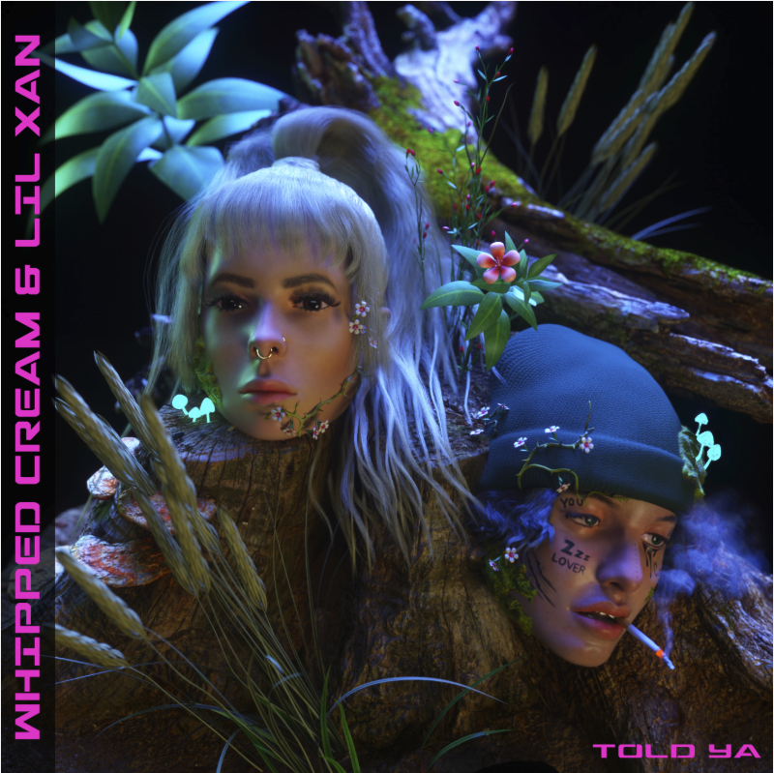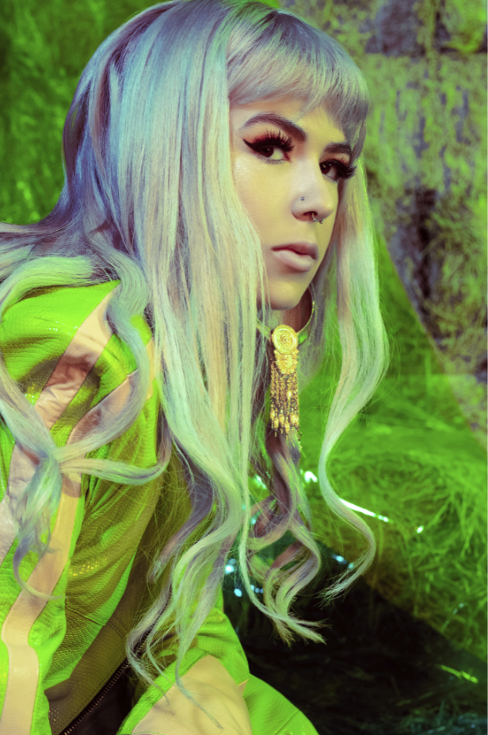

The emerging queen of dance music WHIPPED CREAM has been steadily trickling out new singles throughout 2019, but today is the day her cult following has been highly anticipating… the release of the genre-defying producer’s collaboration with notorious hip-hop/trap prodigy Lil Xan, “Told Ya,” which is out today through Big Beat Records along with the official music video featuring visuals from the world-renowned Swedish visual artist Pastelae – LISTEN/WATCH HERE!

Clocking in at under two minutes, “Told Ya” is a bass-heavy banger that’s so catchy you’ll be keeping it on repeat. WHIPPED CREAM’s penchant for dark, hip-hop influenced, heavy bass music mixed with clanging trap-heavy percussion is at the forefront of the new single, which is complemented by Lil Xan’s signature free-flowing rhymes. From being featured as one of Billboard Dance’s “Ones to Watch” and Mixmag’s “most exciting new names in bass music” this year, it’s clear that WHIPPED CREAM is making her mark on the music industry with no signs of slowing down anytime soon.

WHIPPED CREAM is the project of Caroline Cecil, who was once a competitive figure skater training for the Olympics, but after a debilitating accident on the ice, she was eventually led to channel her emotions and creativity through a new form of art inspired by her first ever festival… and the rest was history. Having spent the majority of 2019 in the studio, it’s safe to expect many big things from WHIPPED CREAM in 2020…buckle up - this is just the beginning.

CONNECT WITH WHIPPED CREAM:
Instagram | Facebook | Twitter | Spotify

PRESS ASSETS: https://press.wearebigbeat.com/artists/whipped-cream/

FOR MORE INFORMATION:
Paige Rosoff – Big Beat Records
Paige.Rosoff@atlanticrecords.com

