CHICAGO-BRED/NEWLY LA-BASED PRODUCER
WHETHAN
DELIVERS INFECTIOUS NEW SINGLE
‘GOOD NIGHTS’
OUT TODAY ALONGSIDE THE ANNOUNCEMENT OF HIS
2017 NORTH AMERICAN FALL ‘GOOD NIGHTS TOUR’!

TOUR DATES BEGIN ON SEPTEMBER 14TH AT LOS ANGELES’S EL REY THEATRE

TICKETS GO ON SALE JUNE 29TH AT 10AM LOCAL VIA WHETHAN.COM/GOODNIGHTS

“GOOD NIGHTS” (FEAT. MASCOLO)
LISTEN/POST: https://www.hive.co/l/goodnightsyt
BUY/STREAM: https://BigBeat.lnk.to/goodnightsPR

WATCH “GOOD NIGHTS” TOUR TRAILER: https://www.hive.co/l/goodnightstt

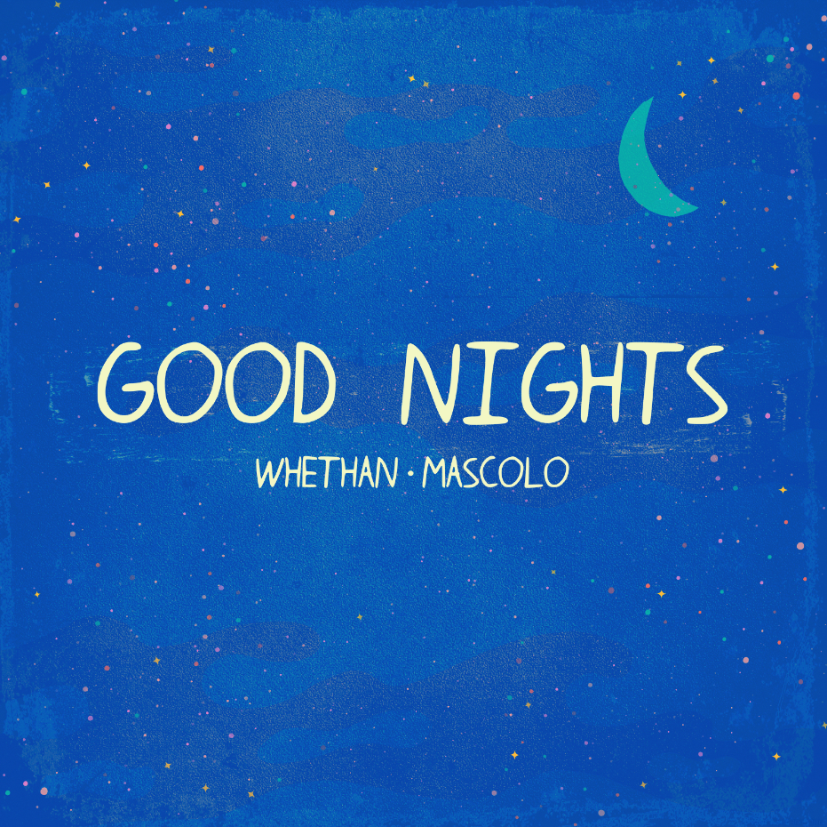

18-year-old fast rising producer Whethan announces his 2017 North American “Good Nights Tour” alongside the release of a new single “Good Nights” (feat. Mascolo) – LISTEN HERE – which is as infectious as it is summer ready.

The “Good Nights North American Tour” (WATCH TOUR TRAILER HERE) kicks off in Whethan’s new residence, Los Angeles on September 14th at El Rey and culminates in his hometown of Chicago on November 11th at Concord Music Hall. Advanced tickets will be available to Soundcloud subscribers tomorrow (June 28th) at 10am local time, alongside the general on-sale for tickets on Thursday June 29th available to fans by logging onto http://whethan.com/goodnights. Support acts on select dates include Bearson, SAINT WKND, Opia and Ashe.

Whethan is the moniker of the Chicago-bred producer Ethan Snoreck, who first made a name for himself as a SoundCloud producer, remixing tracks for Louis The Child (“It’s Strange”), ZAYN (“Pillow Talk”) and Ty Dolla $ign (“Blasé feat. Future & Rae Sremmurd”) which all surpassed 2.5 million plays; before releasing a groundbreaking original cut – “Savage” (feat. Flux Pavilion & MAX)” – having amassed over 25 million streams worldwide. “love gang” (feat. Charli XCX) was the next chapter in Whethan’s already ground-breaking discography. The track kicks off with clanging, discordant synths transposed with Charli XCX’s dazzling vocals, before exploding into an ethereal, hook-laden chorus – LISTEN HERE.

Whethan recently opened for The Chainsmokers on their “Memories Do Not Open” US arena tour, on top of many major festival performances including Coachella, with appearances at DoLab & Heineken House, and will also be performing at Lollapalooza, HARD Music Festival and Electric Forest.

Gaining early attention from the likes of Skrillex and Flux Pavilion, Whethan continued to rise through the ranks building a loyal fan-base into 2017.

##

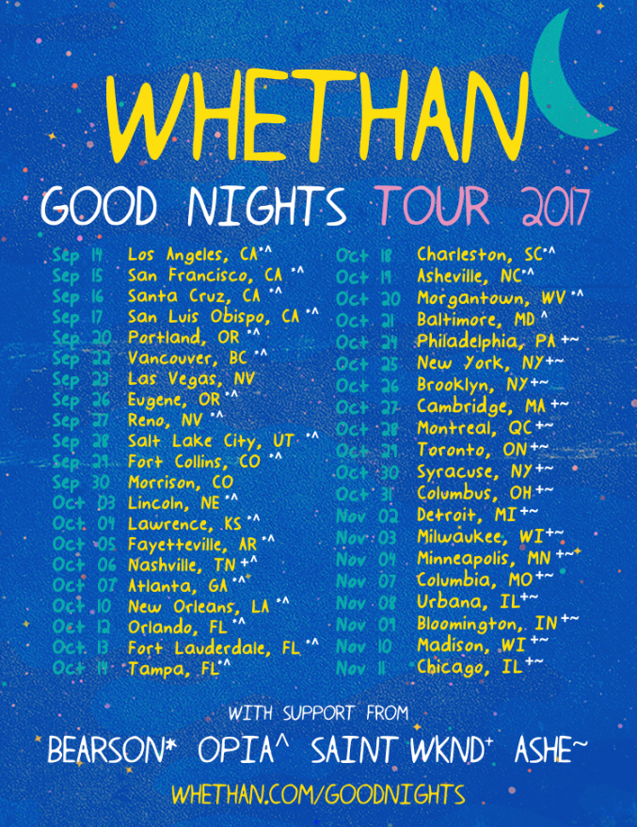
HI-RES DOWNLOAD

WHETHAN
“GOOD NIGHTS” NORTH AMERICAN TOUR DATES
(PLUS ADDITIONAL FESTIVAL DATES)

Sept 14 – Los Angeles, CA @ El Rey Theatre ^*
Sept 15 – San Francisco, CA @ Regency Ballroom ^*
Sept 16 – Santa Cruz, CA @ The Catalyst ^*
Sept 17 – San Luis Obispo @ The Graduate ^*
Sept 20 – Portland, OR @ Wonder Ballroom ^*
Sept 22 – Vancouver, BC @ VENUE ^*
***Sept 23 – Las Vegas, NV @ Life Is Beautiful Festival***
Sept 26 – Eugene, OR @ WOW Hall ^*
Sept 27 – Reno, NV @ Cargo ^*
Sept 28 – Salt Lake City, UT @ The Complex ^*
Sept 29 – Fort Collins, CO @ Aggie Theatre ^*
***Sept 30 – Morrison, CO @ Big Gigantic Rowdytown VI (Red Rocks Amphitheatre)***
Oct 3 – Lincoln, NE @ Bourbon Theatre ^*
Oct 4 – Lawrence, KS @ Bottleneck ^*
Oct 5 – Fayetteville, AR @ George’s Majestic Lounge ^*
Oct 6 – Nashville, TN @ Exit In +SAINT WKND and Opia
Oct 7 – Atlanta, GA @ Terminal West ^*
Oct 10 – New Orleans, TN @ Republic ^*
Oct 12 – Orlando, FL @ Venue 578 ^*
Oct 13 – Fort Lauderdale, FL @ Revolution Live ^*
Oct 14 – Tampa, FL @ The Ritz Ybor ^*
Oct 18 – Charleston, SC @ Music Farm – Charleston ^*
Oct 19 – Asheville, NC @ Orange Peel ^*
Oct 20 – Morgantown, WV @ Mainstage Morgantown ^*
Oct 21 – Baltimore, MD @Soundstage *
Oct 24 – Philadelphia, PA @ Trocadero +~
Oct 25 – New York, NY @ Bowery Ballroom +~
Oct 26 – Brooklyn, NY @ Music Hall of Williamsburg +~
Oct 27 – Cambridge, MA @ The Sinclair +~
Oct 28 – Montreal, QC @ Belmont +~
Oct 29 – Toronto, ON @ Velvet Underground Toronto +~
Oct 30 – Syracuse, NY @ Westcott Theatre +~
Oct 31 – Columbus, OH @ Skully’s +~
Nov 2 – Detroit, MI @ Magic Stick +~
Nov 3 – Milwaukee, WI @Miramar Theatre +~
Nov 4 – Minneapolis, MN @Skyway Theatre +~
Nov 7 – Columbia, MO @ The Blue Note +~
Nov 8 – Urbana, IL @ Canopy Club +~
Nov 9 – Bloomington, IN @Bluebird Nightclub +~
Nov 10 – Madison, WI @ Majestic Theatre +~
Nov 11 – Chicago, IL @ Concord Music Hall +~

with support from Bearson^, Opia*, Saint WKND⁺, and Ashe~
***FESTIVAL DATE***

WHETHAN: Website | Facebook | Twitter | Instagram | SoundCloud | YouTube | Press Site

##

For more information please contact:

Jordan Danielle Frazes
Head of Publicity, Big Beat Records
Jordan.Frazes@atlanticrecords.com

Catherine Corkery
Publicity, Big Beat Records
Catherine.Corkery@atlanticrecords.com

