RISING ARTIST WHIPPED CREAM DROPS NEW SINGLE WITH PERTO
“IDFC” (FT. RAVENNA GOLDEN)

OUT TODAY VIA BIG BEAT RECORDS
LISTEN HERE

DEBUT EP “WHO IS WHIPPED CREAM” DROPPING 8/21
PRE-ORDER HERE

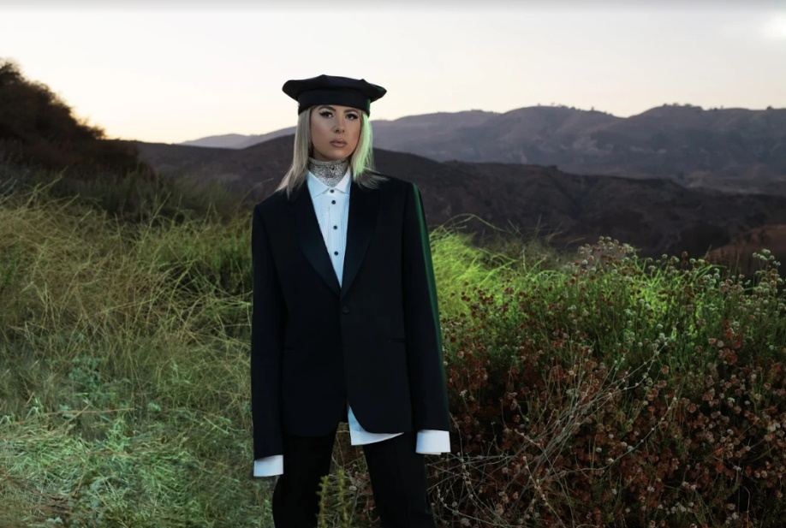
DOWNLOAD PRESS PHOTO HERE

WHIPPED CREAM is back with another heater leading into her debut EP. Out today, “IDFC” with Perto (ft. Ravenna Golden) is the high energy track we all need to keep our spirits lifted through quarantine. Listen to “IDFC” HERE.

The making of “IDFC” was a seamless collaboration. In Perto’s words: “Caroline and I linked when she came to Sydney for some shows and we ended up hanging out for days - in the studio, grabbing meals, we even went to the zoo with Rico [Nasty] lol. Ravenna and I had started IDFC last year, but it sat on my computer for months. I played it to Caroline one of the days and she really fucked with it. We went in on the production and turned it into a whole new record :)”

ABOUT WHIPPED CREAM
Following the recent release of undeniable hits including sultry single I Won’t Let You Fall (ft. Finn Askew), there’s no doubt 2020 is shaping up to be WHIPPED CREAM’s biggest year yet - one that will bring the release of her debut EP “WHO IS WHIPPED CREAM”, a testament to her “limitless” style that draws from roots in hip-hop, dubstep, trap, dnb and experimental bass. This multifaceted EP will answer the very question, “WHO IS WHIPPED CREAM”, one that many fans have had since she first arrived in the scene. This project will not only reveal who WHIPPED CREAM is as a human but also as an innovator who continues to blend genres and tell a sensory story through her music. With releases of gritty originals and filthy hip-hop cuts such as “Told Ya” feat. Lil Xan, and “DUMB SH!T” feat. Jasiah still on the rise and proving that she will continue pushing boundaries and creating “music that can be felt by anyone”. Make sure to stay tuned for more incredible music and exciting news to come from WHIPPED CREAM.

ABOUT PERTO
Perto is undoubtedly Australia’s biggest (and youngest) new export. His eclectic brand of electronic production has seen him release singles and remixes streamed millions of times, perform high-energy live sets around the world to thousands of devoted fans, and hit the studio with some of the world’s biggest acts — and he’s just turned 18. The Sydney-born producer is a certified musical prodigy, whose output is mature beyond his years but as innovative and fortuitous as one would expect from an internet-fuelled savant with the world’s musical history at his fingertips. Since hearing Skrillex’s ‘Bangarang’ on the radio at the age of 10, Perto’s life has been filled with bizarre twists and turns. “Skrillex is the reason I got into music, and then fast forward to last year and we’re singing Evanescence in a club in Myanmar together.”
It’s clear he doesn’t need one. Before even releasing his first EP, he’s created official remixes for Flosstradamus and Valentino Khan, supported Alison Wonderland on tour, performed kinetic live sets at sold-out shows across the globe, released infectious single 'Bad Maybe Good’ with GRAMMY-nominated Nigerian singer-songwriter Kah-Lo, and he’s just getting started.

CONNECT WITH WHIPPED CREAM:
Instagram | Facebook | Twitter | Spotify

CONNECT WITH PERTO
Instagram | Facebook | Twitter | Spotify

CONNECT WITH RAVENNA GOLDEN
Instagram | Facebook | Twitter | Spotify

PRESS ASSETS: https://press.wearebigbeat.com/artists/whipped-cream/

FOR MORE INFORMATION:
Paige Rosoff – Atlantic/Big Beat Records
Paige.Rosoff@atlanticrecords.com

