electro-pop producer VASCO RECRUITS NIKKI VIANNA
FOR UNDENIABLE NEW SINGLE, “TWO SHOTS”

LISTEN HERE

OUT TODAY VIA BIG BEAT RECORDS!

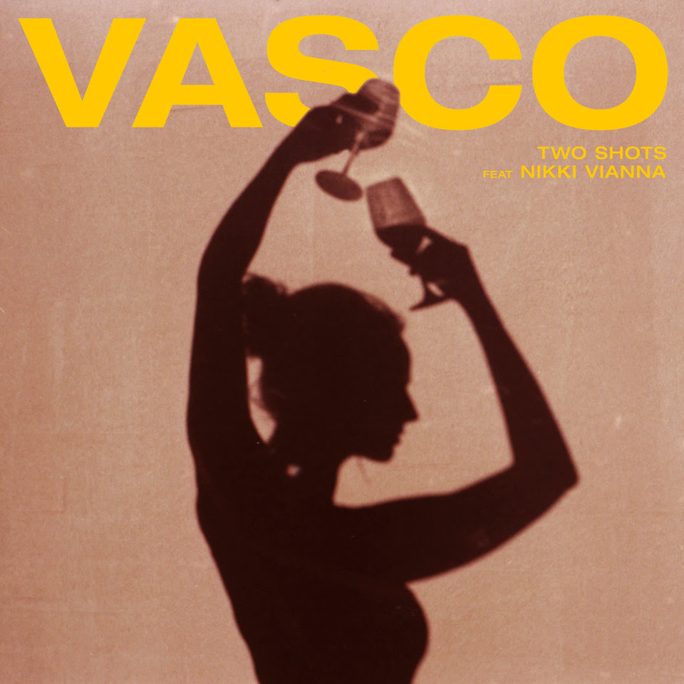
DOWNLOAD ARTWORK HERE

The enigmatic producer Vasco just released his debut Tender Luv EP in March, but the rising artist is already back with new music in the form of an undeniably melodic new single called “Two Shots” that features vocals from the seductive Queens born pop singer-songwriter, Nikki Vianna, another one of Atlantic Records’ rising stars. The hook-laden production on “Two Shots” is exemplary of Vasco’s signature left-field sound. Combining Vasco’s memorable production with Vianna’s soulful delivery makes for a match made in chart-topping heaven! Listen/watch here!

Vasco’s music has been released by the likes of Baauer, MØ, Terror Jr, and Soleima, while Nikki Vianna has already amassed 28 million Spotify streams with only three official releases to her name; her Instagram following has grown significantly as a result, now sitting comfortably at 3.2 million followers and counting, including Diplo, Dillon Francis, Sean Paul, and Supreme Patty. Vasco has a penchant for crafting smart, innovative electronic compositions in the vein of Mura Masa and Cashmere Cat. Being that Vasco is the cryptic production force behind many critically-acclaimed artists of recent past, it’s safe to say he’s your favorite producer’s favorite producer, and your soon-to-be favorite artist on the rise.

Nikki Vianna always knew her purpose. The Queens-born singer, songwriter, and pop force of nature first picked up a microphone as a child and never looked back; she tirelessly pushed forward and quietly attracted an international fan base through sharing a resonant, relatable, and real truth by way of traffic-stopping vocal delivery, sly swagger, and seductive soul. With only a few releases under her belt (so far!), Nikki Vianna has already amassed over 21 million streams and 3.2 million IG followers to her name from her work with Matoma, Poo Bear, Flo Rida, and Cash Cash, to name a few. In the midst of rigorous academic training growing up, she found herself recording in sessions alongside legends and influential songwriters, namely Scott Storch [Dr. Dre, Christina Aguilera], Toby Gad [Beyoncé, John Legend], Poo Bear [Justin Bieber, Sam Smith], and more. Throughout this journey, she’s cultivating and crafting a singular style that draws inspiration from the likes of Amy Winehouse, Sia, Beyoncé, and Billie Holiday, in which she translates their signature raw soul into ambitious pop. Keep an eye out for new music coming from this star on the rise.

With resumes as impressive as both Vasco’s and Nikki Vianna’s, “Two Shots” is a mere glimpse into a very bright future for them both.

Connect with Vasco:
Instagram | Facebook | Spotify

Connect with Nikki Vianna:
Instagram | Facebook | Spotify

For Vasco press assets, please visit: http://press.wearebigbeat.com/artists/vasco/

FOR MORE INFORMATION:
Paige Rosoff – Big Beat Records
Paige.Rosoff@atlanticrecords.com

