THE KNOCKS’ SINGLE “HEAT” (FT. SAM NELSON HARRIS)
GETS FULL REMIX EP RELEASE, OUT NOW VIA BIG BEAT RECORDS
featuring remixes from Wet, Toyboy & Robin, Manila Killa & more!

STREAM/BUY: https://BigBeat.lnk.to/heatrmxsPR

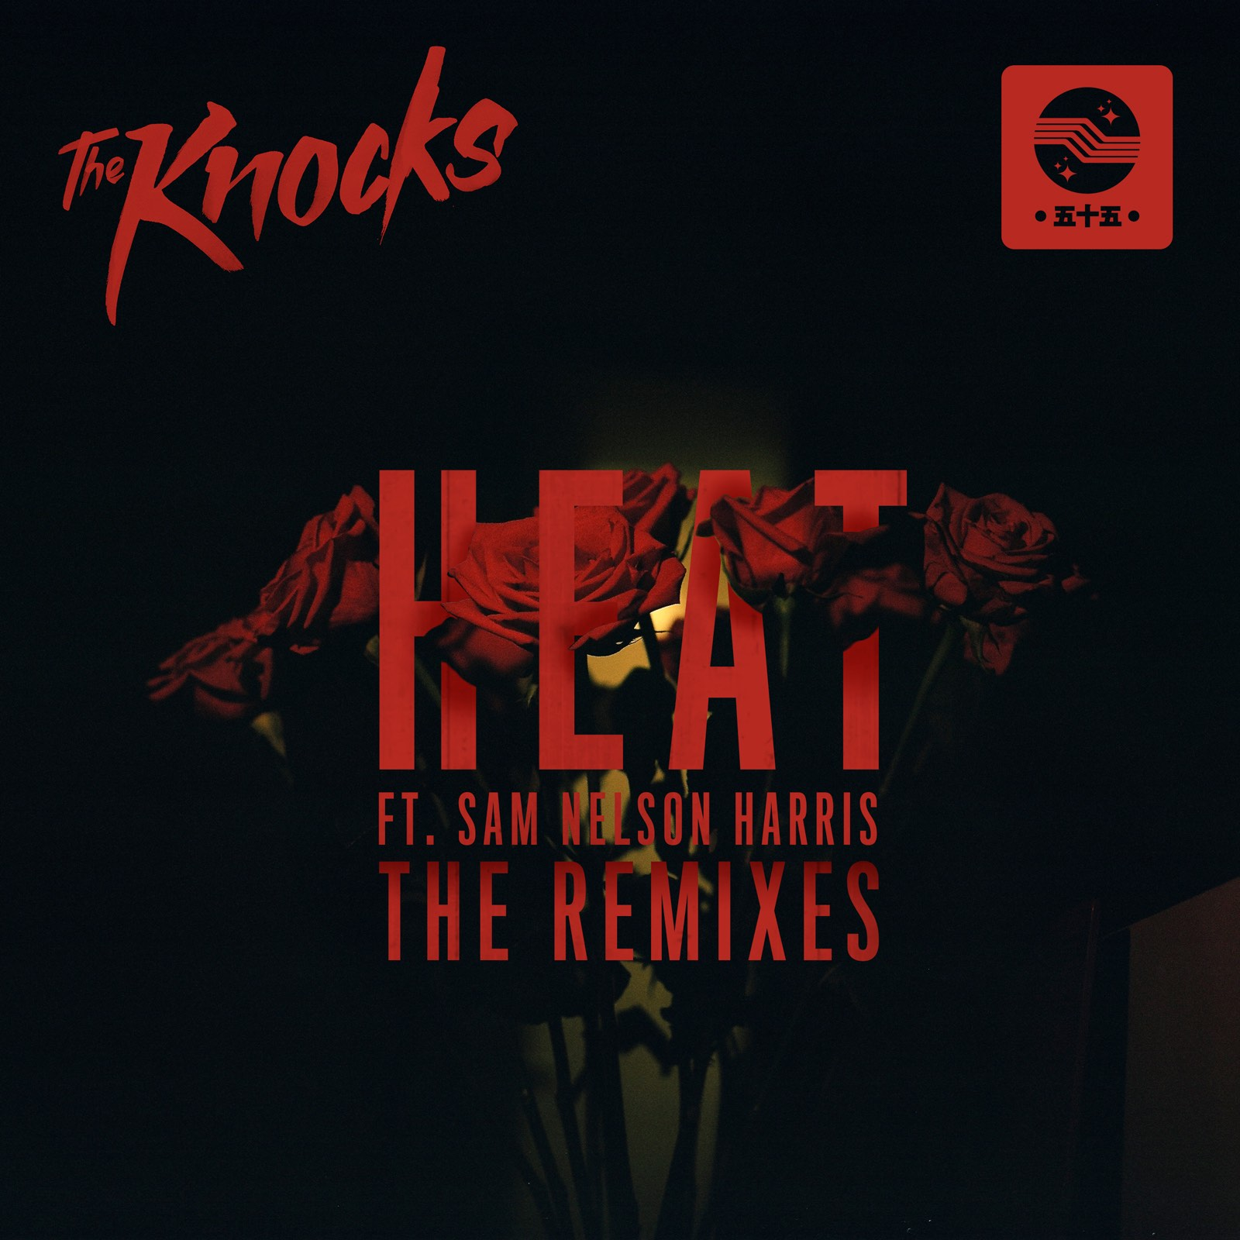

New York City’s legendary production duo The Knocks are still riding high off the release of their TESTIFY EP earlier this year. Now the EP’s outstanding single “HEAT (ft. Sam Nelson Harris)” is getting the full remix treatment, in the form of a remix EP (out today via Big Beat Records). “HEAT” was the fiery futuristic lead single from TESTIFY, which features sleek R&B-tinged vocals from Harris – lead vocalist of the alternative rock group X Ambassadors. The EP is comprised of five remixes, courtesy of the sultry NYC dream-pop trio Wet, the prodigious Manila Killa, the Dutch production duo Pep & Rash, newcomer MishCatt Skollhaus, and London electronic duo Toyboy & Robin.

The Knocks recently wrapped up their huge FEEL GOOD FEEL GREAT North American tour and are now looking forward to their summer tour dates, which have them headlining Santa Monica’s Infatuation EEEEEATSCON in May and Brooklyn’s ELEMENTS Music & Art Festival in August. The duo will also grace the stage at the Shaky Beats Music Festival in Atlanta, along with other festival appearances at Boom Boom Music Festival, Camp Bisco, Kaaboo Festival and the Cayuga Sound Festival. All dates below!

In addition to Harris, The Knocks’ TESTIFY EP (buy/stream) saw the production masterminds breaking sonic ground with other featured artists including breakthrough multi-platinum artist MNEK, Jerm (whose songwriting credits include Beyoncé’s Lemonade), and GRAMMY nominated songwriter Tayla Parx.

TESTIFY arrived on the heels of The Knocks’ critically-acclaimed 2016 debut album ‘55’ (buy/stream) which also featured a star-studded cast, from New York’s hip hop legend Cam’ron to pop-sensation Carly Rae Jepsen. The album twists and turns with diverse musical styles and genre-bending flavor, leading VICE’s NOISEY to laud ‘55’ as “bombastic, funk-finagled, and fun.”

In 2008, JPatt and B-Roc took out a loan and opened the HeavyRoc studio at 55 Chrystie, in the same broken-down building where the Beastie Boys used to rehearse. From there, in a dance music ecosystem increasingly dominated by reticent bedroom producers or big-tent corporate names, The Knocks have stayed on a certain downtown grind. To this day, their classic New York open-format DJ style continues to suffuse every record, with music able to work a crowd from all angles, full of pre-dawn tenacity and the energy of a dance-floor crush.

HEAT FEAT. SAM NELSON – THE REMIXES
1. HEAT (feat. Sam Nelson Harris) (MishCatt Skolhaus Remix)
2. HEAT (feat. Sam Nelson Harris) (Wet Remix)
3. HEAT (feat. Sam Nelson Harris) (Manila Killa Remix)
4. HEAT (feat. Sam Nelson Harris) (Toyboy & Robin Remix)
5. HEAT (feat. Sam Nelson Harris) (Pep & Rash Remix)

THE KNOCKS UPCOMING TOUR DATES
05-MAY-17 - Atlanta, GA @ Shaky Beats Music Festival
20-MAY-17 - Santa Monica, CA @ Infatuation EEEEEATSCON *Headlining
09-JUN – 11-JUN-17 - Palm Springs, CA @ Splash House
23-JUN – 25-JUN-17 - Heber City, UT @ Bonanza Campout
24-JUN-17 - Thornville, OH @ Boom Boom Music Festival
13-JUL-17 - Scranton, PA @ Camp Bisco
12-AUG – 13-AUG-17 - Brooklyn, NY @ ELEMENTS Music & Art Festival *Headlining
15-SEP – 17-SEP-17 - San Diego, CA @ Kaaboo Festival
22-SEP – 23-SEP-17 - Ithaca, NY @ Cayuga Sound Festival

Connect with The Knocks:
https://www.facebook.com/theknocksnyc
https://soundcloud.com/theknocks
https://twitter.com/theknocks
https://instagram.com/the_knocks
http://theknocks.com

Press assets: http://press.wearebigbeat.com/artists/the-knocks/

For press inquiries:

Jordan Danielle Frazes
Head of Publicity, Big Beat Records
Jordan.Frazes@AtlanticRecords.com

Ilana Gold (tour requests)
Ilana.Gold@AtlanticRecords.com

