RALPH FELIX & SDJM

RELEASE ‘THE HEAT (I WANNA DANCE WITH SOMEBODY)’
ON JANUARY 13th OUT NOW WITH BIG BEAT RECORDS
Stream/Buy: https://bigbeat.lnk.to/theheatPR

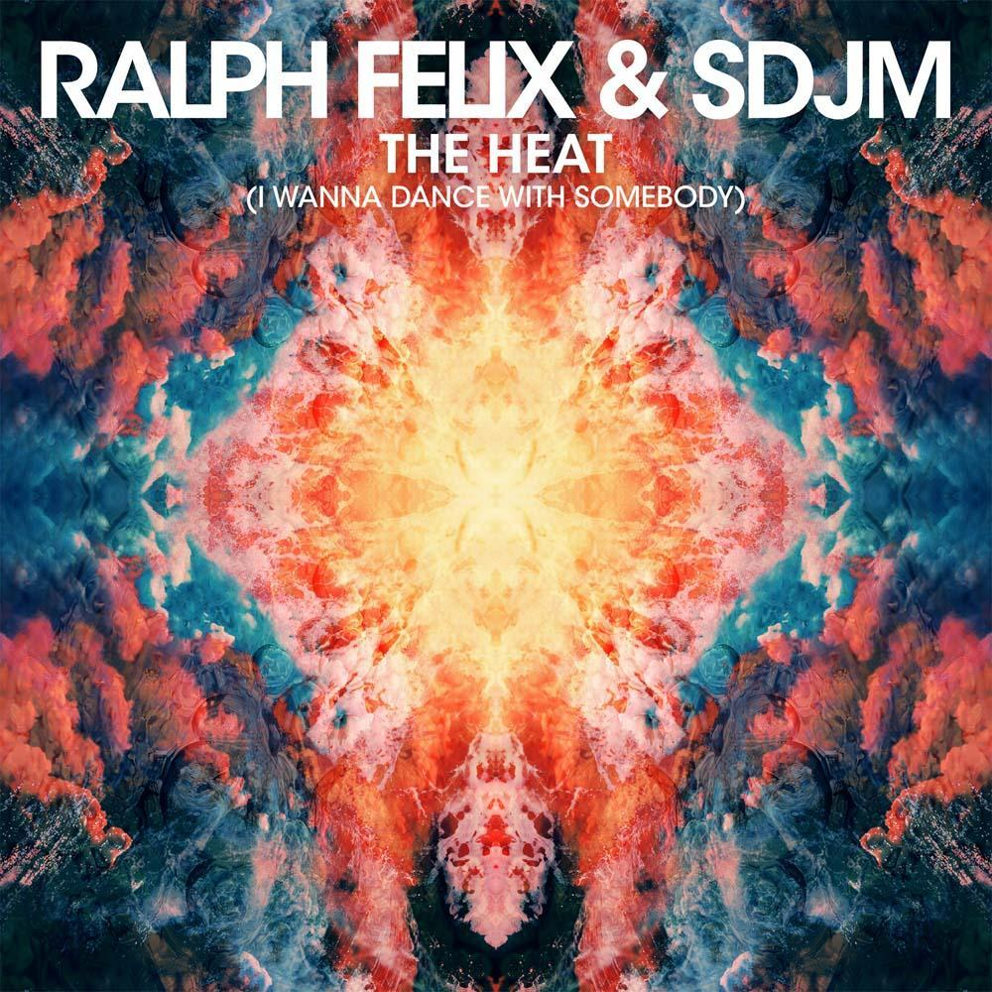

‘The Heat (I Wanna Dance With Somebody)’ has trended at #1 on Shazam every time that it has been played on Radio 1’s Dance Anthem. It’s a sign that the track from Ralph Felix & SDJM will be a huge hit. ‘The Heat (I Wanna Dance With Somebody)’ is now available across all DSP’s via Big Beat Records.

One listen reveals exactly why the track is capturing the public’s attention. By blending a sample from Whitney Houston’s iconic 80s hit with contemporary commercial house, Ralph Felix & SDJM have expertly blended the old with the new to craft a killer cut for a whole new audience.

‘The Heat (I Wanna Dance With Somebody)’ is the result of a collaboration between three rising producers:

Ralph Felix was previously one-half of the Dutch production duo NEW_ID who featured heavily on Swedish House Mafia’s record-breaking ‘One Last Tour’. Recently signed to Warner Music, Ralph Felix is currently working on new material.

SDJM are Milan-based DJ/producer duo Simon de Jano and Madwill. ‘Temptation’, their biggest track to date, was premiered by Steve Angello at Ultra Music Festival and subsequently hit #1 on Beatport’s Progressive House chart. They have also created official remixes for artists such as Bob Sinclar, A-Trak and Benny Benassi.

Press Assets: http://press.wearebigbeat.com/singles/the-heat-i-wanna-dance-with-somebody/

Connect with Ralph Felix
https://www.facebook.com/ralphfelix/
https://soundcloud.com/ralph-felix-1
https://twitter.com/ralphfelixdj

Connect with SDJM
https://twitter.com/SDJMmusic
https://www.facebook.com/SDJMmusic
For more information please contact:

Jordan Danielle Frazes
Head of Publicity, Big Beat Records
jordan.frazes@atlanticrecords.com

Lindsay Herr
lindsay@thewanderlvst.com

