THE KNOCKS’ GET A ‘CLASSIC’ REMIX FROM RAC!
PLUS, ANNOUNCE NORTH AMERICAN TOUR w/ RAC, KICKING OFF IN OCTOBER!

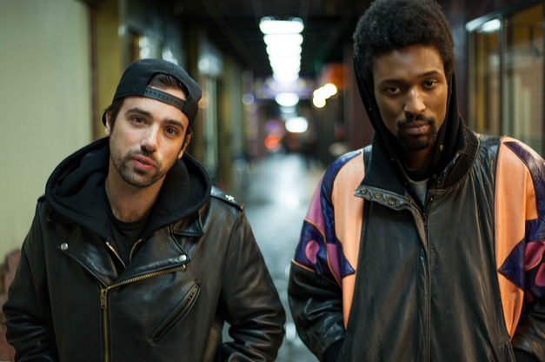

THE KNOCKS ‘CLASSIC (FT. POWERS)’ (RAC REMIX):
https://soundcloud.com/rac/the-knocks-classic-rac-mix

RAC’S ‘CHEAP SUNGLASSES’ (THE KNOCKS REMIX):
https://soundcloud.com/theknocks/rac-cheap-sunglasses-ft-matthew-koma-the-knocks-remix/

PURCHASE ‘CLASSIC (FT. POWERS)’ VIA BIG BEAT RECORDS:
http://smarturl.it/TheKnocksClassic

LES/NY-based The Knocks - comprised of producers JPatt and B-Roc - are recognized as masters of soul-infused electronic funk and trip/hip-hop. The duo reveal forthcoming live dates supporting critically acclaimed artist/producer RAC (aka André Allen Anjos), intertwined with headline and festival dates, as well as stops with St. Lucia. In celebration, The Knocks deliver a new remix for RAC’s new single “Cheap Sunglasses” feat. Matthew Koma (LINK) and also reveal a remix from RAC (LINK) made for their summer anthem ‘Classic (ft. Powers),’ arriving on a forthcoming ‘Classic’ remix package to be released on Big Beat Records.

THE KNOCKS ON TOUR
Headline Dates * | Festival dates ^^
Supporting RAC + | Supporting St. Lucia #

August 23rd – Lawrence, KS @ University of Kansas * (DJ Set)
August 29th – Burlington, VT @ University of Vermont *
August 30th – Ithaca, NY @ Cornell University *
September 20th – Monterrey, Mexico @ Hellow Fest ^^ (DJ Set)
October 23rd – New York, NY - Terminal 5 +
October 30th - Danforth, Toronto, ON +
October 31st - Altar, Pittsburgh, PA +
November 1st – Chicago, IL @ Concord Music Hall +
November 3rd - Majestic, Madison, WI +
November 5th – Denver, CO @ Gothic Theatre +
November 7th – Seattle, WA @ The Crocodile +
November 8th –Seattle, WA @ The Crocodile +
November 10th – Vancouver, BC @ Commodore +
November 14th – Los Angeles, CA @ The Fonda +
November 15th – San Francisco, CA @ Warfield +
November 17th – Montreal, QC @ Corona Theatre #
November 20th – Boston, MA @Royale Nightclub #
November 22nd – New York, NY@ Terminal 5 #
November 24th – Philadelphia, PA @ Theatre of the Living Arts #
November 25th – Washington, DC @ 9:30 Club #

“… The Knocks' collaboration with Brooklyn's X Ambassadors…was what we've come to expect from the duo: bombastic, funk-finagled, and fun, it was a dance track that had us dreaming of martinis and yachts moored off the coast of Miami. I really didn't think they could pack more #goodvibes into a cut but whatever, they've done it again.”
– VICE’s Noisey

“Dance duo the Knocks have already proven that they have the chops to deliver a seriously bright summer banger, and now they repeat the feat.”
--SPIN

“If you call a song “Classic,” it better deliver. This does. “Classic” is self-fulfilling prophecy for the track’s hit potential, and a late contender for the Song of the Summer.”
--Flavorwire

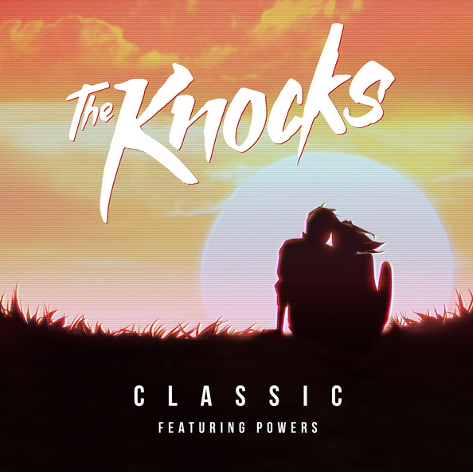

# # #

For more information / log on
https://www.facebook.com/theknocksnyc
https://twitter.com/theknocks
http://theknocks.tumblr.com/

For press materials / download
http://press.wearebigbeat.com/singles/classic-feat-powers/

For press inquiries / Jordan Frazes
Jordan.Frazes@atlanticrecords.com
via Big Beat Records / 212.707.2022

