THE KNOCKS & MALLRAT TEAM UP ON NEW SINGLE “R U HIGH”

LISTEN HERE: https://knocks.lnk.to/RUHighID

OUT TODAY VIA BIG BEAT RECORDS

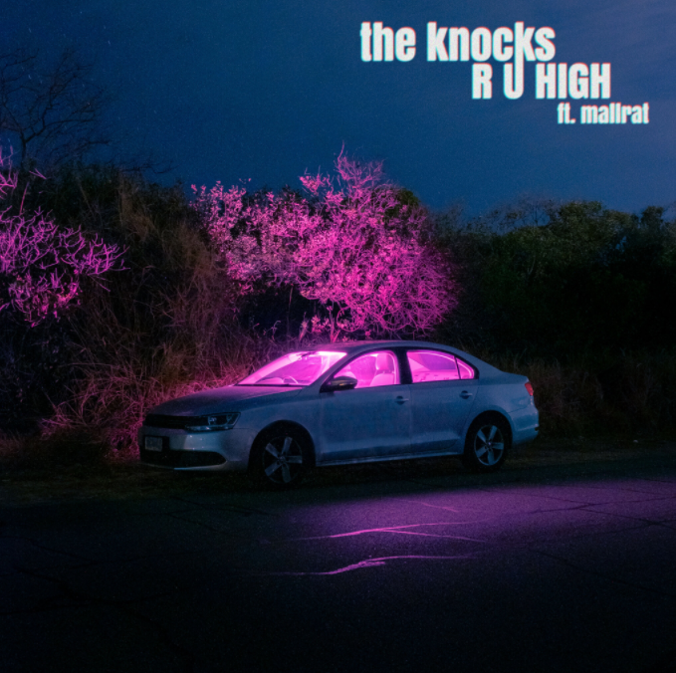
DOWNLOAD ARTWORK HERE

Fresh off the buzzing release of their Melody & Silence mixtape with Foster the People, The Knocks are back today with another binge-worthy track, this time with beloved Australian singer-songwriter, Mallrat. The Knocks’ signature captivating production style paired with Mallrat’s solemn, ethereal vocals makes “R U HIGH” so addicting it’s impossible to listen just once. Listen HERE.

Both masters of their crafts, this collaboration is nothing short of a perfect match – and only fitting that they’ve created a song that’s best described as the sonic equivalent of dancing under a disco ball at the club.

“I’ve been a fan of Mallrat since I heard her early stuff & we finally met before I went to her first show in NYC”, said Ben from The Knocks. “We talked about doing a song together and eventually our schedules aligned while we were both in California and got together for a couple of days. Her sense of melody and lyric writing is really special and in a lane of its own. All her work is honest and personal, which is hard to find these days."
“I loved making this song with The Knocks,” said Mallrat. “They rented a big airbnb in the Hollywood hills and we made this song together in the living room about a year ago. I’ve spent a lot of time between now and then dancing around my kitchen to the demo and I’m glad that it’s finally out in the world.”

The Knocks are a New York City-based electronic music institution who have consistently evolved throughout their continuingly successful career. Their current single “All About You” with Foster the People is soaring on the Alternative Radio charts (#15 and rising), and their Melody & Silence mixtape is buzzing in the media and amongst tastemakers, all while reaching a lifetime peak of 6 + Million Monthly Listeners on Spotify. In addition, their collab with Purple Disco Machine, “Fireworks”, is soaring up the charts around the globe and also received massive sync launch, airing throughout CBS ad programming during the 2021 Grammys and March Madness. Furthermore, their release “Bodies” (with MUNA) has been streamed over twelve million times globally since release, resulting in a brilliant performance on Jimmy Kimmel Live! The duo has collaborated with some of music's biggest names [Carly Rae Jepsen, X Ambassadors, Big Boi] and toured around the world with music heavyweights including The 1975, Justin Bieber, and Ellie Goulding. Their hit single, “Ride or Die” featuring Foster the People reached #11 on the alt radio charts and landed them a live performance on The Late Show With Stephen Colbert. In addition, their collaboration with Sofi Tukker "Best Friend" has accumulated more than 190 million streams across platforms to date. They performed the song live on The Tonight Show Starring Jimmy Fallon and was the feature song in Apple's iPhone X campaign and keynote address. The Knocks' hit song "Shades" is currently featured in Pepsi's 2020-2021 national ad campaign.

The 22-year old Australian artist, Mallrat, has a penchant for writing sticky melodies that you just can't shake. Her songs nestle comfortably between pop and indie hip hop and have garnered attention from the likes of NY Times, Nylon and more, including NPR - who said that the only downside to listening to her track "Better" is that "your heart may actually explode with happiness." PAPER Magazine recently named her in their "100 Women Revolutionizing Pop". After making it onto the “Best of” lists by The FADER, Billboard, NOISEY, NME and Triple J, Teen Vogue deemed her one of "16 Young Musicians You Need to Be Listening to." Mallrat’s profile continues to build with the latest track “Charlie.” At home, the track placed at #3 on Triple J Hottest 100, just behind Billie Eilish and Flume. In the states, she made her late-night TV performance debut on the Late Late Show With James Corden, while in the UK, winning “Best Australian Solo Act” at this year’s NME Awards. She's toured alongside Maggie Rogers, King Princess and Post Malone and recently headlined sold-out tours across Australia, the UK, Europe and the US.

CONNECT WITH THE KNOCKS:
Instagram | Facebook | Twitter | Spotify

CONNECT WITH MALLRAT:
Instagram | Facebook | Twitter | Spotify

Press Assets: http://press.wearebigbeat.com/artists/the-knocks/

Press inquiries:
Paige.Rosoff@atlanticrecords.com
Big Beat Records | Atlantic Records

