THE KNOCKS & FOSTER THE PEOPLE TEAM UP TO REIMAGINE
90’S CLASSICS ON NEW ‘MELODY & SILENCE’ MIXTAPE

LISTEN HERE: https://knocks.lnk.to/MelodyAndSilenceID

OUT TODAY VIA BIG BEAT RECORDS

What do you get when New York City’s funky house stalwarts The Knocks and Foster the People, one of the biggest indie-pop artists of the past decade, team up to reimagine some of the most enduring alternative classics from the 1990’s? Their undeniable new mixtape Melody & Silence. Longtime friends and collaborators, The Knocks and Foster The People teamed up to record covers of iconic 90’s classics Beck’s “Devil’s Haircut,” The Verve’s “Bittersweet Symphony,” and Moby’s “South Side” - all songs that ruled the decade, and were influential to both artists’ respective upbringing. Also featuring a Sunrise edit of The Knocks and Foster The People’s latest hit single, the anthemic single “All About You” to round out the mixtape, Melody & Silence is yet another chapter in the two artists’ ongoing collaborations, which dates back several years to 2018’s unforgettable single, “Ride or Die” - LISTEN HERE.

Featuring The Knocks’ warm feel-good production and effortless, sleek vocals from Foster The People’s Mark Foster, “All About You” also utilizes an epic, soulful sample of Pastor T.L. Barrett’s “Like a Ship” in the chorus that takes it over the top to give the track one final divine, ethereal touch for good measure. On Melody & Silence, Mark Foster does a brilliant job emulating each vastly different artists’ distinctive vocals (Beck, Richard Ashcroft, Moby). Paired with The Knocks’ golden touch behind the boards, and we now have new modern takes on unforgettable songs to hold both artists’ fans over for the time being. Stay tuned for more from The Knocks very soon.

The Knocks & Foster The People Present: Melody & Silence
- Bittersweet Symphony
- Devil’s Haircut
- South Side
- All About You ft. Foster The People (Sunrise Version)

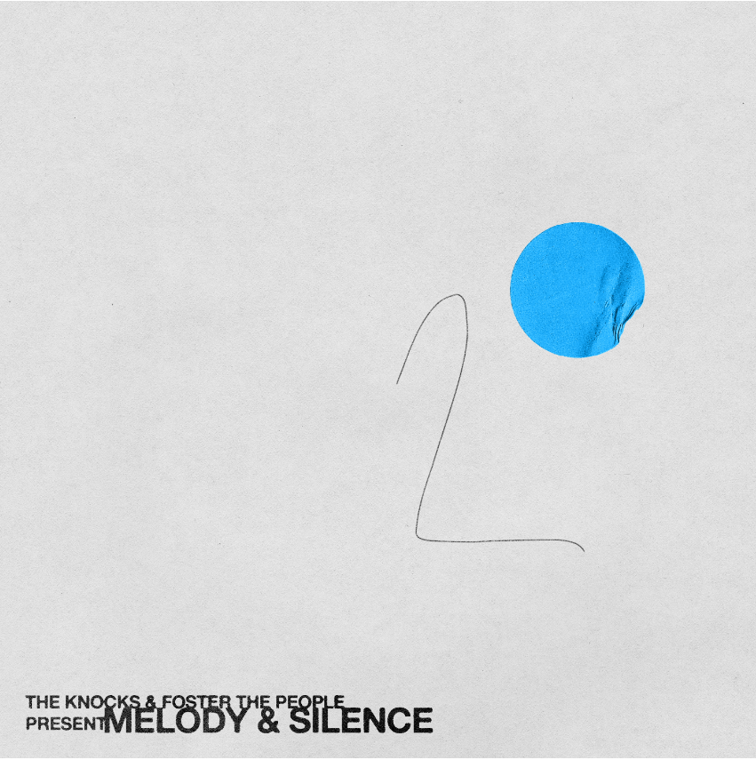

CONNECT WITH THE KNOCKS:
Instagram | Facebook | Twitter | Spotify

Press Assets: http://press.wearebigbeat.com/artists/the-knocks/

Press inquiries:
Paige Rosoff
Director of Publicity, Big Beat Records
Paige.Rosoff@atlanticrecords.com

