The Knocks Announce So Classic EP &
“Dancing With Myself” music video!

WATCH: “Dancing With Myself”: http://youtu.be/5qDzFJC7k4A
“So Classic” EP out April 7th via Big Beat/Neon Gold

“The funk-laced dance track features vocals by B-Roc's bandmate, JPatt (aka James Patterson), and comes from their upcoming So Classic EP, out April 7th via Big Beat/Neon Gold.” —PAPER MAG

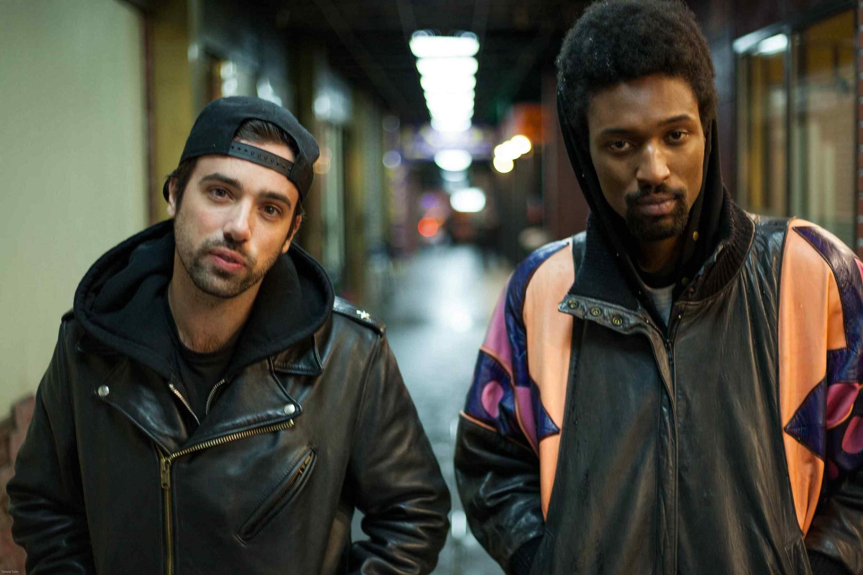

Lower East Side dance staples The Knocks announce the release of their forthcoming So Classic EP arriving April 7th via Big Beat/Neon Gold. The EP was executive produced by Mike Del Rio whose project POWERS appears and co-writes on Classic. GLEE star Alex Newell also appears, as well as the duos own JPatt taking the lead on “Dancing With Myself,” which is celebrated with a music video streaming on PAPER MAG.

“Dancing With Myself” – co-produced by Mike Del Rio – is a sultry slow-jam with tasteful disco riffs added in. The video, which was directed and produced by Tyler Richardson, Jameson Rich, and Kevin Tkach, follows the duo through NYC’s Chinatown and features some pretty amazing synchronized choreography from passers-by!

The Knocks has built an impressive resume of legendary remixes and original material over the past seven years, all of which is reminiscent of the golden years of vocal house and credible pop music. The duo has also been hailed by the NME in their “20 hottest producers in music,” and The Guardian has called them “cred-pop’s answer to the Neptunes.”

JPatt’s background in soul and funk and B-Roc’s years spent immersed in trip-hop and hip-hop beats built the duos sound. The two initially gained recognition for their remixes for artists including Haim, Santigold, Foster The People, Two Door Cinema, Ellie Goulding, Passion Pit and The 1975, but eventually found themselves experimenting with sounds of their own.

Their debut Big Beat/Neon Gold LP is slated for a spring 2015 release, and is preceded by their recent single “Classic” (stream), which features the fast-rising West Coast duo POWERS.

So Classic EP tracklisting:
1. Dancing With Myself
2. Time
3. Classic (feat. POWERS)
4. Collect My Love (feat. Alex Newell)
5. Classic (POWERS Sunset Version)

Dancing With Myself Tour Dates: (FLYER | DATES)
3.18 - Austin, TX - 78 Rainey (SXSW)
3.21 - Austin, TX - Empire Garage (SXSW)
5.24 - Quincy, WA - Sasquatch
5.26 - Portland, OR - Doug Fir
5.28 - San Francisco, CA - The Independent
5.29 - Los Angeles, CA – Echoplex (FLYER)
5.31 - San Diego, CA - Casbah

Connect with The Knocks:
https://www.facebook.com/theknocksnyc
https://soundcloud.com/theknocks
https://twitter.com/theknocks
http://theknocks.com

For all press assets, please visit: http://press.wearebigbeat.com/artists/the-knocks/

Press Contacts:
National: Jordan.Frazes@atlanticrecords.com
Tour: Jill.Segal@atlanticrecords.com

