THE KNOCKS and GREAT GOOD FINE OK TEAM UP
FOR UNDENIABLE NEW SINGLE “LUCKY ME”

LISTEN HERE: https://BigBeat.lnk.to/LuckyMePR

OUT TODAY VIA BIG BEAT/NEON GOLD/ATLANTIC RECORDS!

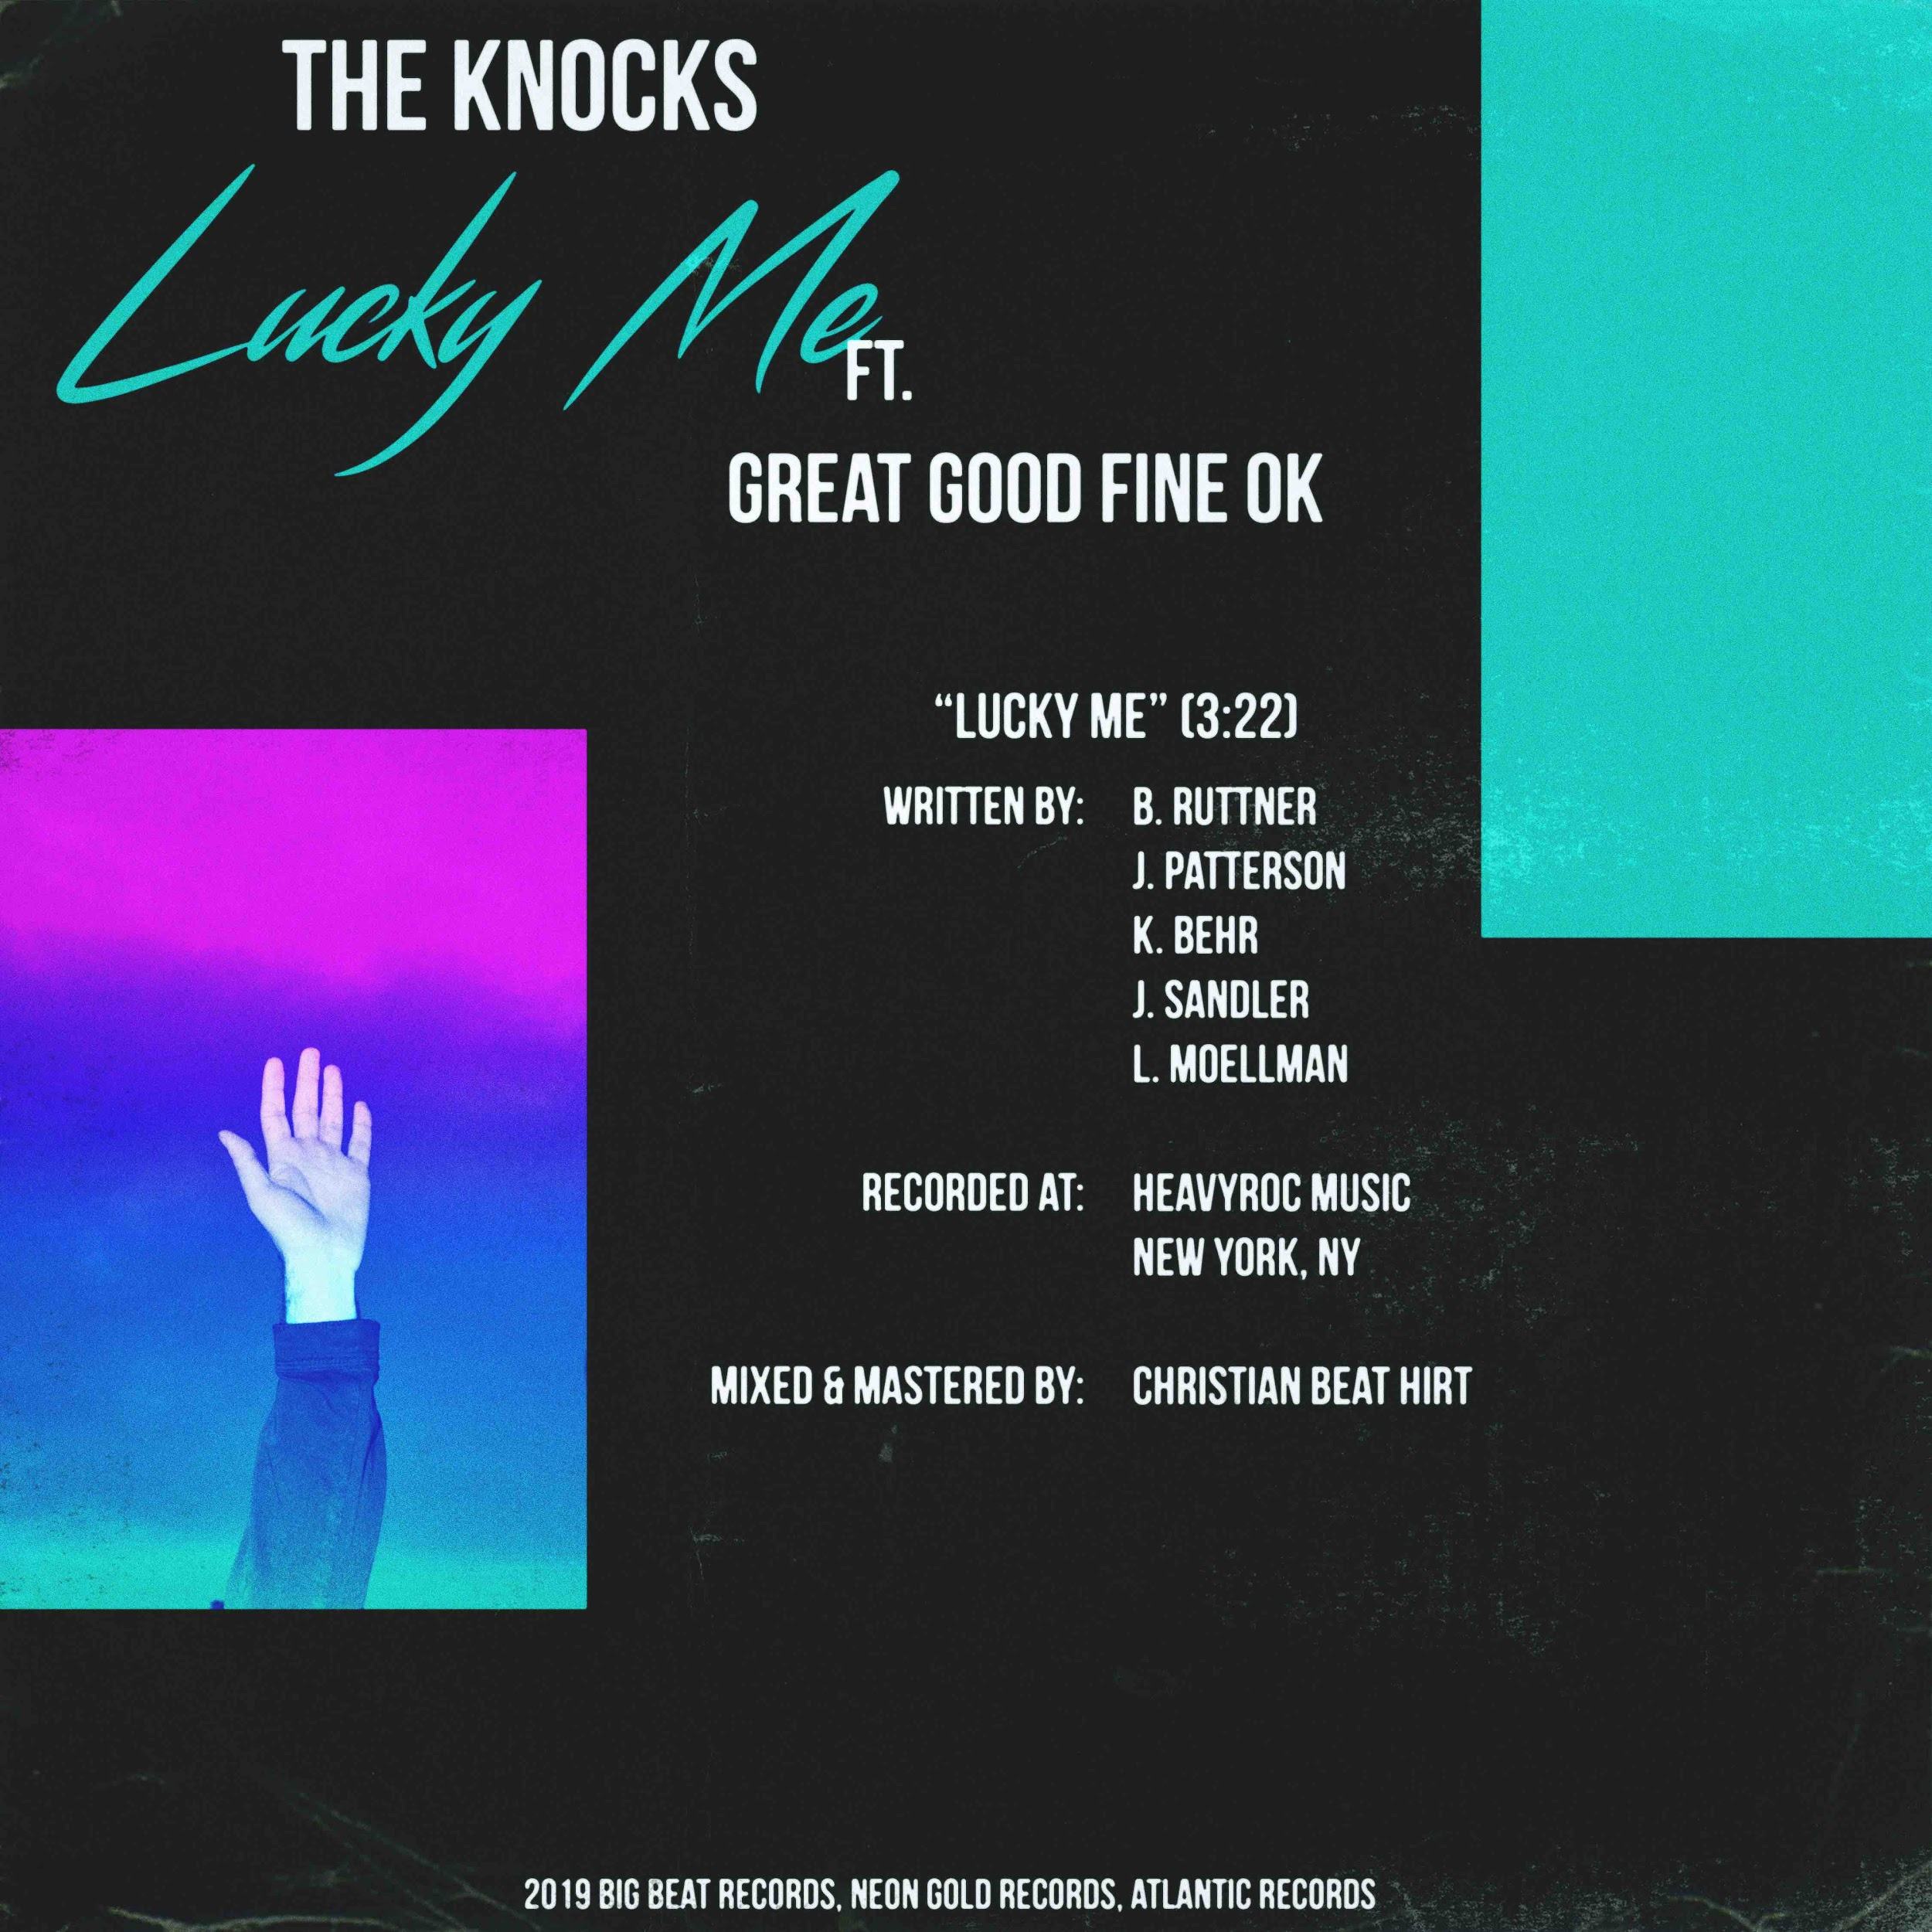

Everyone’s favorite prolific production duo, The Knocks, have been on quite a roll in 2019 and even with just about six weeks left in the year, are showing no sign of slowing down anytime soon. Today sees the release of yet another undeniable single, in the form of a high-profile collaboration called “Lucky Me” with Brooklyn’s critically-acclaimed electro-pop duo Great Good Fine Ok. Featuring The Knocks’ signature electronic-leaning, disco-house fusion of production that we’ve all come to know and love, the breezy pop single also features Great Good Fine Ok’s Jon Sandler’s smooth vocals that truly complete the track - LISTEN HERE!

The Knocks have been churning out house banger after house banger this year, including “New York Luau,” “No Requests,” “Colors,” and “Summer Luv” (with Whethan, feat. Crystal Fighters). They’re also fresh off releasing their massive collaboration with Kah-Lo called “Awa Ni” that was recently featured on the FIFA ‘20 soundtrack, and in case there was any doubt that The Knocks are the hardest working artists in the game, they’re now gearing up to support Gryffin for a massive 30-date tour, which sees them traversing the entire US in just over a month.

Great Good Fine Ok just returned from a sold-out tour of Asia, which included stops in China, Singapore, Jakarta and Hong Kong. With recent features in Billboard, Earmilk, Variance, Atwood Magazine, and Substream Mag along with having collaborated with everyone from The Chainsmokers to St. Lucia, GGFO are in-demand studio musicians and songwriters with over 100 million global streams to date and counting (their latest single “GGFOUR” accounting for 20 million of those streams alone!).

Together for over a decade, The Knocks’ stock has been on the rise since the release of their debut album 55. Their second album, New York Narcotic, has been celebrated for the duo’s ability to continually bridge sonic barriers, salute multiple genres, and seamlessly fuse electronic, alternative and urban music. The album includes their smash single “Ride or Die” ft. Foster the People which has garnered over 67 Million streams, hitting #1 on iTunes Dance chart, 22+ weeks on Billboard Dance chart and 20 weeks on the Billboard Alternative chart. They’ve also collaborated with the likes of Whethan, Sofi Tukker, Big Boi, Method Man, X Ambassadors, Carly Rae Jepsen and more, while amassing over 125 million streams to date. Given their innate ear for churning out irrefutable hits, together with Great Good Fine Ok, “Lucky Me” is destined to shoot up the charts.

CONNECT WITH THE KNOCKS:
Instagram | Facebook | Twitter | Spotify

PRESS ASSETS: http://press.wearebigbeat.com/artists/the-knocks/

PRESS INQUIRIES:
Paige Rosoff - Big Beat/Atlantic Records
Paige.Rosoff@atlanticrecords.com

