THE KNOCKS SHARE NEW “TROUBLE” OFFICIAL MUSIC VIDEO/REMIX EP! PLUS, CATCH THEM ON ‘FEEL GOOD FEEL GREAT’ TOUR!

WATCH “TROUBLE”: https://www.youtube.com/watch?v=YISir6xJnFw
BUY / STREAM “TROUBLE” REMIX EP: https://BigBeat.lnk.to/TroubleRmxPR

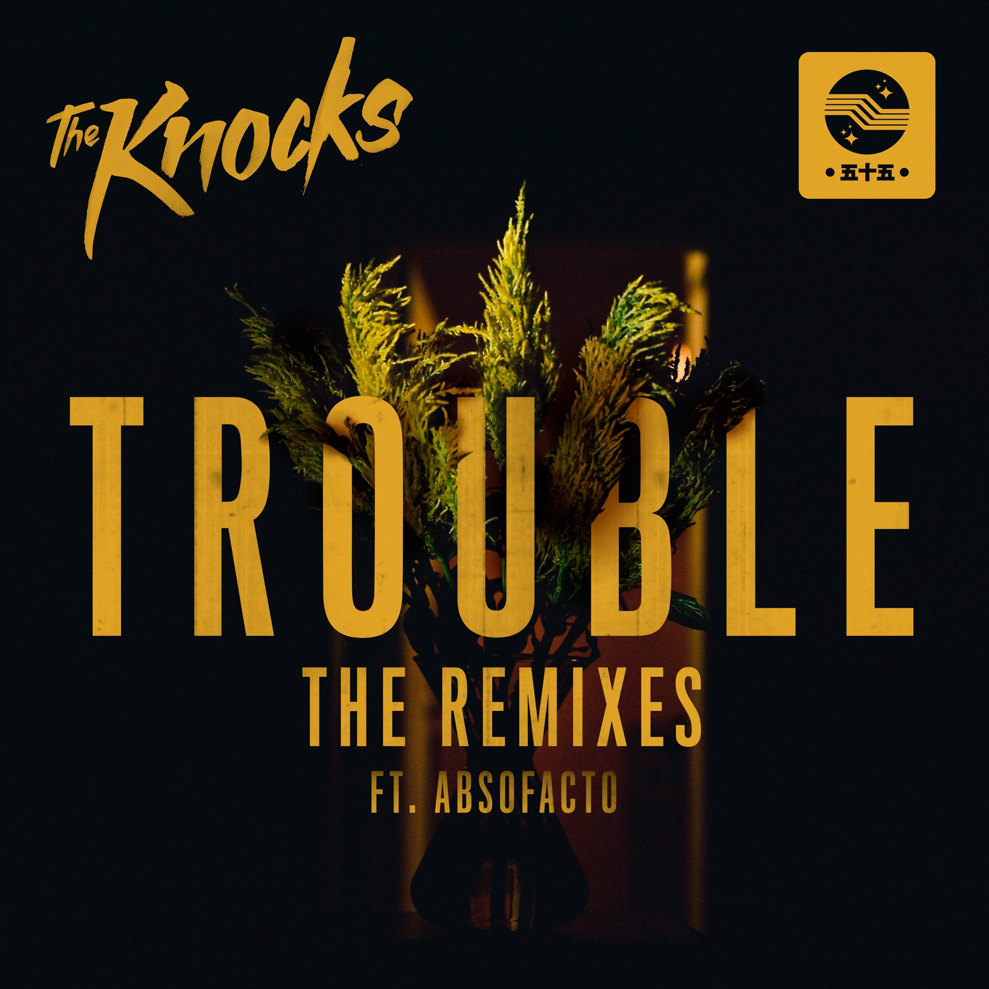

The Knocks stay true to form with an already-prolific 2017, which has seen the release of a new Testify EP out now via Neon Gold/Big Beat Records. The New York City-based duo returns with the official music video for their single, “TROUBLE” feat. Absofacto – an endearing story which stars Kyle Pacek (“Guardians of the Galaxy”) and David Child (“Live Hold On”) forming an unlikely interspecies friendship, and shines a positive light on the topic of mental health – WATCH HERE. Also out today, a remix EP for their single, including reworks from the disco/house producer Treasure Fingers, London’s Mr. Sanka, and fellow New York producers NotNo – LISTEN HERE!

“When we made this song, we kept envisioning a concept for a video that involved an alien singing the lyrics to someone to help them or give them advice – like a weird guardian angel. We had been trying to do a video with [director] Kevin Eis for a while and knew he'd be perfect for this concept. After spit-balling ideas back and forth for a while, we landed on this narrative and couldn't be happier with the result.” -- The Knocks

“The video playfully captures the feeling of the song, coming out of a dark place, but trying to dance your way back into the light.” -- Absofacto

"The concept behind the video definitely has to do with mental health. Ben and I were throwing around ideas and we wanted a topic that was simple, funny, but also had something to say…perhaps this video will open a discussion. Especially now, when everyone in the country feels like they’re losing their mind, it seemed appropriate. The main character in the video suffers from agoraphobia and has a fear of leaving his apartment. Much like the character, I myself suffer from that disorder. We actually shot the entire thing in my apartment where I wrote and produced the video, which was rather fitting because I never had to leave. There's a stigma surrounding mental health. People are afraid to talk about it, admit they have a problem, admit they're seeking help, etc. Albeit, I don't have hallucinations of a little alien encouraging me to leave, but this video came from a place extremely heartfelt and real. I hope people can both enjoy and take something valuable out of this." -- Kevin Eis (video director)

The Knocks ‘TROUBLE’ Remix Package:
1. TROUBLE (feat. Absofacto) (Treasure Fingers Party Mix)
2. TROUBLE (feat. Absofacto) (Mr Sanka Remix)
3. TROUBLE (feat. Absofacto) (NotNo Remix)

THE KNOCKS 2017 “FEEL GOOD FEEL GREAT” TOUR:
Buy Tickets: http://smarturl.it/FGFGTour
FRI 10-Mar-17 Urbana, IL - Canopy Club***
SAT 11-Mar-17 Chicago, IL - Concord Music Hall***
TUE 14-Mar-17 Lansing, MI - The Loft***
THU 16-Mar-17 Detroit, MI – Shelter***
FRI 17-Mar-17 Toronto, ON - Velvet Underground***
SAT 18-Mar-17 Montreal, QC - Belmont ***
TUE 21-Mar-17 Portland, ME - Port City Music Hall***
WED 22-Mar-17 Syracuse, NY - Westcott Theater***
THU 23-Mar-17 Boston, MA - Royale Boston***
FRI 24-Mar-17 New Haven, CT - Toad's Place***
SAT 25-Mar-17 New York, NY - Terminal 5***
*support from Mark Johns & Skylar Spence
**support from Lophiile, Mark Johns & Skylar Spence
***support from Bipolar Sunshine & Gilligan Moss

More on The Knocks:

The Knocks are a New York story through and through, first meeting at the age of nineteen in a studio at the New School. Ben “B-Roc” Ruttner DJ’d clubs while James “JPatt” Patterson played the organ at a church outside the city. In 2008, JPatt and B-Roc took out a loan and opened the HeavyRoc studio at 55 Chrystie, in the same broken-down building where the Beastie Boys used to rehearse. The Knocks have already become synonymous with warm, retro-future, disco production, and with the “TESTIFY” EP and their new single “Trouble,” the duo certainly aim to expand on that, taking their craft to the next level.

2016 was a breakout year for The Knocks, which saw them selling out headlining shows, supporting the European leg of Justin Bieber’s “Purpose” tour, and delivering critically acclaimed performances. The duo is now in the midst of their current Feel Good Feel Great tour, which includes support from a slew of their friends, including Bipolar Sunshine, Mark Johns, Skylar Spence, Lophiile, and Gilligan Moss. The Knocks also cut their teeth performing huge festival dates including Bonnaroo (which made Billboard’s Best of Bonnaroo 2016 list), Governors Ball (which made Rolling Stone’s 15 Best Things We Saw list and Fuse’s Top 10 Best Performances of Governors Ball), and Outside Lands. The Knocks have previously supported The 1975, Ellie Goulding, Bruno Mars, Sleigh Bells and DJ Shadow.

“dance-pop masterminds" – SPIN

“The Knocks are pushing boundaries and catapulting us into the future.” –Billboard

Connect with The Knocks:
https://www.facebook.com/theknocksnyc
https://soundcloud.com/theknocks
https://twitter.com/theknocks
https://instagram.com/the_knocks
http://theknocks.com
Press assets: http://press.wearebigbeat.com/artists/the-knocks/

For press inquiries:

Jordan Danielle Frazes / Head of Publicity, Big Beat Records / Jordan.Frazes@atlanticrecords.com
Ilana Gold / Tour Requests / Ilana.gold@atlanticrecords.com

