WITH A EUROPEAN JUSTIN BIEBER TOUR HALFWAY THROUGH,
The Knocks HEAT THINGS UP WITH 2017 North American “Feel Good Feel Great” tour ANNOUNCEMENT + NEW MANILA KILLA REMIX/TOUR DIARY!

WATCH: https://youtu.be/5k4laZwckYA
BUY/STREAM REMIX: https://BigBeat.lnk.to/HEATMKRmxPR
BUY TICKETS: http://smarturl.it/FGFGTour

"genre-shifting, versatile electronic duo" – V Magazine

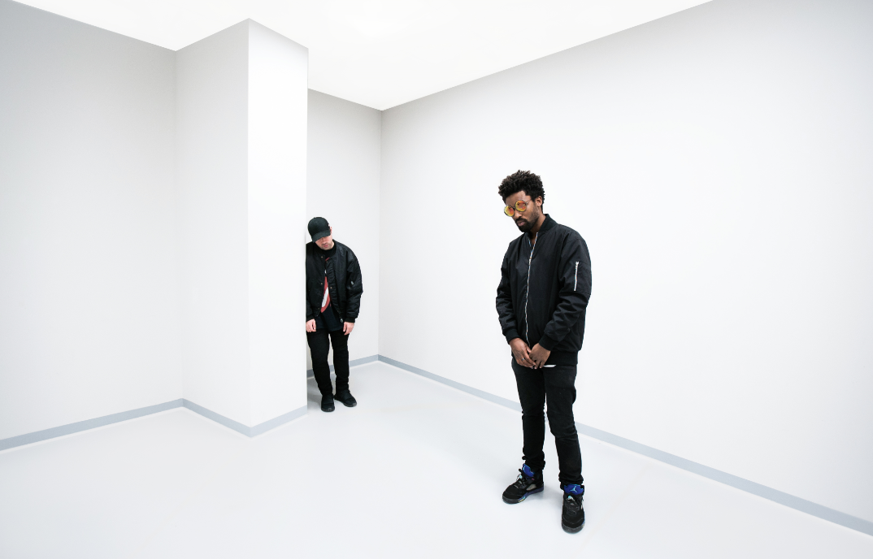
(credit: Dusty Kessler – high res)

Fresh off releasing the new smashing single, “HEAT” (feat. Sam Nelson Harris), New York based electronic duo The Knocks (who are known for their critically-acclaimed sold-out live shows) announce a massive 2017 North American “Feel Good Feel Great” tour. The Knocks have curated a support lineup that boasts a diverse mix of "who's next" in electronic and dance music, including Manchester, UK multi-platinum recording artist and DJ Snake-collaborator Bipolar Sunshine, left-field house music production duo Gilligan Moss, LA based DJ Lophiile, OWSLA signee Mark Johns, and the continuation of Ryan DeRobertis’ Saint Pepsi project Skylar Spence. To celebrate the occasion, The Knocks also shared a visually-stunning tour diary; set to Manila Killa’s wavy, ethereal remix of their new single, “HEAT” (LINK). The video masterfully splices together live and candid cinematic footage from The Knocks on the road during recent sold-out international tour supporting Justin Bieber on the European leg of his “Purpose” tour, making for a compelling tour diary to get fans excited for what’s to come. Manila Killa’s remix is available worldwide today via Big Beat Records. The Knocks have most recently toured with global sensations Ellie Goulding and The 1975, on top of huge festival dates and sold-out headlining shows worldwide.

The genre-defying duo’s fiery, futuristic electronic burner with R&B influences “HEAT” is the first original work by The Knocks since their debut full-length effort ‘55’, released earlier this year. ‘55’ was a triumph, and a resolutely DIY dance album that pulses with the heart of the city. The album features a star-studded cast; a diverse list of musical styles and artistic approaches, from New York’s hip hop legend Cam’ron to pop-sensation Carly Rae Jepsen. The album twists and turns with unexpected guests and genre-bending flavor, featuring contributions from artists like GRAMMY-winner Wyclef Jean, to Fetty Wap, and Walk The Moon, each of which provide an unparalleled gusto best described by NOISEY as “bombastic, funk-finagled, and fun.”

With more new music on the way, executive producers on Wyclef Jean’s new LP, and a slew of A-list festivals and support tours under their belt, 2017 brings high-hopes to the Lower East Side DJ/producer juggernauts. As The Huffington Post most aptly put it... “The Knocks are one of the best bets for what’s next in pop music, as their eventual ascension to stardom is all but secured.”

THE KNOCKS 2017 “FEEL GOOD FEEL GREAT” TOUR:
FRI 03-Feb-17 Vancouver, BC - Fortune Sound Club*
SAT 04-Feb-17 Seattle, WA - Neptune*
MON 06-Feb-17 Portland, OR - Wonder Ballroom*
WED 08-Feb-17 San Luis Obispo, CA - The Graduate*
THU 09-Feb-17 San Francisco, CA - The Fillmore**
SAT 11-Feb-17 Los Angeles, CA - Henry Fonda Theatre**
SUN 12-Feb-17 Santa Barbara, CA - SoHo Music Club*
MON 13-Feb-17 Santa Cruz, CA - The Catalyst*
THU 02-Mar-17 Washington, DC - 9:30 Club***
SAT 04-Mar-17 Philadelphia, PA - The Foundry @ The Fillmore Philadelphia** *
FRI 10-Mar-17 Urbana, IL - Canopy Club***
SAT 11-Mar-17 Chicago, IL - Concord Music Hall***
TUE 14-Mar-17 Lansing, MI - The Loft***
THU 16-Mar-17 Detroit, MI – Shelter***
FRI 17-Mar-17 Toronto, ON - Velvet Underground***
SAT 18-Mar-17 Montreal, QC - Belmont ***
TUE 21-Mar-17 Portland, ME - Port City Music Hall***
WED 22-Mar-17 Syracuse, NY - Westcott Theater***
THU 23-Mar-17 Boston, MA - Royale Boston***
FRI 24-Mar-17 New Haven, CT - Toad's Place***
SAT 25-Mar-17 New York, NY - Terminal 5***
*support from Mark Johns & Skylar Spence
**support from Lophiile, Mark Johns & Skylar Spence
***support from Bipolar Sunshine & Gilligan Moss

Connect with The Knocks:
http://www.facebook.com/theknocksnyc
http://www.twitter.com/theknocks
http://www.instagram.com/the_knocks
http://www.theknocks.com
http://www.snapchat.com/add/Theknocks
For all press assets, please visit: http://press.wearebigbeat.com/artists/the-knocks/

For press inquiries:

Jordan Danielle Frazes
Head of Publicity, Big Beat Records
Jordan.Frazes@atlanticrecords.com

Ilana Gold
Ilana.gold@atlanticrecords.com

