THE KNOCKS ‘TESTIFY’ EP OUT TODAY VIA BIG BEAT/NEON GOLD + KICK OFF FEEL GOOD FEEL GREAT TOUR TONIGHT!

STREAM: link
PURCHASE: link

“We started off with just a concept, creating the "can I testify" sampley vocal because we originally thought the idea would turn into the title track. We were on our tour bus in London during the Purpose Tour (Bieber) and started building out the track. From there, we sent it over to Sam Harris to see if he could add some gospel flair. Sam loved it and fleshed out the sampley hook. We then wanted to incorporate R&B vibes in the verses and chorus and sent it over to our boy MNEK who was on his way back to London from LA. He wrote and recorded an amazing topline in a week and we then finished it soon after in NYC. A truly collaborative effort and we think it really captures who The Knocks are.”
—THE KNOCKS

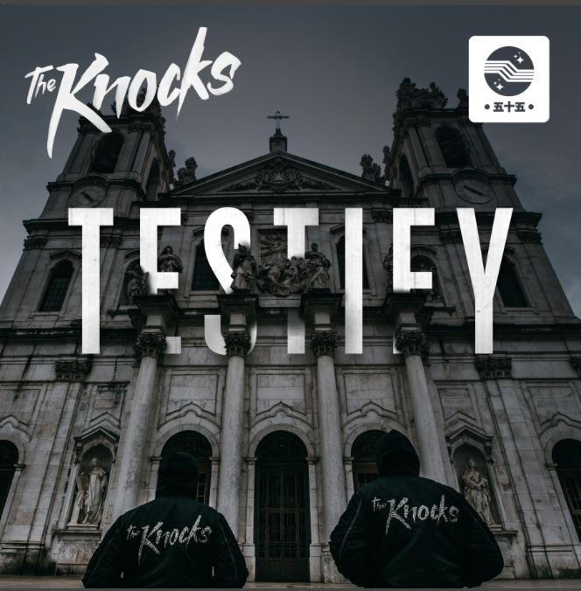

New Single: “Trouble” feat. Absofacto:
WATCH/POST: https://youtu.be/4bIzs18GCB4
STREAM/BUY: https://BigBeat.lnk.to/troublePR

“dance-pop masterminds" –SPIN
“The Knocks are pushing boundaries and catapulting us into the future.” –Billboard

We’re barely a month into 2017, but genre-defying Lower East Side duo The Knocks are already on a roll! The duo is riding high on the success of their newest single “Trouble” (feat. Absofacto), the lead song from their new “TESTIFY” EP which is officially out today through Big Beat/Neon Gold Records. The “TESTIFY” EP sees the production masterminds breaking even more sonic ground, which fans will be able to witness in real life on their current Feel Good Feel Great tour that kicks off tonight in Vancouver.

“TESTIFY”’ opens with “WORSHIP” featuring MNEK, whose breakthrough multi-platinum selling single “Never Forget You” made waves last year. The duo previously shared “HEAT” (feat. Sean Nelson Harris of X Ambassadors) – destined to be a futuristic R&B classic. Up next is “TROUBLE,” which The Knocks say “The idea was to write something that felt melancholy and classic. After we laid down the original idea, he left and we started experimenting with it - treating it like a sample - totally chopping it up and flipping it.” “FEEL LOVE” features an irresistible slow-burn cut that features yearning vocals from rising star Delacey. The hook-laden track “YOUR EYES” features seductive vocals from GRAMMY nominated songwriter, vocalist & actress Tayla Parx. Finally, “LIE,” highlighted by a wall of sound style approach and Jerm (whose songwriting credits include Beyoncé’s Lemonade) on vocals, builds to an epic climax.

“TESTIFY” arrives on the heels of The Knocks’ critically-acclaimed 2016 debut album, ‘55’ (iTunes +Spotify + YouTube + SoundCloud) which featured guest features from Alex Newell, Cam’ron, Carly Rae Jepsen, Fetty Wap, Justin Tranter, Magic Man, Matthew Koma, Phoebe Ryan, POWERS, Walk The Moon, Wyclef Jean, and X Ambassadors.

2016 was a breakout year for The Knocks, which saw them selling out headlining shows, direct support on Justin Bieber’s European leg of his Purpose tour and delivering critically acclaimed performances. The current Feel Good Feel Great tour includes support from a slew of their friends, including Bipolar Sunshine, Mark Johns, Skylar Spence, Lophiile, and Gilligan Moss. The Knocks also cut their teeth performing huge festival dates including Bonnaroo (which made Billboard’s Best of Bonnaroo 2016 list), Governors Ball (which made Rolling Stone’s 15 Best Things We Saw list and Fuse’s Top 10 Best Performances of Governors Ball), and Outside Lands! The Knocks have previously supported The 1975, Ellie Goulding, Bruno Mars, Sleigh Bells and DJ Shadow.

The Knocks are a New York story through & through, first meeting at age 19 in a studio at the New School. Ben “B-Roc” Ruttner DJ’d clubs while James “JPatt” Patterson played the organ at a church outside the city. In 2008, JPatt and B-Roc took out a loan and opened the HeavyRoc studio at 55 Chrystie, in the same broken-down building where the Beastie Boys used to rehearse. The duo’s already become synonymous with warm, retro-future, disco production and their “TESTIFY” EP aims to expand on that, taking The Knocks to the next level.

THE KNOCKS 2017 “FEEL GOOD FEEL GREAT” TOUR:
Buy Tickets: http://smarturl.it/FGFGTour
FRI 03-Feb-17 Vancouver, BC - Fortune Sound Club*
SAT 04-Feb-17 Seattle, WA - Neptune*
MON 06-Feb-17 Portland, OR - Wonder Ballroom*
WED 08-Feb-17 San Luis Obispo, CA - The Graduate*
THU 09-Feb-17 San Francisco, CA - The Fillmore**
SAT 11-Feb-17 Los Angeles, CA - Henry Fonda Theatre**
SUN 12-Feb-17 Santa Barbara, CA - SoHo Music Club*
MON 13-Feb-17 Santa Cruz, CA - The Catalyst*
THU 02-Mar-17 Washington, DC - 9:30 Club***
SAT 04-Mar-17 Philadelphia, PA - The Foundry @ The Fillmore Philadelphia** *
FRI 10-Mar-17 Urbana, IL - Canopy Club***
SAT 11-Mar-17 Chicago, IL - Concord Music Hall***
TUE 14-Mar-17 Lansing, MI - The Loft***
THU 16-Mar-17 Detroit, MI – Shelter***
FRI 17-Mar-17 Toronto, ON - Velvet Underground***
SAT 18-Mar-17 Montreal, QC - Belmont ***
TUE 21-Mar-17 Portland, ME - Port City Music Hall***
WED 22-Mar-17 Syracuse, NY - Westcott Theater***
THU 23-Mar-17 Boston, MA - Royale Boston***
FRI 24-Mar-17 New Haven, CT - Toad's Place***
SAT 25-Mar-17 New York, NY - Terminal 5***
*support from Mark Johns & Skylar Spence
**support from Lophiile, Mark Johns & Skylar Spence
***support from Bipolar Sunshine & Gilligan Moss

The Knocks ‘TESTIFY’ EP arriving Feb 3 via Big Beat/Neon Gold
1) Worship (feat. MNEK) LISTEN HERE
2) Heat (feat. Sam Nelson Harris) LISTEN HERE
3) Trouble (feat. Absofacto) LISTEN HERE
4) Feel Love (feat. Delacey) LISTEN HERE
5) Your Eyes (feat. Tayla Parx) LISTEN HERE
6) Lie (feat. Jerm) LISTEN HERE

Connect with The Knocks:
https://www.facebook.com/theknocksnyc
https://soundcloud.com/theknocks
https://twitter.com/theknocks
https://instagram.com/the_knocks
http://theknocks.com

Press assets: http://press.wearebigbeat.com/artists/the-knocks/

For press inquiries:

Jordan Danielle Frazes
Head of Publicity, Big Beat Records
Jordan.Frazes@atlanticrecords.com

Ilana Gold (tour requests)
Ilana.gold@atlanticrecords.com

