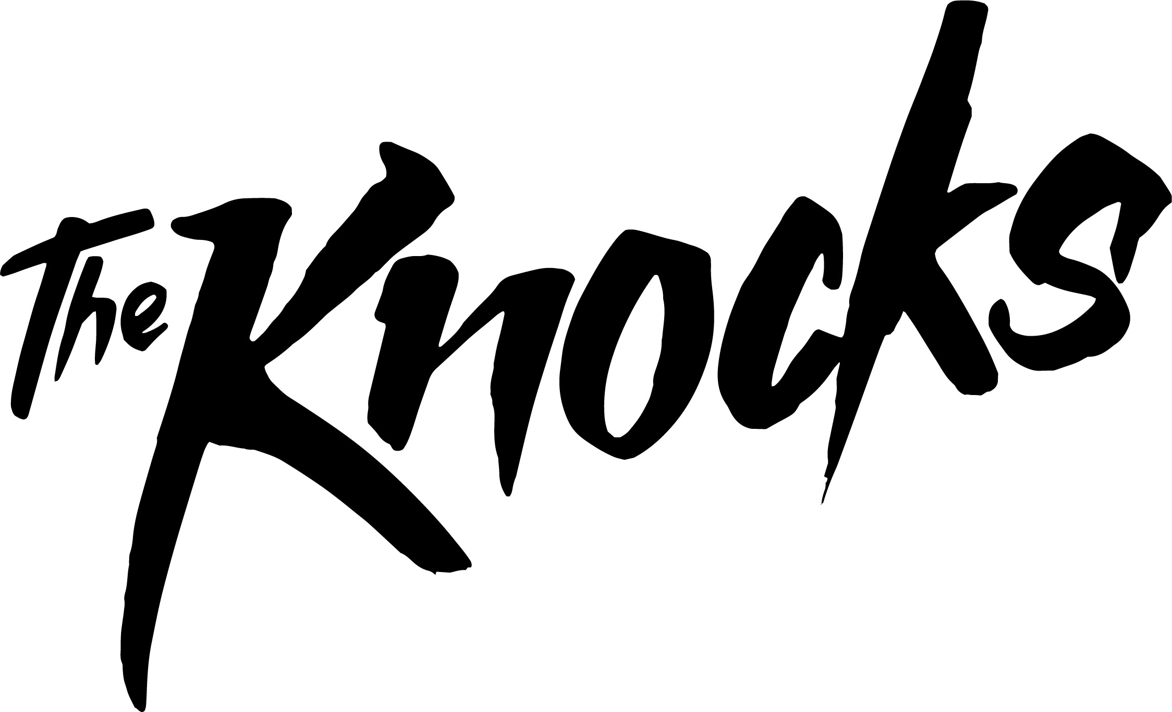
Listen to the new Sunrise Club Edit & Sunset Version of The Knocks’ groovin’ summer single, “Classic” ft Powers, available now via all DSPs via Big Beat/Neon Gold.

Plus, check out the incredibly nostalgic Sunset Version visual!

Watch/Post: http://youtu.be/rPhhPiqIO6c
PURCHASE: http://smarturl.it/ClassicRemixes

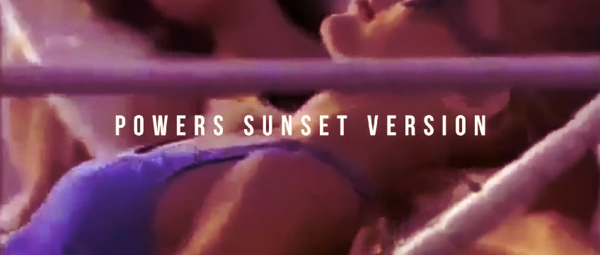

“Everything is old-timey and idealistic (hence the name of the song), painting the world to seem flawlessly glamorous and beautiful in the summer sun. Lana Del Rey is sitting in a hotel room somewhere, chain-smoking cigarettes while wishing she could teleport herself into this video.”--Noisey

SOUNDCLOUD: POWERS SUNSET VERSION & THE KNOCKS SUNRISE CLUB EDIT

SPOTIFY: http://smarturl.it/StreamClassic

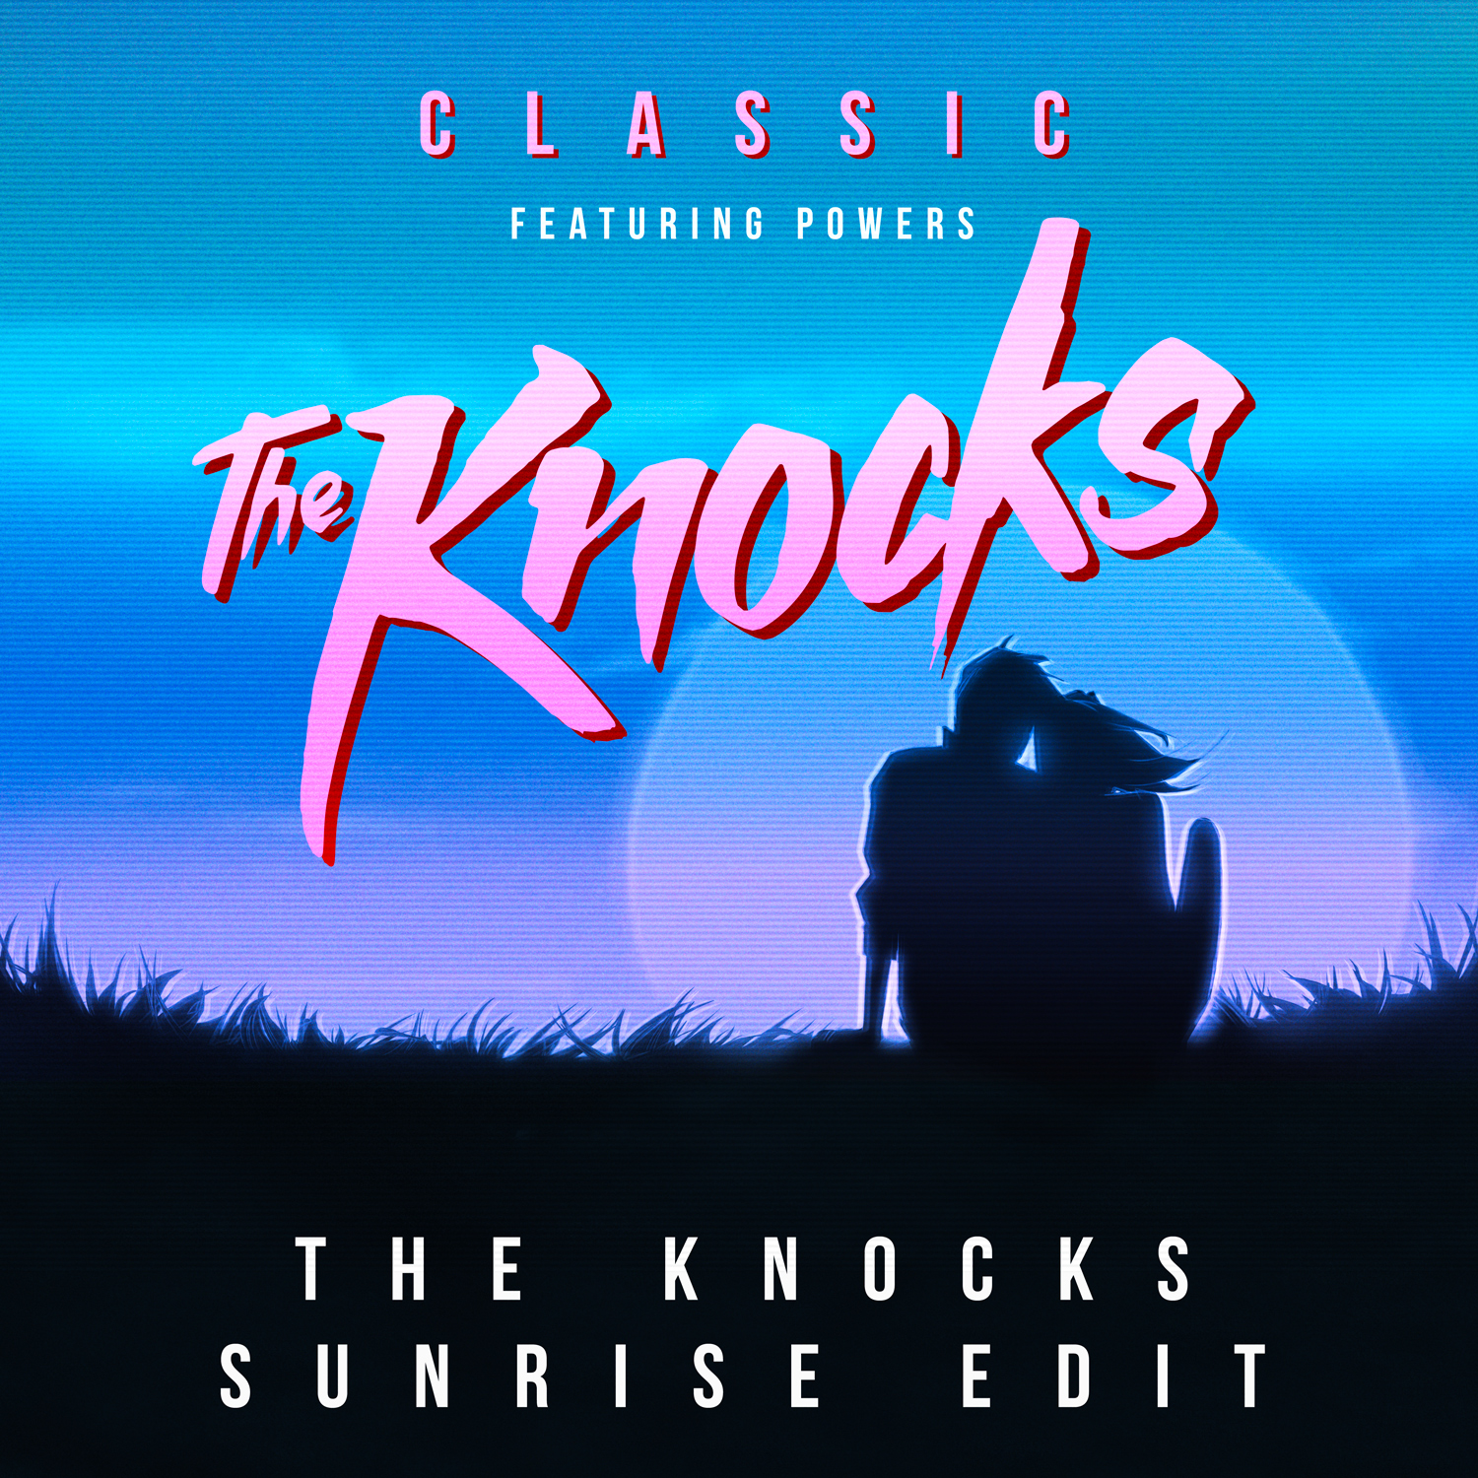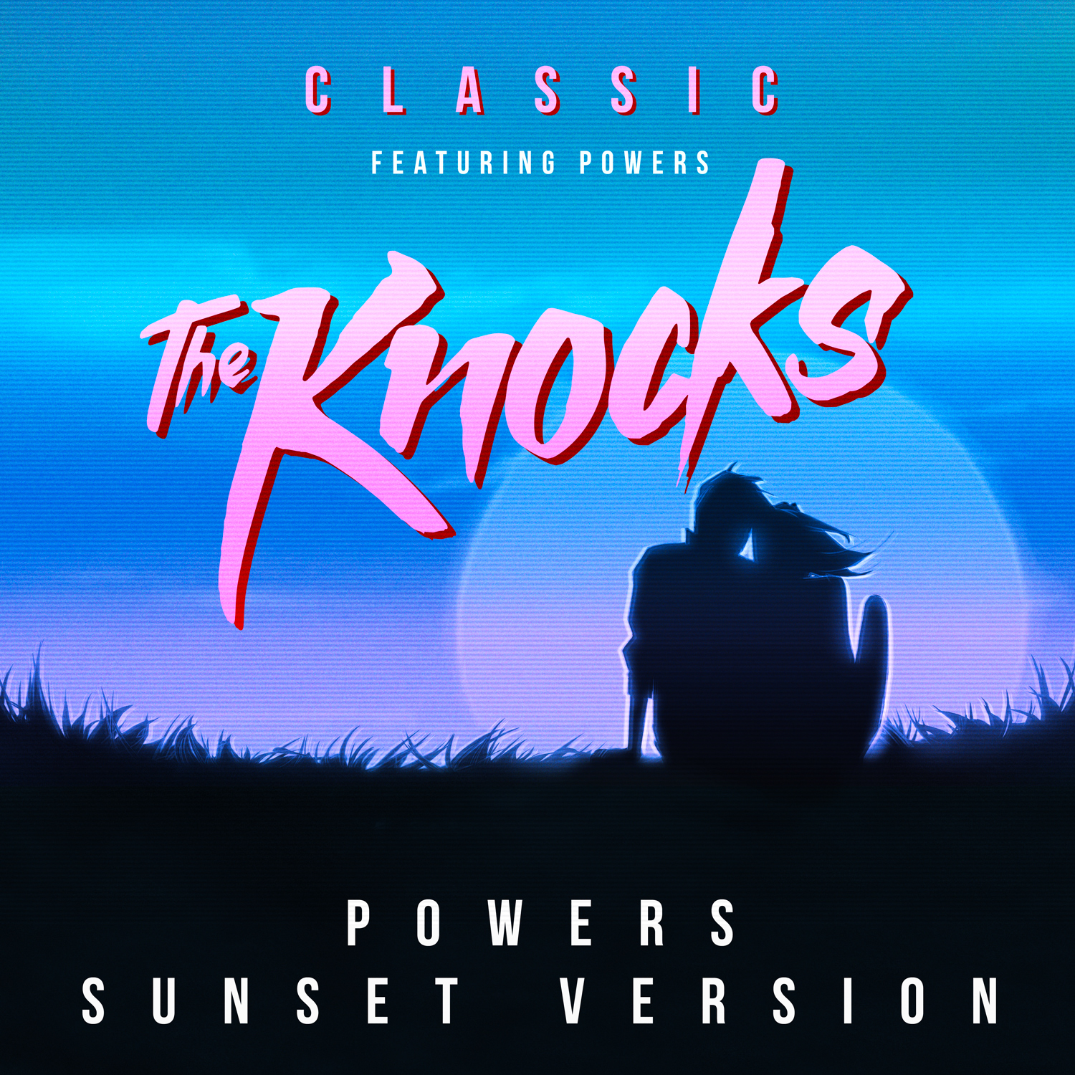

Declared by the NME as one of the “20 hottest producers in music” as “cred-pop’s answer to the Neptunes” by The Guardian – LES/NYC-rooted bedroom producers, The Knocks are now one of the most buzzed-about electronic acts. JPatt’s background in soul and funk and B-Roc’s years spent immersed in trip-hop and hip-hop beats has allowed them to quickly ascend the production ranks. Jet-setting around the globe for DJ gigs, the duo have shared stages with RAC, St. Lucia, Grouplove, M.I.A., Ellie Goulding, Two Door Cinema Club, Chromeo—while receiving recognition for their reworks on singles from Haim, Santigold, Foster the People, Two Door Cinema, Ellie Goulding, Passion Pit and The 1975.

“It's a straight up summer smash, the kind of dance track that hangs in an era-less vacuum; the kind of tune makes you feel like you're in a movie montage, that begins in the hazy magic hour and splices together every amazing moment till dawn.”
– VICE’s NOISEY

Dance duo the Knocks have already proven that they have the chops to deliver a seriously bright summer banger, and now they repeat the feat. – SPIN

Don’t miss The Knocks on tour!
KEY: Supporting St. Lucia * | Supporting RAC +
November 5th – Denver, CO - Gothic Theatre +
November 7th – Seattle, WA - The Crocodile +
November 8th – Seattle, WA - The Crocodile +
November 9th - Bellingham, WA - Wild Buffalo House of Music +
November 10th – Vancouver, BC - Commodore Ballroom +
November 11th - Portland, OR - Wonder Ballroom +
November 13th - Los Angeles, CA - The Fonda Theatre +
November 14th – Los Angeles, CA - The Fonda Theatre +
November 15th – San Francisco, CA - The Warfield +
November 17th - Montreal, QC - Virgin Mobile Corona Theatre *
November 20th - Boston, MA - Royale Nightclub *
November 22nd - New York, NY - Terminal 5 *
November 24th - Philadelphia, PA - Theatre of The Living Arts *
November 25th - Washington, DC - 9:30 Club *
November 26th - Washington, DC - 9:30 Club *

Connect:
Facebook | Twitter

Press tools:
http://press.wearebigbeat.com/artists/the-knocks/

Contact:
Jordan.Frazes@atlanticrecords.com (National)
Jill.Segal@atlanticrecords.com (Tour)



