THE KNOCKS RELEASE VIDEO FOR “SOUND THE ALARM” FT RIVERS CUOMO OF WEEZER & ROYAL & THE SERPENT

WATCH HERE

OUT TODAY VIA BIG BEAT RECORDS

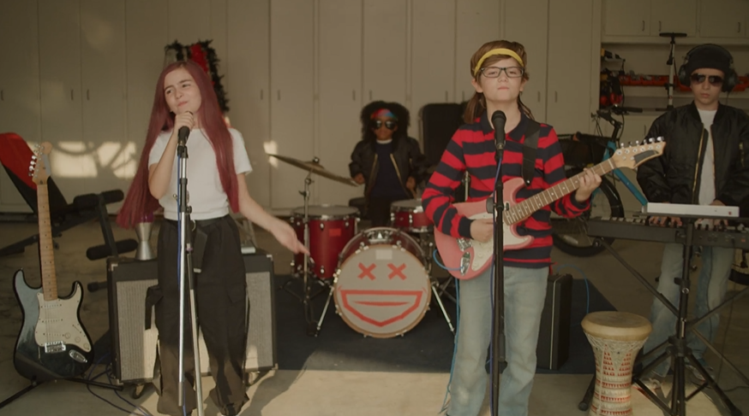

The Knocks release the official music video for “Sound The Alarm” featuring Rivers Cuomo of Weezer and Royal & the Serpent of alternative hit “Overwhelmed” today. As a meteor heads towards earth, young Rivers Cuomo, Royal & the Serpent and JPatt and B-Roc of The Knocks stride through
suburban chaos to perform “Sound The Alarm,” garage band style. Watch HERE!

On the collaboration The Knocks say, “We are so honored and thrilled to be collaborating with such talented artists. Both Rivers and Royal brought a unique energy and sound that complimented each other so well. With Sound The Alarm, we wanted to capture the feeling of letting go and the freedom that it provides. The production is rooted in electronic music, but it was a fun challenge to find the balance between both of their musical styles and ours and create something new that is uniquely all of us.”

“I grew up listening to Weezer as a kid, says Ben Ruttner of The Knocks, and one of our early gigs as The Knocks in 2012 was playing the Weezer cruise, so it’s been surreal to have this all come full circle.”

“Sound The Alarm” follows The Knocks’ last singles “R U High” ft Australian breakthrough talent Mallrat, “Bedroom Eyes,” a collaboration with international electro-pop group Studio Killers of viral global hit “Jenny,” “All About You” featuring Alternative mainstays Foster The People, and “Bodies” with electro-pop band MUNA. The Knocks also worked with Foster The People on the Melody & Silence mixtape, released in March of this year, which got the attention of Stereogum, Under The Radar, NME, and more.

Additionally, “Fireworks,” a 2021 collaboration between The Knocks, Purple Disco Machine and Moss Kena, continues to grow globally with more than 90 million streams to date. The song also achieved Top 20 global airplay chart placement and the #1 spot on APC charts in Italy and Germany.

The prolific multi-platinum selling NYC dance music luminaries The Knocks deliver a carefree electronic sound that draws from soul, funk, disco, hip hop, house, and pop. Comprised of James Patterson and Ben Ruttner, the duo have been producing a dizzying array of danceable New York inspired music for a decade now, bringing their DJ sets and live performances all over the world alongside pop superstars such as The 1975, Justin Bieber, and Ellie Goulding among others.

They have released 2 full length albums [55, New York Narcotic], 5 EP's, and performed their hit singles 'Ride or Die', 'Best Friend', and 'Bodies' on US late night TV shows including Stephen Colbert, Jimmy Fallon, Jimmy Kimmel, and Seth Meyers. The Knocks’ “Ride or Die” and "All About You,” both featuring Foster the People, reached #11 and #14 respectively on the US alt radio chart. In addition, their collaboration with Sofi Tukker "Best Friend" has accumulated more than 200 million streams across platforms to date. Known for their collaborative prowess, The Knocks have worked with artists across the musical spectrum, ranging from indie [Foster The People, MGMT, Will Butler of Arcade Fire], hiphop [Cam'ron, Big Boi, Method Man], dance [Purple Disco Machine, Mat Zo, Sofi Tukker], and pop [Carly Rae Jepsen, MNEK, Charli XCX]. They are currently in the studio producing their 3rd album.

Los Angeles-based Royal & the Serpent made her debut in 2017, earning acclaim for a series of self-released singles such as “MMXX,” “Salvador Dali,” and “Bad Bad Blood”, which was featured in the Season 6 trailer for ABC’s How To Get Away With Murder. She made her Atlantic Records debut in 2020 with “Overwhelmed,” which spent 22 weeks on Billboard’s Alternative Airplay chart. In each piece of music she shares with the world, Royal reveals the wild duality at the heart of her artistry and speaks to the incredible power of embracing your true nature, in all its outrageous complexity. A Gemini to the core, she’s passionate but pensive, sensitive but self-possessed, enigmatic but an open book when it comes to exposing what’s inside her mind. “I definitely feel like I’m two people living in one body, where I can just slip at the drop of dime and become a totally different person,” notes Santiago, who equally identifies as a “sweet sunshine angel” (i.e., the Royal persona) and a “freaky devil maniac” (the Serpent).

CONNECT WITH THE KNOCKS:
Instagram | Facebook | Twitter | Spotify

Press Assets: http://press.wearebigbeat.com/artists/the-knocks/

Press inquiries:
Paige.Rosoff@atlanticrecords.com
Big Beat Records | Atlantic Records

