THE KNOCKS EMBRACE THE SUMMER HEAT WITH
“SHADES”
NEW TRACK OUT TODAY VIA NEON GOLD/BIG BEAT
FORTHCOMING LP New York Narcotic ARRIVES THIS FALL
WATCH/POST: https://youtu.be/6H8pDUykox0
BUY/STREAM: https://bigbeat.lnk.to/ShadesPR

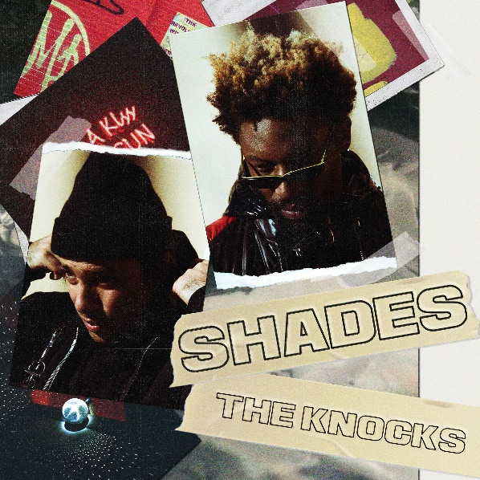
Hit-making New York City electronic duo The Knocks will not let the summer heat slow them down. Fresh off a brilliant “Ride or Die” ft. Foster The People music video release which stars both acts, alongside a cameo from VENOM’s star Scott Haze, and hilariously parodies several cult classic movies; The Knocks deliver a new track today, “Shades”, fusing elements of soul and funk with horn samples set against the duo’s signature, seemingly effortlessly-cool production. “Shades” is yet another can’t miss track from The Knocks, the third from their forthcoming sophomore album, New York Narcotic, due out this fall- officially out today through Neon Gold/Big Beat Records – alongside a lyric video highlighting both B-Roc and JPatt (also on vocals) sporting an eclectic mix of cool shades – WATCH HERE!
“Ride or Die” continues to climb the charts, hitting #1 on the iTunes Electronic Chart and HypeMachine Chart, top 20 on the Spotify Viral Charts, and has quickly risen into the top 40 on Billboard’s Dance Chart and Alternative Chart and as well as top 30 on US radio’s Alternative Charts.
The Knocks are also in the midst of curating a monthly The Knocks & Friends residency at PUBLIC Arts in New York City which is bringing back the anything-goes Manhattan party-scene. The prodigious duo are also fresh off a string of television performances including The Tonight Show w/ Jimmy Fallon and TRL for their smash collaboration with Sofi Tukker, NERVO, and Alisa Ueno, “Best Friend” – which peaked at #1 on the iTunes Dance, US Dance Radio, Billboard Commercial, Billboard Dance/Mix Show, and Shazam Dance Charts, and also peaking at #3 on the Shazam Worldwide Main Charts, after debuting during Apple’s Keynote address. The track was also prominently featured in advertisements for the iPhone X (watch here).
Connect with The Knocks:
https://www.facebook.com/theknocksnyc
https://soundcloud.com/theknocks
https://twitter.com/theknocks
https://instagram.com/the_knocks
http://theknocks.com

Press inquiries:
Jordan Danielle Frazes
Head of Publicity, Big Beat Records
Jordan.Frazes@atlanticrecords.com
Press assets: http://press.wearebigbeat.com/artists/the-knocks/

