THE KNOCKS SAY GOODBYE TO SUMMER WITH “RIVER,”
FEATURING PARSON JAMES

LISTEN HERE

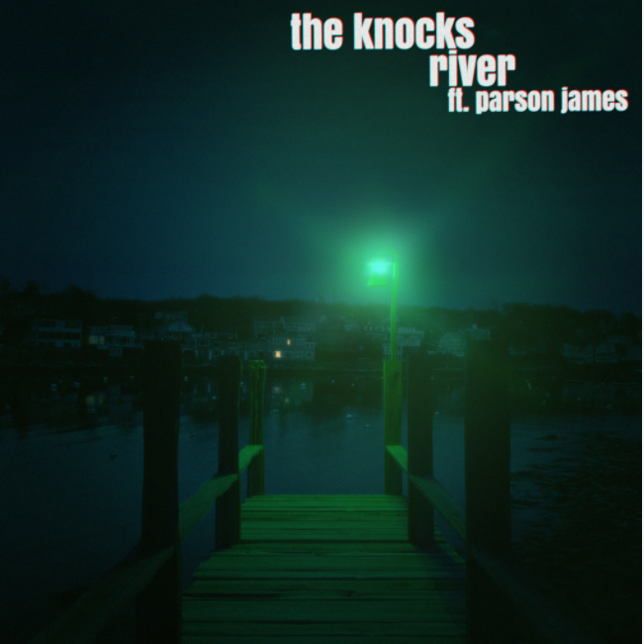
DL photos

New York-based electronic duo mainstay The Knocks release the sentimental single “River” today, featuring platinum-certified singer and songwriter Parson James. Listen HERE!

On the release The Knocks say, "River" is a special one for us. I [Ben] started this while quarantined at my parent's house in the woods during lock down. I was inspired by the environment around me and wanted to create a warm, aurally pleasing track. Initially it was sample-based but having the opportunity to sit with it for several months, the song eventually evolved into something brighter and more energetic. We then sent it over to Parson, who took the lyrics and vocals to a new level. He wrote about an experience he had in a recent relationship and we are grateful to him for sharing such a personal moment in his life. "River" is that. It's a place in time. An ode to the end of summer and a snapshot into the past while hopefully serving as a bridge to the future.”

Parson says, “River” is one of the most exciting records I’ve gotten the pleasure to be a part of. I’ve admired The Knocks and have been friends with Ben for quite some time so to finally get the chance to collaborate is amazing. I originally heard the beginnings of this record earlier this year & I immediately fell in love with it. I had just been through a painful experience during quarantine with a guy who I fell for pretty hard. There were so many complicated elements that led to our situation not working out but when things were good, they were incredible. I had this vivid memory of us during my birthday sitting on the dock at this lake we went to celebrate... something about that moment resonated with me and I felt like I knew it was going to be one of the last times things were good. So, I wanted to savor it. When I heard the River demo all of that rushed right back to me & I immediately started writing the second verse with that experience in mind. This one is super special to me & I’m grateful to the guys for allowing me into their magic.”
“River” continues The Knocks’ roll-out of dance infused singles. Earlier this year, they released "R U HIGH" ft. Australian indie-pop darling Mallrat followed previously by “All About You” featuring alternative mainstays Foster The People, and fan-favorite “Bodies” featuring the electronic pop band Muna. Additionally, The Knocks also released the alternative leaning “Sound The Alarm” featuring Rivers Cuomo of Weezer and Royal & the Serpent and “Bedroom Eyes,” a collaboration with international electro-pop group Studio Killers of viral global hit “Jenny.” To top it off, the duo rejoined forces once again with Foster The People on the Melody & Silence mixtape, released in March of this year, which got the attention of Stereogum, Under The Radar, NME, and more.

Furthermore, “Fireworks,” a 2021 collaboration between The Knocks, Purple Disco Machine and Moss Kena, continues to grow globally with more than 100 million streams to date. The song has achieved platinum status in Italy while also receiving the #1 spot on both Germany's and Italy's APC charts and top 20 GLOBALLY on the airplay charts.

The prolific multi-platinum selling NYC dance music luminaries The Knocks deliver a carefree electronic sound that draws from soul, funk, disco, hip hop, house, and pop. Comprised of James Patterson and Ben Ruttner, the duo have been producing a dizzying array of danceable New York inspired music for a decade now, bringing their DJ sets and live performances all over the world alongside pop superstars such as The 1975, Justin Bieber, and Ellie Goulding among others.

They have released 2 full length albums [55, New York Narcotic], 5 EP's, and performed their hit singles 'Ride or Die', 'Best Friend', and 'Bodies' on US late night TV shows including Stephen Colbert, Jimmy Fallon, Jimmy Kimmel, and Seth Meyers. The Knocks’ “Ride or Die” and "All About You,” both featuring Foster the People, reached #11 and #14 respectively on the US alt radio chart. In addition, their collaboration with Sofi Tukker "Best Friend" has accumulated more than 200 million streams across platforms to date. Known for their collaborative prowess, The Knocks have worked with artists across the musical spectrum, ranging from indie [Foster The People, MGMT, Will Butler of Arcade Fire], hiphop [Cam'ron, Big Boi, Method Man], dance [Purple Disco Machine, Mat Zo, Sofi Tukker], and pop [Carly Rae Jepsen, MNEK, Charli XCX]. They are currently in the studio producing their 3rd album.

CONNECT WITH THE KNOCKS:
Instagram | Facebook | Twitter | Spotify | TikTok

Press Assets: http://press.wearebigbeat.com/artists/the-knocks/

CONNECT WITH PARSON JAMES:
Instagram | Twitter | Spotify | YouTube | TIkTok

Press Assets: https://www.dropbox.com/sh/qf83tif0mq412dt/AAD4vxewFo2lPiLOgaoAw3-va?dl=0

Press inquiries:
Paige.Rosoff@atlanticrecords.com
Big Beat Records | Atlantic Records

