THE KNOCKS PARODY YOUR FAVORITE CULT CLASSICS IN NEW “RIDE OR DIE” FT. FOSTER THE PEOPLE MUSIC VIDEO!

“The video embraces the song’s loose and surreal funk soundtrack with a retro aesthetic and the group’s full, unrestrained commitment to their performances.” – Billboard

LISTEN/POST: https://youtu.be/x_y1riy0WYU
BUY/STREAM: https://BigBeat.lnk.to/rodPR
(Neon Gold/Big Beat Records)

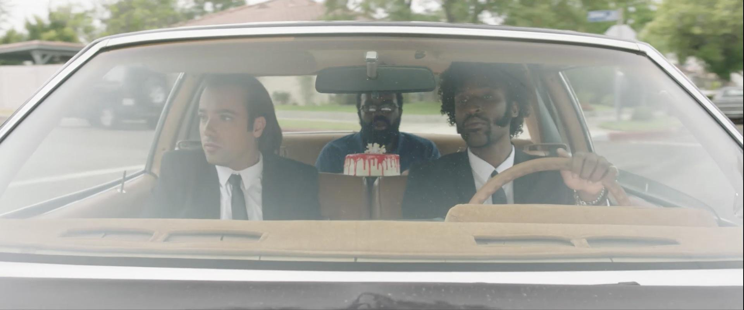

“Writing the song, we wanted to create a warm nostalgic sound that centered around the idea of friendship and celebration. We always knew that Mark was perfect for the song, so when we linked up in the studio, we all immediately knew there was something special there. When our friend Kenny Laubbacher approached us with the idea of shooting a music video based on classic movie duos, that same feeling of specialness was there. Our love for nostalgic movies and referencing classic imagery made it a no brainer... getting freezing cold water sprayed in our face for 5 minutes was just the icing on the cake. And if any NBA teams (The Knicks) are looking for a versatile swingman, JPatt is readily available.”
-THE KNOCKS

“I’d been a fan of The Knocks for a while so when they asked if I wanted to do a song, I jumped to it. Our friend Kenny Laubbacher introduced us last year and everything came full circle with Kenny coming up with this music video concept that paid homage to famous duos from the past. I got to play the weird third wheel guy in each sequence, so naturally I said yes. If you ever need someone to play Burgess Meredith, don’t think, please just call me.”
-FOSTER THE PEOPLE

New York City’s mainstay electronic duo The Knocks delivered their latest collaborative single “Ride Or Die” ft. Foster The People on Neon Gold/Big Beat Records and today, they’re solidifying their song of the summer status with one of the better music videos in recent memory. Directed by Kenny Laubbacher (Tove Lo) and starring B-Roc and JPatt from The Knocks and Foster The People’s Mark Foster, the video also features a cameo from VENOM’s star Scott Haze and hilariously parodies several cult classic movies that the duo hand-picked throughout; White Men Can’t Jump, Pulp Fiction, Rocky and even a little Men In Black cameo… WATCH HERE!

Driven by a bouncy bassline, lush, steady rhythms and the duo’s prodigious production skills, “Ride or Die” also features an effortless hook-laden topline from Foster the People’s Mark Foster – a match made in indie hit-making heaven – LISTEN HERE! The single has garnered over 10 million streams, has reached #1 on iTunes electronic chart, #1 on HypeMachine, and is currently charting on both the Billboard Dance and Billboard Alternative charts. Additionally, “Ride Or Die” is met with two new remixes from Dutch DJ/producer duo Vicetone (listen here) and NYC producer/songwriter Dave Edwards (listen here)!

The duo is also fresh off a string of television performances including The Tonight Show w/ Jimmy Fallon and TRL for their smash collaboration with Sofi Tukker, NERVO, and Alisa Ueno, “Best Friend” – which peaked at #1 on the iTunes Dance, US Dance Radio, Billboard Commercial, Billboard Dance/Mix Show, and Shazam Dance Charts, and also peaking at #3 on the Shazam Worldwide Main Charts, after debuting during Apple’s Keynote address. The track was also prominently featured in advertisements for the iPhone X (watch here). The Knocks are also curating a monthly The Knocks & Friends residency at PUBLIC Arts in New York City which is bringing back the anything-goes Manhattan party-scene.

Connect with The Knocks:

https://www.facebook.com/theknocksnyc
https://soundcloud.com/theknocks
https://twitter.com/theknocks
https://instagram.com/the_knocks
http://theknocks.com

Press inquiries:

Jordan Danielle Frazes
Head of Publicity, Big Beat Records
Jordan.Frazes@atlanticrecords.com
Press assets: http://press.wearebigbeat.com/artists/the-knocks/

