THE KNOCKS ENLIST FOSTER THE PEOPLE ON
“RIDE OR DIE”

LISTEN/POST: https://youtu.be/vKrQEYiAGh4
BUY/STREAM: https://BigBeat.lnk.to/rodPR
(Neon Gold/Big Beat Records)

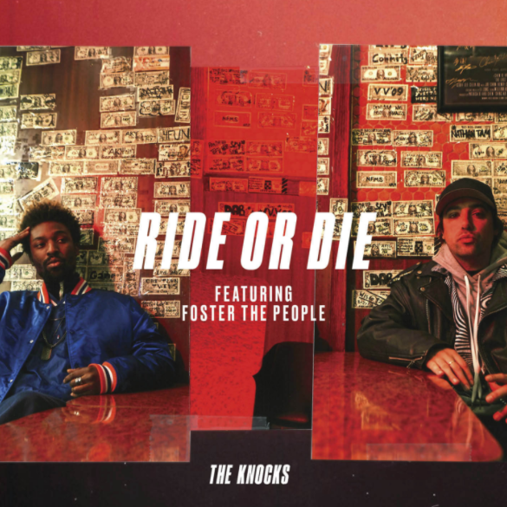

New York City’s favorite electronic duo The Knocks are already vying for “Song of the Summer” status with the release of “Ride or Die” – their new collaborative single with indie-pop greats Foster the People, out today via Neon Gold/Big Beat Records. Driven by a bouncy bassline, lush, steady rhythms and the duo’s prodigious production skills, “Ride or Die” also features an effortless hook-laden topline from Foster the People’s Mark Foster – a match made in indie hit-making heaven – LISTEN HERE!

The Knocks are fresh off a string of television performances including The Tonight Show w/ Jimmy Fallon and TRL for their smash collaboration with Sofi Tukker, NERVO, and Alisa Ueno, “Best Friend” – which peaked at #1 on the iTunes Dance, US Dance Radio, Billboard Commercial, Billboard Dance/Mix Show, and Shazam Dance Charts, and also peaking at #3 on the Shazam Worldwide Main Charts, after debuting during Apple’s Keynote address. The track was also prominently featured in advertisements for the iPhone X (watch here). The lower-east-side duo’s single “House Party” is currently featured in Hollister’s spring ad campaign, which you can check out here. “House Party” capped off an incredibly prolific year for the duo, beginning with the release of their TESTIFY EP in February 2017 (featuring MNEK, Sam Nelson Harris of the X Ambassadors, Absofacto, Delacey, Tayla Parx and JERM). In between, the duo headlined a sold-out North American FEEL GOOD FEEL GREAT headline tour and brought their acclaimed, high-octane live show to the summer festival circuit, with performances at Shaky Beats, Camp Bisco, Kaaboo, ELEMENTS Festival, All Things Go Fall Classic, and more. Stay tuned for more from The Knocks!

Connect with The Knocks:
https://www.facebook.com/theknocksnyc
https://twitter.com/theknocks
https://instagram.com/the_knocks
https://soundcloud.com/theknocks
http://theknocks.com
Press assets: http://press.wearebigbeat.com/artists/the-knocks/

Connect with Foster the People:
https://www.facebook.com/fosterthepeople/
https://twitter.com/fosterthepeople
https://www.instagram.com/fosterthepeople/
https://www.fosterthepeople.com/

FOR PRESS INQUIRIES:

The Knocks:

Jordan Danielle Frazes

Head of Publicity, Big Beat Records

Jordan.Frazes@atlanticrecords.com

Catherine Corkery

Tour Publicist, Big Beat Records

Catherine.Corkery@atlanticrecords.com

Foster The People:

Kelly McWilliam
Senior Director of Publicity, Columbia Records
Kelly.McWilliam@sonymusic.com

