The Knocks release “New York City” (feat. Cam’ron) track off long awaited forthcoming album ‘55’ arriving early 2016 via Big Beat/Neon Gold Records!

LP will feature Alex Newell, Cam’ron, Carly Rae Jepsen, Fetty Wap, Justin Tranter, Magic Man, Matthew Koma, Phoebe Ryan, POWERS, Walk The Moon, Wyclef Jean, and X Ambassadors

Post: “New York City” (feat. Cam’ron) via Stereogum
Stream: iTunes + Spotify + YouTube + SoundCloud

“..a low-key jam, sweeping and surging into something huge without resorting to boilerplate electronic music tropes”--Stereogum

"New York hip-hop has been a quintessential point of inspiration for us throughout our career. Our early aspirations included working with the likes of Cam'ron, so for us, this collaboration is the definition of a dream come true. We feel very blessed to be able to finally share this with the world, and we hope everyone gets as much enjoyment out of listening to it as we do."—The Knocks

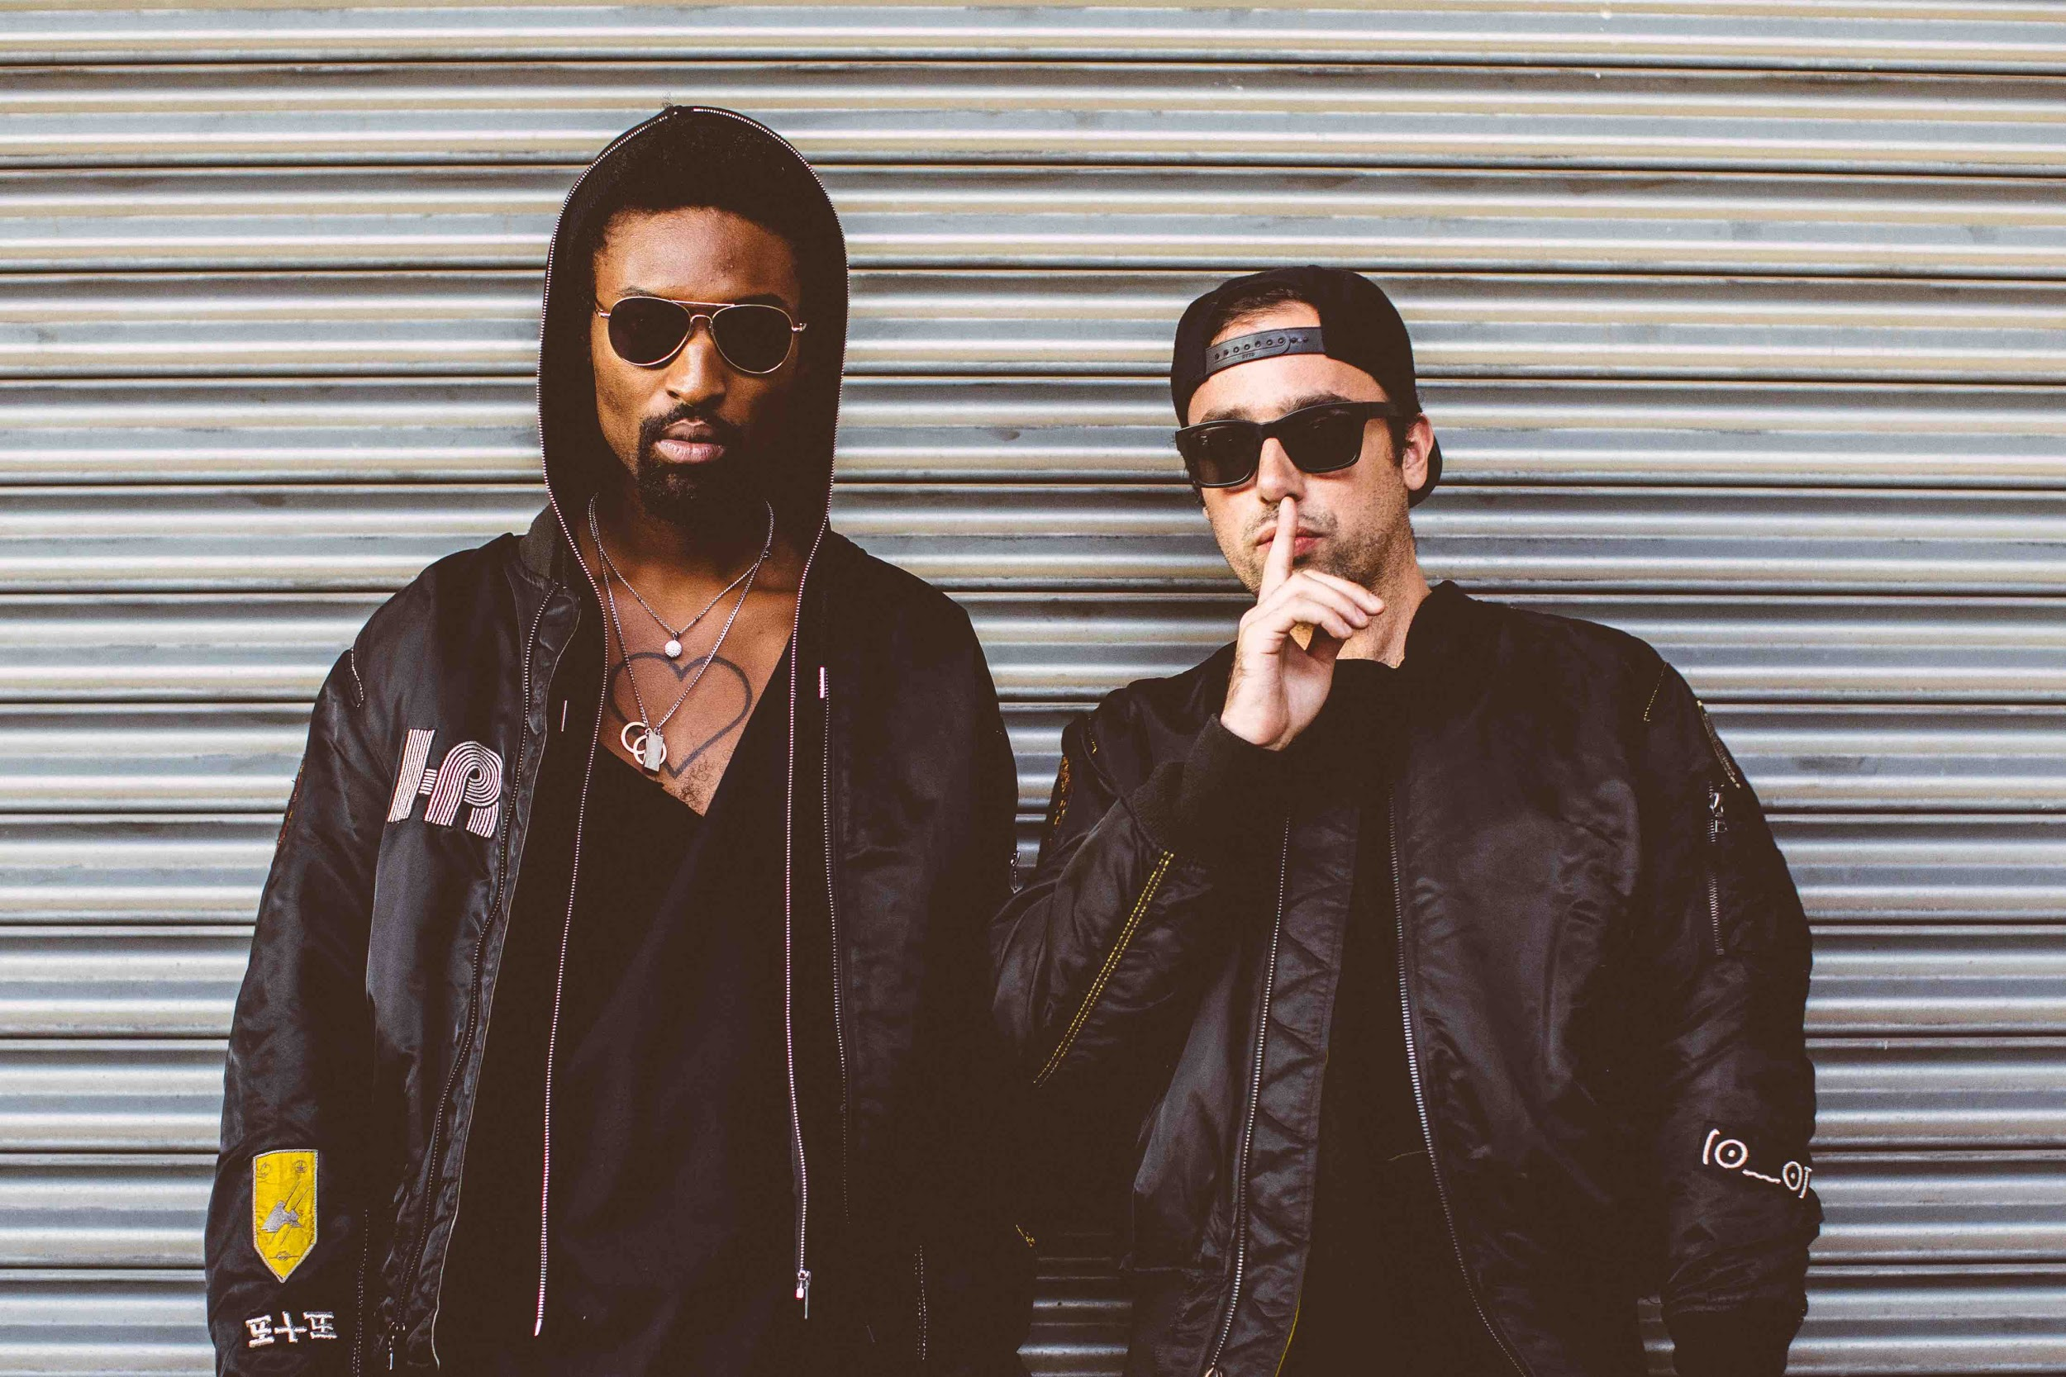
Photo by Rachel Couch

New York City’s finest producers The Knocks recently announced their forthcoming “55” album, which will be arriving in early 2016 and today the duo releases the album opener track “New York City” (feat. Cam’ron) via Big Beat/Neon Gold – (LINK). “55” is laced with nu-disco magic and hip-hop flow –featuring spot-on and electric features including Wyclef Jean, Carly Rae Jepsen, Fetty Wap, POWERS, Matthew Koma, X Ambassadors, Glee’s Alex Newell, Justin Tranter, Magic Man, Phoebe Ryan, as well as Walk The Moon. The LP is a triumph that pulses with the heart of the city, appropriately opening up with none other than Cam’ron, rapping over an uptown piano: gospel voices build in the background, as golden as the light when your plane lands in the outer boroughs, as big as the river when your cab speeds across the bridge. The Knocks celebrate this release with their North American Route 55 Tour, hitting the road in January and February (w/ support from Cardiknox and Sofi Tukker)—see full itinerary below.
***
The Knocks are a New York story through & through, first meeting at age 19 in a studio (at New School). Ben “B-Roc” Ruttner DJed clubs while James “JPatt” Patterson played the organ at a church outside the city. The duo’s already churned out remixes for Katy Perry and Passion Pit (and later reworks for Ellie Goulding and Icona Pop), allowing the Knocks to become synonymous with a certain warm, retro-future, disco-kissed touch. In 2008, JPatt and B-Roc took out a loan and opened the HeavyRoc studio at 55 Chrystie, in the same broken-down building where the Beastie Boys used to rehearse.

The Knocks ‘Route 55’ North American Tour
Buy tickets: https://tickets.warnermusic.com/theknocks
1/14 – Brooklyn, NY – Baby’s All Right ++
1/15 - Philadelphia, PA - The Foundry @ The Fillmore++
1/16 - Washington, DC - 9:30 Club++
1/19 - Cambridge, MA - The Sinclair++
1/21 - Montreal, QC - Le Belmont**
1/22 - Toronto, ON - Mod Club **
1/23 - Chicago, IL - Lincoln Hall **
1/26 - Minneapolis, MN - 7th Street Entry **
1/28 - Ames, IA - The Maintenance Shop**
1/29 - Lincoln, NE - Vega**
1/31 - Salt Lake City, UT - Urban Lounge **
2/03 - Vancouver, BC - Imperial Vancouver **
2/04 - Seattle, WA - Neumos **
2/05 - Portland, OR - Doug Fir Lounge **
2/06 - Eugene, OR - HiFi Music Hall**
2/08 - Orangevale, CA - The Boardwalk++
2/09 - San Francisco, CA - The Independent++
2/12 - San Diego, CA - Casbah++
2/13 - Los Angeles, CA - El Rey Theatre++
**Supported by Cardiknox
++Supported by Cardiknox + SOFI TUKKER

Connect with The Knocks:
https://www.facebook.com/theknocksnyc
https://soundcloud.com/theknocks
https://twitter.com/theknocks
http://theknocks.com
https://instagram.com/the_knocks

For all press assets, please visit: http://press.wearebigbeat.com/artists/the-knocks/

For press inquiries / Jordan Frazes
Jordan.Frazes@atlanticrecords.com
via Big Beat/Neon Gold Records

For tour requests / Ilana Gold
Ilana.gold@atlanticrecords.com

