The Knocks announce star-studded ‘55’ album tracklist, release date & “Kiss The Sky” (feat. Wyclef Jean)!

LP arrives March 4th via Big Beat/Neon Gold
+ is available today for pre-order via: LINK

STREAM: “Kiss The Sky” HERE

“[‘Kiss The Sky’] kicks into high-gear with a savage intro that throws it back to the '90s before erupting into a percussive beast laced with stellar synths that come into high focus on the party chorus. Wyclef's presence is especially felt in the track's intoxicating backbeat that bounces from reggae to electronic and back again. ” – Complex

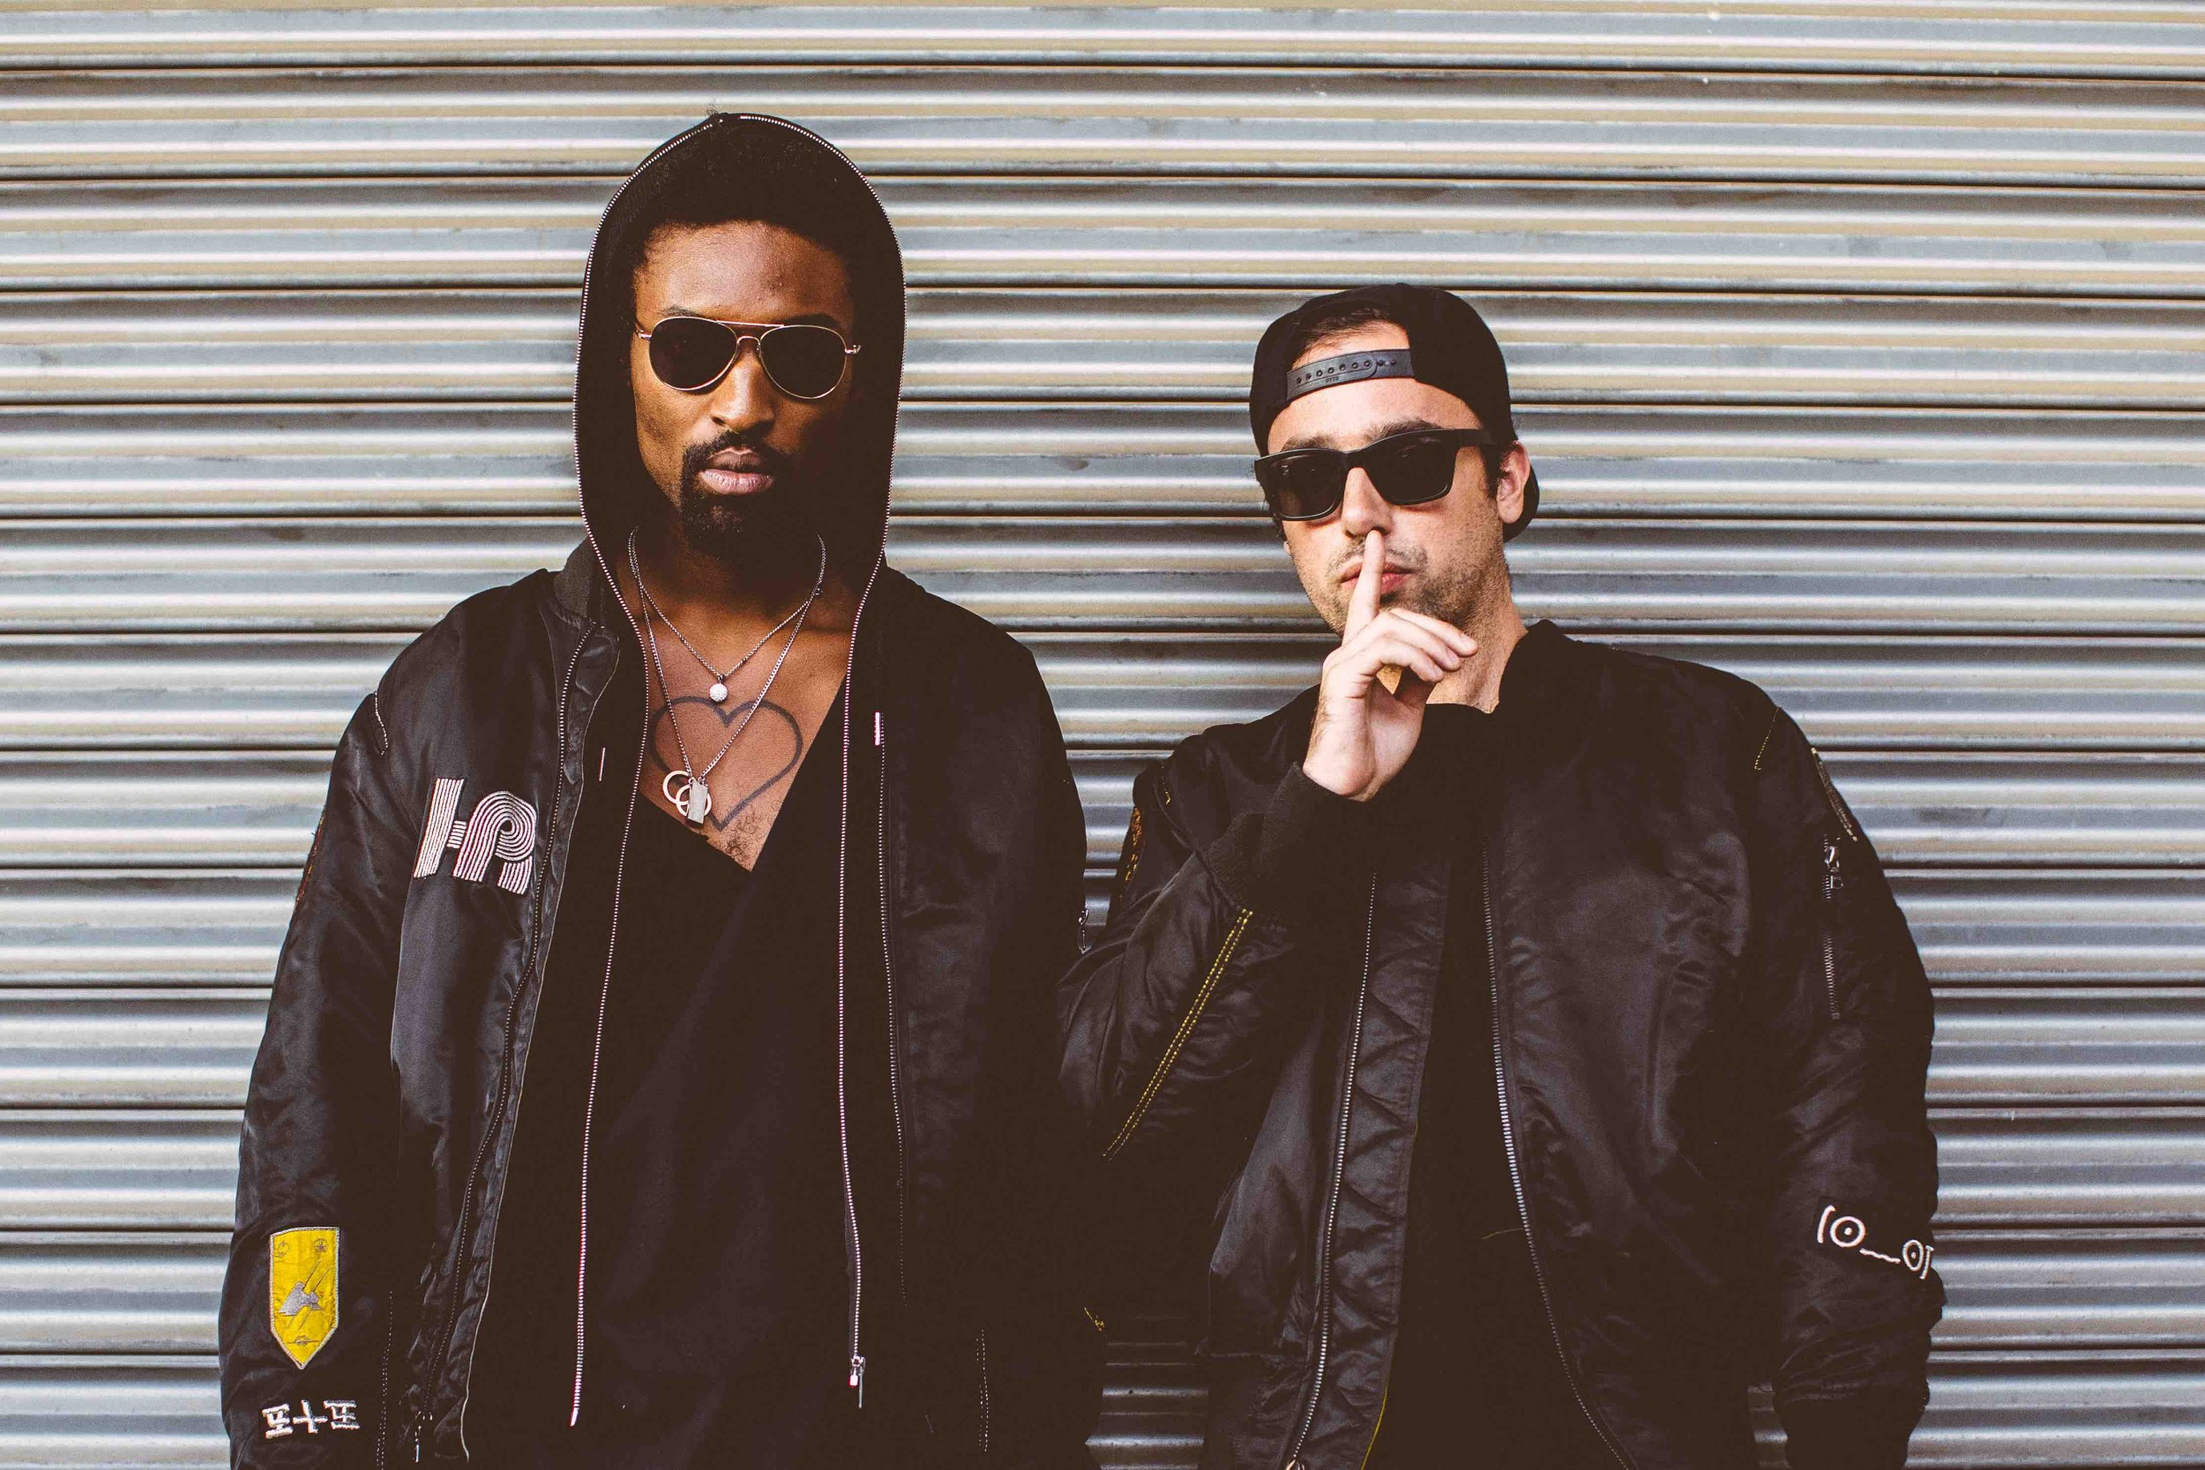
(Photo credit: Rachel Couch)

New York City dance staples The Knocks has announced the release date of their debut album “55”, which will be seeing an official release through Big Beat/Neon Gold Records on March 4th and is available today for pre-order via LINK. In conjunction, the duo has shared their massive new track “Kiss The Sky,” (LINK) which features GRAMMY Award winning artist and producer, Wyclef Jean.

“Kiss The Sky” is the follow up to “55’s” previous stand-out singles “Classic” (stream), feat. Fetty Wap & POWERS) and newly buzzing single “I Wish (My Taylor Swift) feat. Matthew Koma (stream). The Knocks has also announced a full North American tour (Route 55 Tour), which has them on the road in January and February, with support from Cardiknox and Sofi Tukker. “55” is a genre-bending musical journey, redefining what it means to be a dance act in 2016. The album features star-studded vocal contributions from Alex Newell, Cam’ron, Carly Rae Jepsen, Fetty Wap, Justin Tranter, Magic Man, Matthew Koma, Phoebe Ryan, POWERS, Walk The Moon, Wyclef Jean, and X Ambassadors (full tracklisting and all tour dates below).

The Knocks:
The Knocks are a New York story through & through, first meeting at age 19 in a studio (at New School). Ben “B-Roc” Ruttner DJed clubs while James “JPatt” Patterson played the organ at a church outside the city. Working out of their bedrooms, The Knocks first remixed Jay-Z’s entire American Gangster album in two days, calling it American G-Funk. The duo translated this online success further, soon churning out remixes for the likes of Katy Perry, Passion, and Ellie Goulding, among others, The remixes became synonymous with a certain warm, retro-future, disco-kissed touch. In 2008, JPatt and B-Roc took out a loan and opened the HeavyRoc studio at 55 Chrystie, in the same broken-down building where the Beastie Boys used to rehearse.

Wyclef Jean:
Poet. Producer. Songwriter. Philanthropist. Wyclef Jean was born to a Nazarene minister in Haiti and moved to the projects in Brooklyn at the age of nine. As a founding member of the Fugees, with Pras Michel and Lauryn Hill, the group went on to earn two Grammys and sell more than 16 million albums. The Fugees' "The Score" was listed in Rolling Stone Magazine's list greatest albums of all time.
Wyclef's first solo project, "The Carnival", earned three Grammy nominations and platinum sales, and the following year, he won another Grammy for his work on Santana's "Supernatural". He is a prolific producer, developing the breakout single "No, No, No" for Destiny's Child and the platinum single "My Love is Your Love" for Whitney Houston. Over the last decade, Wyclef impacted the Grammy's three more times, receiving nominations for his collaborations with Mary J. Blige, Jerry Duplessis, and Shakira (with her "Hips Don't Lie" reaching the number one spot on charts in 55 countries, including the U.S. Billboard Hot 100). Wyclef's collaborations read like the who's who of the music industry, including Michael Jackson, Norah Jones, Bono, Mick Jagger, Tom Jones, Eric Clapton, The Black Eyed Peas, and countless more. Wyclef is currently working on his 7th studio album for release this year.

“55” Tracklisting:
1) New York City (feat. Cam'Ron)
2) Time
3) Classic (feat. Powers)
4) Kiss The Sky (feat. Wyclef Jean)
5) Dancing With Myself
6) Comfortable (feat. X Ambassadors)
7) The Knocks & Matthew Koma - I Wish (My Taylor Swift)
8) Collect My Love (feat. Alex Newell)
9) The Key
10) Tied To You (feat. Justin Tranter)
11) Love Me Like That (feat. Carly Rae Jepsen)
12) Cinderella (feat. Magic Man)
13) Purple Eyes (feat. Phoebe Ryan)
14) Best For Last (feat. Walk The Moon)

The Knocks ‘Route 55’ North American Tour:
Buy tickets: https://tickets.warnermusic.com/theknocks
1/14 – Brooklyn, NY – Baby’s All Right ++
1/15 - Philadelphia, PA - The Foundry @ The Fillmore++
1/16 - Washington, DC - 9:30 Club++
1/19 - Cambridge, MA - The Sinclair++
1/21 - Montreal, QC - Le Belmont**
1/22 - Toronto, ON - Mod Club **
1/23 - Chicago, IL - Lincoln Hall **
1/26 - Minneapolis, MN - 7th Street Entry **
1/28 - Ames, IA - The Maintenance Shop**
1/29 - Lincoln, NE - Vega**
1/30 - Denver, CO - Larimer Lounge**
1/31 - Salt Lake City, UT - Urban Lounge **
2/03 - Vancouver, BC - Imperial Vancouver **
2/04 - Seattle, WA - Neumos **
2/05 - Portland, OR - Doug Fir Lounge **
2/06 - Eugene, OR - HiFi Music Hall**
2/08 - Orangevale, CA - The Boardwalk++
2/09 - San Francisco, CA - The Independent++ *SOLD OUT*
2/10 - San Francisco, CA - The Independent++
2/12 - San Diego, CA - Casbah++
2/13 - Los Angeles, CA - El Rey Theatre++
**Supported by Cardiknox
++Supported by Cardiknox + SOFI TUKKER

Connect with The Knocks:
https://www.facebook.com/theknocksnyc
https://soundcloud.com/theknocks
https://twitter.com/theknocks
http://theknocks.com
https://instagram.com/the_knocks

For all press assets, please visit: http://press.wearebigbeat.com/artists/the-knocks/

For press inquiries / Jordan Frazes
Jordan.Frazes@atlanticrecords.com
via Big Beat/Neon Gold Records

For tour requests / Ilana Gold
Ilana.gold@atlanticrecords.com

