The Knocks premiere official video for “I Wish (My Taylor Swift)” on MTV + announce “Route 55” North American Tour in 2016!

WATCH/POST: “I Wish (My Taylor Swift)” HERE
Purchase: http://smarturl.it/TheKnocksIWish
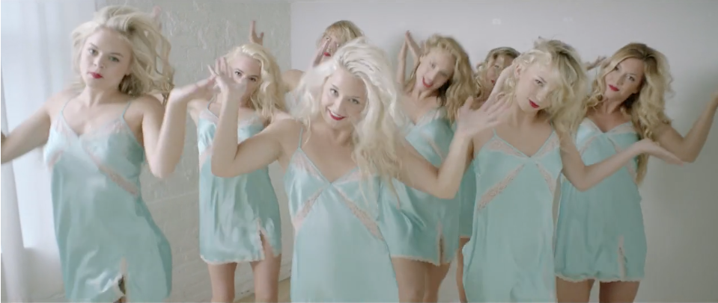
Check out The Knocks “So Classic” EP on SoundCloud + Spotify + iTunes
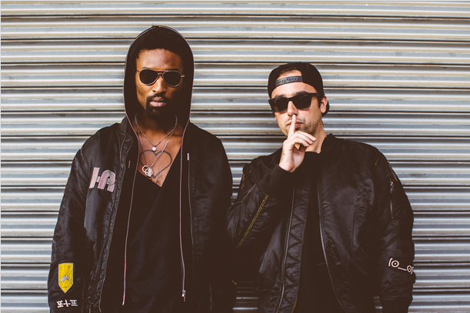
(photo credit: Rachel Couch)

The Lower East Side’s finest electronic duo The Knocks deliver a brand new video for their wistful new hit (a collaboration with Matthew Koma ) “I Wish (My Taylor Swift),” which you can watch HERE. The single is out now via Big Beat/Neon Gold Records, and The Knocks have announced their headlining “Route 55” tour of live dates and DJ sets across North America in early 2016, supported by Cardiknox and SOFI TUKKER on select dates – see itinerary below.

In the video, The Knocks awake to find out that their wish to find a girl like Taylor Swift comes true… and then some! Tune in and see what transpires. The duo is still riding high on the release of their “So Classic EP” which features the hit song “Classic” (feat. POWERS) as well as “Collect My Love” (feat. Alex Newell), a first taste of the duo’s forthcoming debut album!
The Knocks ‘Route 55’ North American Tour
Buy tickets: https://tickets.warnermusic.com/theknocks
10/30 - San Francisco, CA - Armory (DJ Set)
10/31 - Denver, CO - Club Vinyl (DJ Set)
11/13 - Austin, TX - Kingdom (DJ Set)
11/20 - New York, NY - Webster Hall (homecoming show)
1/15 - Philadelphia, PA - The Foundry @ The Fillmore++
1/16 - Washington, DC - 9:30 Club++
1/19 - Cambridge, MA - The Sinclair++
1/21 - Montreal, QC - Le Belmont**
1/22 - Toronto, ON - Mod Club **
1/23 - Chicago, IL - Lincoln Hall **
1/26 - Minneapolis, MN - 7th Street Entry **
1/28 - Ames, IA - The Maintenance Shop**
1/29 - Lincoln, NE - Vega**
1/31 - Salt Lake City, UT - Urban Lounge **
2/03 - Vancouver, BC - Imperial Vancouver **
2/04 - Seattle, WA - Neumos **
2/05 - Portland, OR - Doug Fir Lounge **
2/06 - Eugene, OR - HiFi Music Hall**
2/08 - Orangevale, CA - The Boardwalk++
2/09 - San Francisco, CA - The Independent++
2/12 - San Diego, CA - Casbah++
2/13 - Los Angeles, CA - El Rey Theatre++
**Supported by Cardiknox
++Supported by Cardiknox + SOFI TUKKER

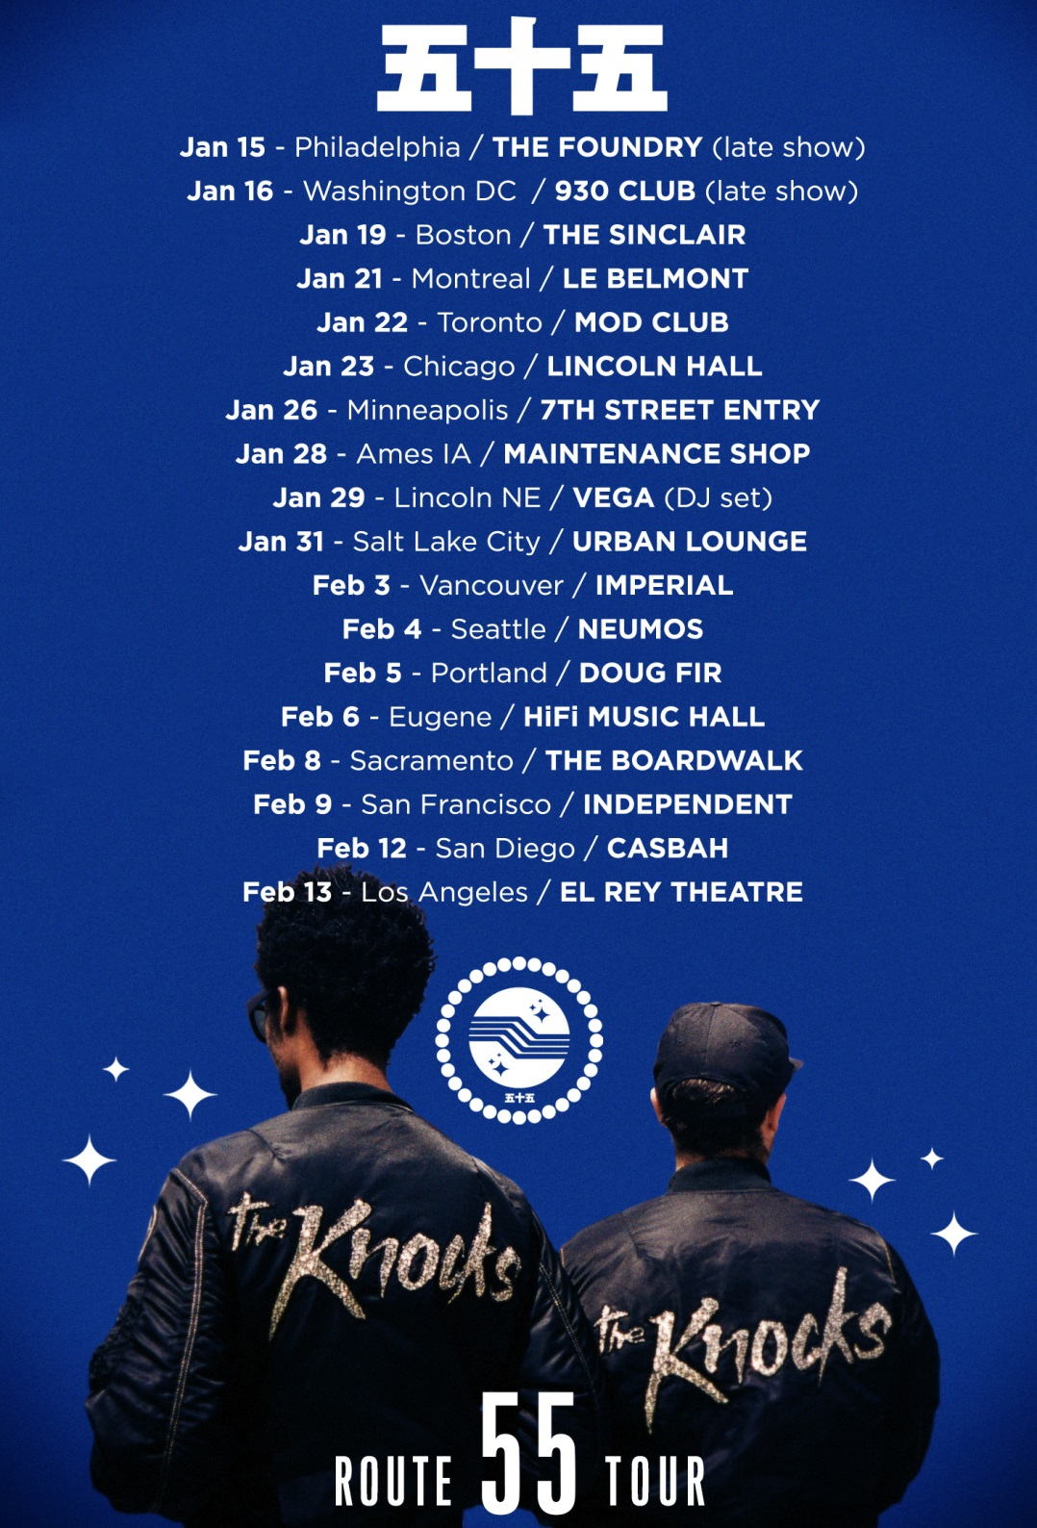

Connect with The Knocks:
https://www.facebook.com/theknocksnyc
https://soundcloud.com/theknocks
https://twitter.com/theknocks
http://theknocks.com
https://instagram.com/the_knocks

For all press assets, please visit: http://press.wearebigbeat.com/artists/the-knocks/

For press inquiries / Jordan Frazes
Jordan.Frazes@atlanticrecords.com
via Big Beat/Neon Gold Records

For tour requests / Ilana Gold
Ilana.gold@atlanticrecords.com

