The Knocks release new “I Wish (My Taylor Swift)” ft. Matthew Koma Remixes
in support of forthcoming ‘55’ album release

Post: https://soundcloud.com/theknocks/sets/i-wish-my-taylor-swift-remixes
Download: http://smarturl.it/IWishRemixEP
Stream: http://smarturl.it/IWishRemixStream
‘55’ LP arrives March 4th via Big Beat/Neon Gold (pre-order via: LINK)

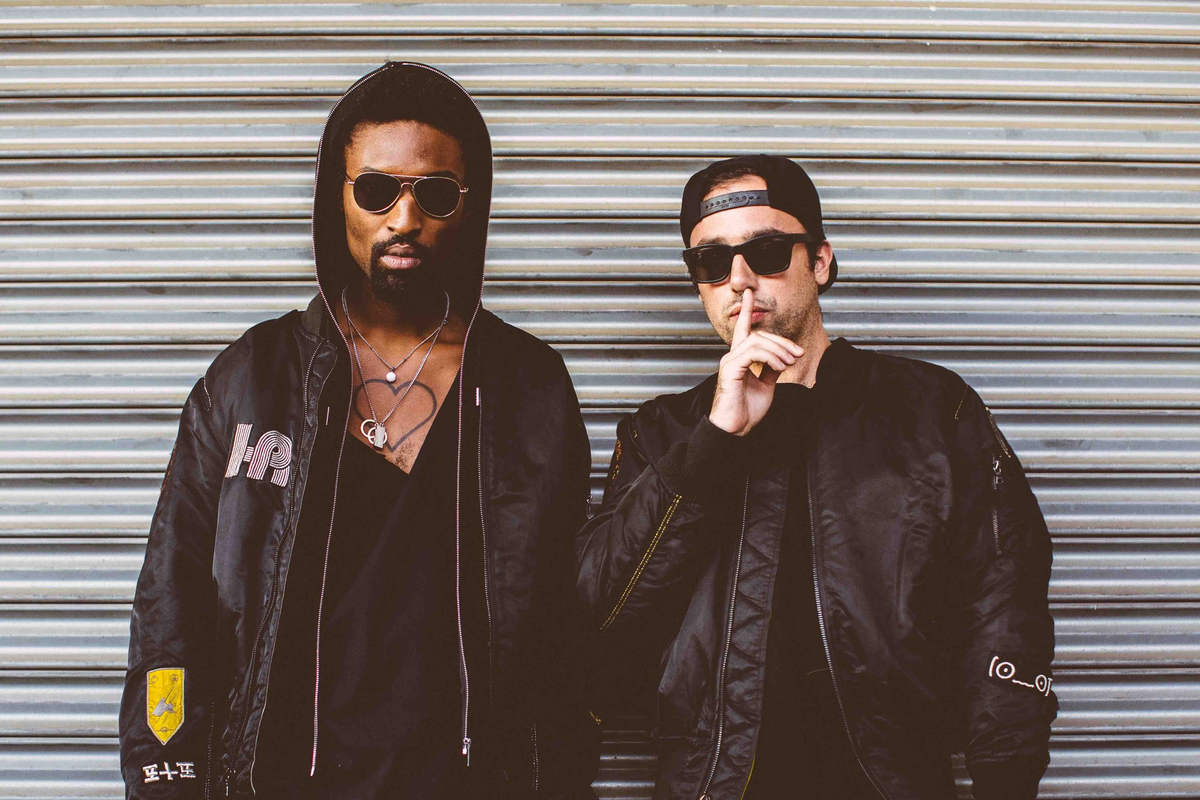
(Photo credit: Rachel Couch)

New York City dance staples The Knocks release an official remix package for their smash single “I Wish (My Taylor Swift)” off their forthcoming debut album “55”, arriving March 4th (currently available for pre-order) via Big Beat/Neon Gold. The package features four hot acts in the dance world, including Chicago-duo Louis the Child, progressive-house stars East & Young, LA bred producer/DJ Jayceeoh, alongside the electropop project, Penguin Prison – each remix garnering support across the dance spectrum:

“Replacing the original indie feels with a funky soundscape adorned with skilfully placed off-beat melodies and their signature synth work we've come to love, Louis The Child manages to keep the core themes of the song flourishing while putting their own tasty electronic flavors into the mix. ” – This Song Is Sick

“…eschewing the original’s vaguely tropical ache for a more thumping, groovy take that builds and builds without ever being overbearing.” - SPIN

“We’ve had The Knocks’ and Matthew Koma’s I Wish on repeat since it was released in September 2015, not to mention infinite plays of the wildly entertaining music video that surfaced shortly thereafter. Just when we thought we might need a quick break from the catchy hit, East & Young (pictured) introduce a fresh take that’s just as addictive…” – Less Than 3

“I Wish (My Taylor Swift)” (and its subsequent remixes) is another winning collection in congruency with the group’s forthcoming “55” a genre-bending musical journey, redefining what it means to be a dance act in 2016. The LP eliminates any idea of full length “filler” and putting to rest the idea that dance acts struggle to properly release a long player -- featuring star-studded vocal contributions from Alex Newell, Cam’ron, Carly Rae Jepsen, Fetty Wap, Justin Tranter, Magic Man, Matthew Koma, Phoebe Ryan, POWERS (‘Classic’), Walk The Moon, Wyclef Jean (‘Kiss the Sky’), and X Ambassadors (full tracklisting and all tour dates below).

##

The Knocks are a New York story through & through, first meeting at age 19 in a studio (at New School). Ben “B-Roc” Ruttner DJed clubs while James “JPatt” Patterson played the organ at a church outside the city. Working out of their bedrooms, The Knocks first remixed Jay-Z’s entire American Gangster album in two days, calling it American G-Funk. The duo translated this online success further, soon churning out remixes for the likes of Katy Perry, Passion, and Ellie Goulding, among others, The remixes became synonymous with a certain warm, retro-future, disco-kissed touch. In 2008, JPatt and B-Roc took out a loan and opened the HeavyRoc studio at 55 Chrystie, in the same broken-down building where the Beastie Boys used to rehearse.

“I Wish (My Taylor Swift) Remixes”
1. I Wish (My Taylor Swift) (Louis The Child Remix)
2. I Wish (My Taylor Swift) (Jayceeoh Remix)
3. I Wish (My Taylor Swift) (East & Young Remix)
4. I Wish (My Taylor Swift) (Penguin Prison Remix)

The Knocks ‘Route 55’ North American Tour
1/29 - Lincoln, NE - Vega**
1/30 - Denver, CO - Larimer Lounge**
1/31 - Salt Lake City, UT - Urban Lounge **
2/03 - Vancouver, BC - Imperial Vancouver **
2/04 - Seattle, WA - Neumos **
2/05 - Portland, OR - Doug Fir Lounge **
2/06 - Eugene, OR - HiFi Music Hall**
2/08 - Orangevale, CA - The Boardwalk++
2/09 - San Francisco, CA - The Independent++ *SOLD OUT*
2/10 - San Francisco, CA - The Independent++
2/12 - San Diego, CA - Casbah++
2/13 - Los Angeles, CA - El Rey Theatre++
Buy tickets: https://tickets.warnermusic.com/theknocks
**Supported by Cardiknox
++Supported by Cardiknox + SOFI TUKKER

Connect with The Knocks:
https://www.facebook.com/theknocksnyc
https://soundcloud.com/theknocks
https://twitter.com/theknocks
http://theknocks.com
https://instagram.com/the_knocks

For all press assets, please visit: http://press.wearebigbeat.com/artists/the-knocks/

For press inquiries / Jordan Frazes
Jordan.Frazes@atlanticrecords.com
via Big Beat/Neon Gold Records

For tour requests / Ilana Gold
Ilana.gold@atlanticrecords.com

