THE KNOCKS & CAPTAIN CUTS RECRUIT NIGHTLIFE MAINSTAYS FOR “HOUSE PARTY” MUSIC VIDEO!

WATCH/POST: https://www.youtube.com/watch?v=-GMlZfFzxso

BUY/STREAM: https://bigbeat.lnk.to/HPpr

(Neon Gold/Big Beat Records)

“…a shower of neon lights and silver confetti" – PAPER

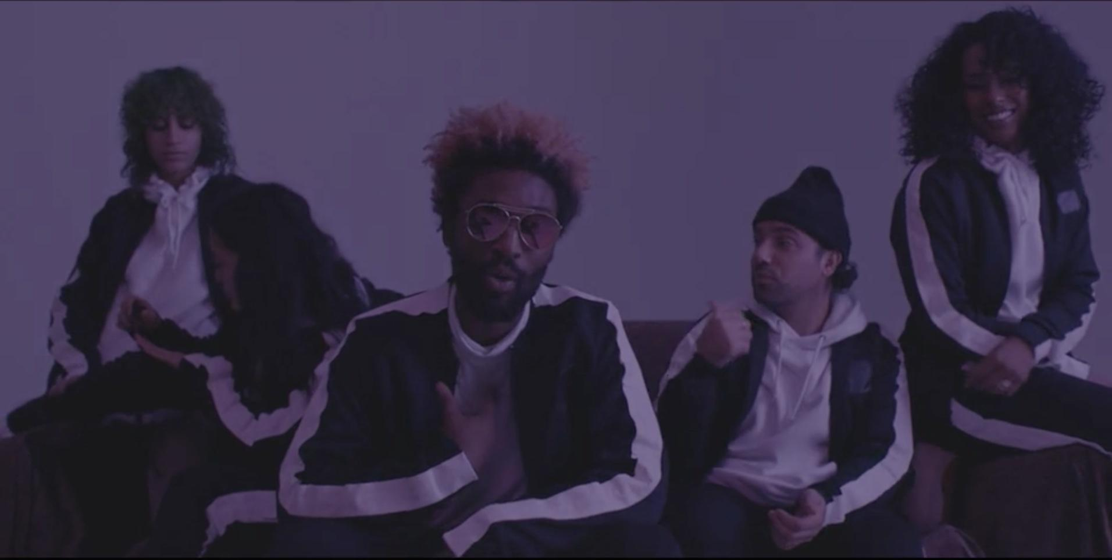

New York City’s prolific hit-making electronic duo The Knocks invite you to join them for a house party presented in their new video for their single of the same name; a collaboration with multi-platinum songwriting, production, and remix team Captain Cuts, featuring vocals from The Knocks’ own JPatt. Watch HERE!

“House Party,” directed by Austin Peters (Peters’ previous credits include videos for HAIM, Bastille, and CHVRCHES, as well as a new documentary highlighting Major Lazer’s performance in Cuba) sees JPatt and BRoc sardonically mocking the “house party DJ” stereotype and ultimately, as the lyrics promise, saving the night in heroic fashion by taking the party back to The Knocks’ house. Captain Cuts’ very own Ben Berger, Ryan McMahon, and Ryan Rabin (also of Grouplove) also appear at the party.

BRoc shares “We wanted this video to capture the essence of weird New York and the different kinds/colors/shapes of people you run into going out in the city... we came up partying with Austin (the director) in New York and running around town together, so we knew he’d be able to capture it perfectly. All the kids cast for this video live and breathe New York and are from a scene of young creatives from all different worlds... the shoot and atmosphere was a blast and quickly turned into an actual party on set.”

JPatt continues “‘House Party’ came together because we were looking to do something different than we’ve done historically. The talk/rappy vibe felt like a perfect fit for my voice, and the best approach to the track we had made. I freestyled the lyrics about a party I had been to in New York the night before our session with Captain Cuts. And yes, there was an actual ladder you had to climb to get to this party.”

Of directing the video, Peters explains: “I was happy to get to spend Halloween shooting this video with The Knocks and all our friends in New York that celebrates being yourself and what we love about the city. It is dedicated to anyone who moved here to be who they have always been.”

Featuring a propulsive, elastic beat driving the track underneath JPatt’s alternating spoken word verses and effortlessly-sung smooth chorus, “House Party” features co-production from Captain Cuts (co-writers on the inescapable triple-platinum hit “Shut Up and Dance” with Walk The Moon and Grouplove’s platinum hit “Tongue Tied,” alongside songs for The Chainsmokers, Halsey, Tove Lo, Bebe Rexha, Tegan and Sara, and more). Recently, their new single “Cocaina” (listen here) hit #1 on the Spotify Viral Chart.

“House Party” caps off an incredibly productive year for The Knocks, beginning with the release of their TESTIFY EP in February (featuring MNEK, Sam Nelson Harris of the X Ambassadors, Absofacto, Delacey, Tayla Parx and JERM). Most recently, the duo’s collaboration with Sofi Tukker, Nervo, and Alisa Ueno – “Best Friend” – peaked at #1 on the iTunes Dance Chart and in the Top 5 on Spotify’s US Viral 50 after debuting during Apple’s Keynote address. The track is now prominently featured in advertisements for the iPhone X (watch here).

In between, the duo headlined their sold-out North American FEEL GOOD FEEL GREAT tour, having previously supported Justin Bieber, Bruno Mars, Ellie Goulding, and The 1975. They also brought their acclaimed, high-octane live show to the summer festival circuit, with performances at Shaky Beats, Camp Bisco, Kaaboo, ELEMENTS Festival, All Things Go Fall Classic, and more.

Connect with The Knocks:
https://www.facebook.com/theknocksnyc
https://soundcloud.com/theknocks
https://twitter.com/theknocks
https://instagram.com/the_knocks
http://theknocks.com

Press assets: http://press.wearebigbeat.com/artists/the-knocks/

Connect with Captain Cuts:
https://www.facebook.com/captaincuts/
https://soundcloud.com/captaincuts
https://twitter.com/captaincuts?lang=en
https://www.instagram.com/captaincuts/?hl=en
www.CaptainCutsMusic.com

FOR PRESS INQUIRIES:

The Knocks:

Jordan Danielle Frazes

Head of Publicity, Big Beat Records

Jordan.Frazes@atlanticrecords.com

Catherine Corkery

Tour Publicist, Big Beat Records

Catherine.Corkery@atlanticrecords.com

Captain Cuts:

Darren Baber

VP Publicity, Epic Records

Darren.Baber@epicrecords.com

