The Knocks deliver an on fire new single
“HEAT” (ft. Sam Nelson Harris)!

LISTEN: https://youtu.be/iH0NPk00AaA
STREAM/BUY: https://BigBeat.lnk.to/HEATPR

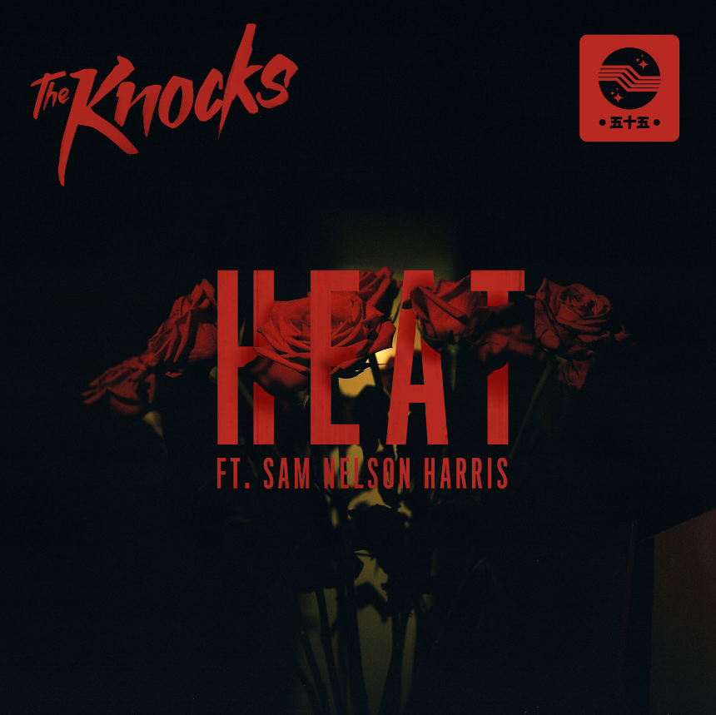

NYC electronic duo The Knocks are back, with the news of a brand-new single called “HEAT” (ft. Sam Nelson Harris) out today via Big Beat/Neon Gold Records. Currently direct support on global superstar Justin Bieber’s Purpose Tour, the genre-defying duo has released a fiery, futuristic electronic burner with R&B influences. Featuring a magnetic performance from Harris, the sultry vocals compliment perfectly with The Knock’s innovative production, displaying a style that signifies a new chapter in the duo’s critically acclaimed career and once again pushing the boundaries for what it means to be a dance-centric act in 2016. “HEAT” is the first original work by the guys since their debut full-length effort ‘55’, released earlier this year.

In 2008, JPatt and B-Roc took out a loan and opened the HeavyRoc studio at 55 Chrystie, in the same broken-down building where the Beastie Boys used to rehearse. From there, in a dance music ecosystem increasingly dominated by reticent bedroom producers or big-tent corporate names, The Knocks stayed on a certain downtown grind. They put out their first big hit in 2010 with the filter-house party anthem “Dancing With the DJ.” The classic New York open-format DJ style suffused every record: this music could work a crowd from all angles, full of pre-dawn tenacity and the energy of a dance-floor crush.

Their subsequent debut ‘55’ was a triumph, and a resolutely DIY dance album that pulses with the heart of the city. It’s a love letter to the old-school way of making music, and to that classic story of two kids who came to NYC to make it big. The album features a star-studded cast; a diverse list of musical styles and artistic approaches, from New York’s hip hop legend Cam’ron to pop-sensation Carly Rae Jepsen. The album twists and turns with unexpected guests and genre-bending flavor, featuring contributions from artists like GRAMMY-winner Wyclef Jean, to Fetty Wap, and Walk The Moon, each of which provide an unparalleled gusto best described by VICE’s NOISEY as “bombastic, funk-finagled, and fun.”

With more new music on the way, executive producers on Wyclef Jean’s new LP, and a slew of A-list festivals and support tours (Ellie Goulding, The 1975, Bieber) under their belt, 2017 brings high-hopes to the Lower East Side DJ/producer juggernauts. As The Huffington Post most aptly put it... “The Knocks are one of the best bets for what’s next in pop music, as their eventual ascension to stardom is all but secured.”

Stay tuned for more from The Knocks, coming soon!

Live:
OCT 23 -MANCHESTER ARENA @ MANCHESTER, UNITED KINGDOM*
OCT 24 -GENTING ARENA @ BIRMINGHAM, UNITED KINGDOM*
OCT 26 -SHEFFIELD ARENA @ SHEFFIELD, UNITED KINGDOM*
OCT 27 -THE SSE HYDRO @ GLASGOW, UNITED KINGDOM*
OCT 29 -THE SSE HYDRO @ GLASGOW, UNITED KINGDOM*
OCT 30 -THE SSE HYDRO @ GLASGOW, UNITED KINGDOM*
NOV 01 -3ARENA @ DUBLIN, IRELAND*
NOV 02 -3ARENA @ DUBLIN, IRELAND*
NOV 08 -STADTHALLE @ VIENNA, AUSTRIA*
NOV 09 -ARENA ZAGREB @ ZAGREB, CROATIA*
NOV 11 -TAURON ARENA @ KRAKOW, POLAND*
NOV 12 -O2 ARENA @ PRAGUE, CZECH REPUBLIC*
NOV 14 -BARCLAYCARD ARENA @ HAMBURG, GERMANY*
NOV 16 -FESTHALLE @ FRANKFURT, GERMANY*
NOV 17 -HALLENSTADION @ ZURICH, SWITZERLAND*
NOV 19 -UNIPOL ARENA @ CASALECCHIO DI RENO, ITALY*
NOV 20 -UNIPOL ARENA @ CASALECCHIO DI RENO, ITALY*
NOV 22 -PALAU SANT JORDI @ BARCELONA, SPAIN*
NOV 23 -BARCLAYCARD ARENA MADRID, SPAIN*
NOV 25 -MEO ARENA @ LISBON, PORTUGAL*
NOV 28 -THE O2 @ LONDON, UNITED KINGDOM*
NOV 29 -THE O2 @ LONDON, UNITED KINGDOM*
Dec 29-31 – SnowGlobe Music FESTIVAL @ South Lake Tahoe, CA
*SUPPORTING JUSTIN BIEBER

Connect with The Knocks:
https://www.facebook.com/theknocksnyc
https://twitter.com/theknocks
https://instagram.com/the_knocks
http://www.snapchat.com/add/Theknocks
http://theknocks.com/

For all press assets, please visit: http://press.wearebigbeat.com/artists/the-knocks/

For press inquiries / Jordan Frazes
Jordan.Frazes@atlanticrecords.com
via Big Beat/Neon Gold Records

For tour requests / Ilana Gold
Ilana.gold@atlanticrecords.com

